MARY LAKE – BUFFALO 115 KV LINE

Problems at the City of Buffalo:

The City of Buffalo is primarily fed by 69 kV transmission source from Lake Pulaski. The alternate source is another 69 kV line from Maple Lake – City of Buffalo. On the summer peak afternoon of 14th of July 2005, the primary source feeding the city from Pulaski overloaded, and the alternative source could not maintain sufficient voltage to support the load of the city.

Load at the City of Buffalo:

The City of Buffalo has been experiencing higher than expected load growth. The summer peak loads for the past 5 years at the City are provided in Table 1. It can be seen that the load grew from 20.2 MW in 2000 to 24.62 MW in 2005. This indicates an average load growth rate of about 4% over the past 5 years.

Table 1

Year | Load
2005 | 24.62 MW
2004 | 22.71 MW
2003 | 22.44 MW
2002 | 21.24 MW
2001 | 22.56 MW
2000 | 20.20 MW

Plan:

The initial plan is to build approximately 6 miles of 115 kV line (operated at 69 kV) from Buffalo to GRE Mary Lake. If the load in the region continues to grow at 4 to 5%, the Pulaski – Buffalo – Mary Lake – Dickinson line will be converted to 115 kV and operated at 115 kV (around 2014).

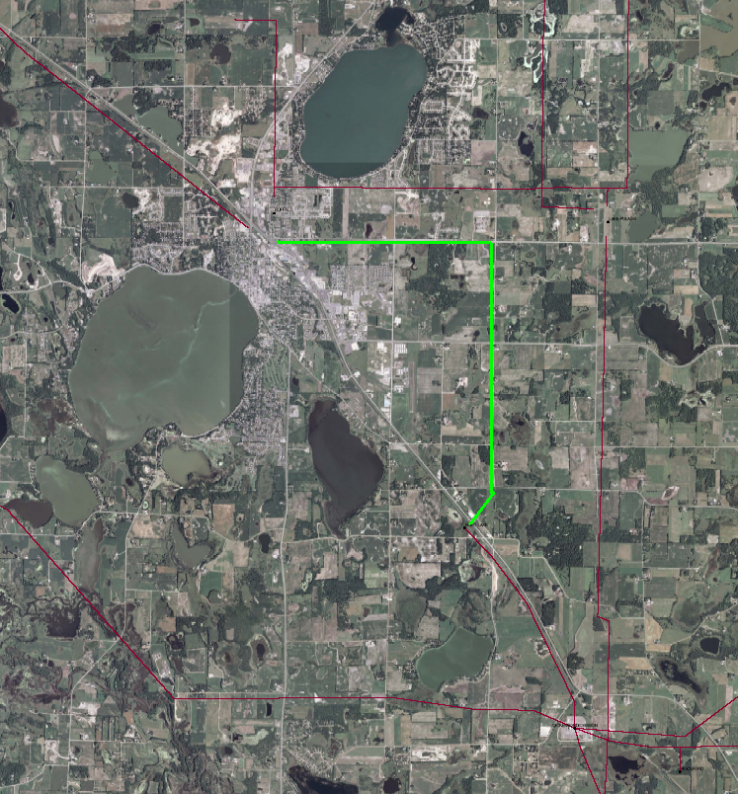Proposed corridor for Mary Lake – Buffalo 115 kV line
Mary Lake
Dickinson
Lake Pulaski
City of Buffalo

