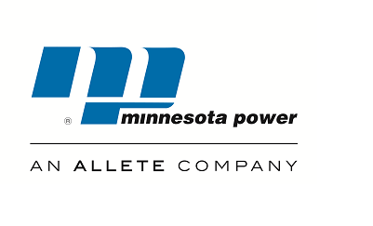 30 west superior street ● duluth, minnesota 55802-2093 ●218.722.2641● www.allete.com
October 5, 2017
Subject: Minnesota Power’s Annual Attachment O Rate Projected Net Revenue Requirement Customer Meeting
Date: Thursday, October 26, 2017
Time: 8:30 a.m. to 9:30 a.m. CDT
Minnesota Power cordially invites you to participate in its Annual Attachment O Rate Projected Net Revenue Requirement Customer Meeting for the 2018 rate year. The purpose of this meeting is to present information that will explain Minnesota Power’s annual filing that was posted on the MISO website on October 5, 2017, and allow Interested Parties an opportunity to seek information and clarifications from Minnesota Power about the projected rate.
Pursuant to the updated formula rate protocols established in FERC Docket NO. ER13-2379, Minnesota Power must calculate and post its formula rate calculations, supporting documentation, and work papers by September 1. In addition, Minnesota Power is required to hold an open meeting among Interested Parties by October 31 of each year to discuss this posting. The Minnesota Power rate information for the 2018 rate year is posted on the MISO website under the name “Allete, Inc.” and is available for viewing at:
https://www.misoenergy.org/MarketsOperations/TransmissionSettlements/Pages/TransmissionOwnerRateData.aspx
The customer meeting presentation will also be posted at the same location prior to the meeting.
To join the meeting via telephone, use the following audio conference information:
Conference Number: (877) 398-7155
Participant Code: 445 460 0220

Sincerely,
Jeanne Kallberg
Transmission Business Analyst II

