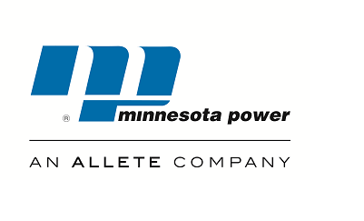 30 west superior street ● duluth, minnesota 55802-2093 ●218.722.2641● www.allete.com
August 2, 2016
Subject: Minnesota Power’s Annual True-Up Meeting
Date: Tuesday, August 23, 2016
Time: 10:00 to 11:00 CDT

Minnesota Power cordially invites you to participate in its Annual True-Up meeting for the 2015 rate year. The purpose of this meeting is to present information that will explain Minnesota Power’s 2015 Annual True-Up filing that was posted on the MISO website on May 27, 2016 and allow Interested Parties an opportunity to seek information and clarifications from Minnesota Power about the Annual True-Up.
Pursuant to the updated formula rate protocols established in FERC Docket NO. ER13-2379, Minnesota Power must calculate and post its formula rate calculations, supporting documentation, work papers, and the Annual True-Up for the previous rate year by June 1 of each year. In addition, Minnesota Power is required to hold an open meeting among Interested Parties by September 1 of each year to discuss this posting. The Minnesota Power rate information for the 2015 rate year is posted on the MISO website under the name “Allete, Inc.” and is available for viewing at:
https://www.misoenergy.org/MarketsOperations/TransmissionSettlements/Pages/TransmissionOwnerRateData.aspx
The customer meeting presentation will also be posted at the same location prior to the meeting.
To join the meeting via telephone, use the following audio conference information:
Conference Number: (877) 398-7155
Participant Code: 445 460 0220

Sincerely,
Jeanne Kallberg
Transmission Business Analyst II

