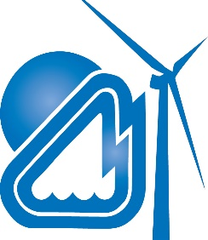
WILLMAR MUNICIPAL
UTILITIES

2016 Annual True-Up Meeting
Purpose: Review 2016 Attachment O True-Up

When: Wednesday, August 30, 2017 at 2:00 p.m. CDT

Where: In person:
Willmar Municipal Utilities
Auditorium
700 Litchfield Ave SW
Willmar, MN 56201

Webcast: Join from PC, Mac, Linux, iOS or Android: https://zoom.us/j/2231231661

Or iPhone one-tap (US Toll): +16465687788, 2231231661# or +14157629988, 2231231661#

Or Telephone:
Dial: +1 646 568 7788 (US Toll) or +1 415 762 9988 (US Toll)
Meeting ID: 223 123 1661
International numbers available:
https://zoom.us/zoomconference?m=TLmL-_LmMaUkOL7-WrXTYYpccaCCt9Pz

Pursuant to the updated formula rate protocols established in FERC Docket No. ER16-18-000, Willmar Municipal Utilities (WMU) must calculate and post its formula rate calculations, supporting documentation, work papers, and the Annual True-Up for the previous rate year by June 1 of each year. In addition, WMU is required to hold an open meeting among Interested Parties by September 1 of each year to discuss this posting.

The 2016 Attachment O True-Up information will be posted on the MISO link prior to the meeting: https://www.misoenergy.org/MarketsOperations/TransmissionSettlements/Pages/TransmissionOwnerRateData.aspx

At your earliest convenience, RSVP to Michelle Marotzke at mmarotzke@wmu.willmar.mn.us and please state whether you will be attending the meeting in person or via teleconference (directions above).

