2 flavors of OASIS postings:
- Outages that affect the CVP ATC:
  - These outages are currently posted and managed in OASIS by the TSS desk, this will remain unchanged.
    - The notification process will change from the current e-mailed PDF to the new e-mailed switching request form. The expectation is that the outage is posted as soon as practical.
- Outages that do not affect CVP ATC:
  - These outages impact the WASN merchant are not currently posted to OASIS and will be the focus of our conversation and Power Point. In the near future the TSS will post and manage these additional scheduling points (lines or CB). No CVP ATC will be assigned.
Process:
- New outages.
  - The TSS desk receives the e-mail from the outage coordinator and posts the outage in the OASIS notices section.
- Date/time changes to existing outages.
  - The outage coordinator will process the date/time change to an existing outage for the below lines, as part of the coordination the affected entities and crews will be sent an e-mail, the TSS desk will be added to the distribution.
  - The TSS desk receives the e-mail from the outage coordinator and posts the date/time change for the outage in the OASIS notices section.
- Cancelled outages.
  - The outage coordinator will process the cancellation of an existing outage for the below lines, as part of the coordination the affected entities and crews will be sent an e-mail, the TSS desk will be added to the distribution.
  - The TSS desk receives the e-mail from the outage coordinator and cancels or deletes the outage in the OASIS notices section.
- At noon each day the TSS will use TOA to filter for OATI outages in the date range to be determined and compare them to the OASIS notices to verify correctness of the posted outages.

WASN OASIS https://www.oasis.oati.com/ WestTrans.net
CVP Transmission Paths posted on WASN OASIS:
COTTONWOOD – ROUND MOUNTAIN
ELVERTA - KESWICK
KESWICK - AIRPORT
KESWICK – COTTONWOOD
KESWICK – ELVERTA
KESWICK – OLINDA
KESWICK – TRACY
OLINDA – KESWICK
ROUND MOUNTAIN – COTTONWOOD
ROSEVILLE – COTTONWOOD
ROSEVILLE – TRACY
TRACY - KESWICK
OBANION – TRACY
OBANION – COTTONWOOD
OLINDA – ELVERTA
WANS lines or paths that do not impact CVP ATC but need to be posted for the WASN merchant in the notices section:
Tracy-Livermore 230kv line (TRY-LLL) WASN merchant schedules to LLN loads.
Livermore-U424 115kv line (LLL-LLN) WASN merchant schedules to LLN loads.
Tracy-Contra Costa 69kv line (TRY-CC) MID scheduling to Contra Costa Water District.
Tracy-Westley #1 & #2 230kv lines (TRY-WES) WASN merchant schedules to MID.
Elverta CB 1182, WASN Elverta to SMUD Elverta (ELV-ESE) WASN merchant schedules to SMUD.
Trinity-Weaverville 60kv line (TNI-WEA) WASN merchant schedules to TPUD.
Trinity-Carr 230kv line (TNI-CAR) WASN merchant schedules to TPUD.

Non-Western lines or paths not posted by WASN may be found at CAISO OASIS:
CAISO OASIS http://oasis.caiso.com/mrioasis ,TRANSMISSION, TRANSMISSION OUTAGES or MARKET AVAILABLE TRANSMISSION CAPACITY, TRANSMISSION INTERFACE ID: select date range then apply
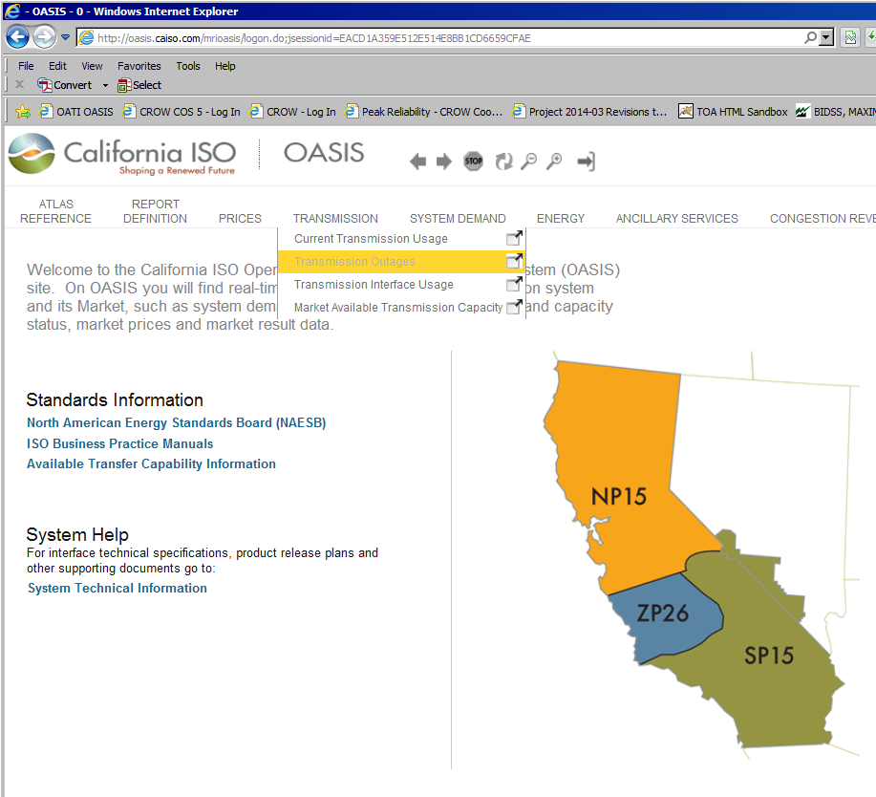
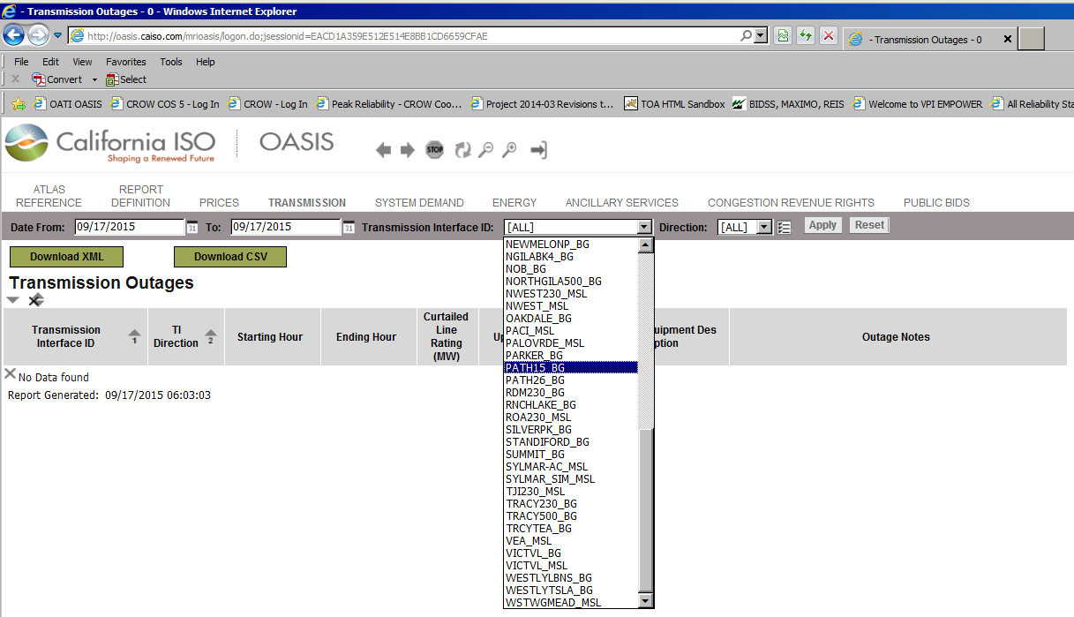
Other lines or paths that impact WASN merchant scheduling but are not posted on WASN OASIS:
Captain Jack-Olinda 500kv line (CPJ-ODA), OASIS Branch Group, (COTPISO_MSL)
Malin-Round Mountain #1 500kv line (MLN-RDM), OASIS Branch Group, (PATH26_BG)
Los Banos-Gates #3 500kv line (LBS-GTS), OASIS Branch Group, (PATH15_BG)
Tesla-Tracy #1 & #2 230kv lines (TES-TRY), scheduling tie between BANC and CAISO, CAISO OASIS Branch Group, (TRACY230_BG)
Tesla-Tracy 500kv lines (TES-TCY), scheduling tie between BANC and CAISO, CAISO OASIS Branch Group, (TRACY500_BG)
Lawrence Lab 115kv tap #1, scheduling tie between BANC and CAISO, CAISO OASIS Branch Group, (LLNL_BG)
Cottle-Melones 230kv line (Cottle-NML), CAISO OASIS Branch Group, (NEWMELONP_BG)
Melones-Wilson 230kv line (NML-WSN), CAISO OASIS Branch Group, (NEWMELONP_BG)
Cottonwood 230kv scheduling tie between BANC and CAISO, CAISO OASIS Branch Group, (CTW_BG)

TANC OASIS www.oatioasis.com/tanc
SMUD OASIS www.oatioasis.com/smd1

