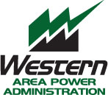 | Western Area Power Administration  Sierra Nevada Region (WASN)  TEST

