Western Area Power Administration Sierra Nevada Region

2009
Annual Ten-Year Transmission Plan Assessment Report

October 30, 2009

For information or questions regarding this Transmission Assessment Report, please contact Larry Tobias via (916) 353-4766 or email at Tobias@wapa.com
Principal Author: Larry Tobias

Approved by: Phil Sanchez Date:
Transmission Planning Manager

Approved by Pete Garris
Power Operations Manager Date:

CONTENTS

Introduction 4
Responsibilities and Objectives 5
Reliability Standards 6
Study Assumptions 8
A. Base Cases Developed for Transmission System Assessment 9
B. Electric Demand and Power Factor Assumptions Methodology 10
C. Import-Export and Major Path Assumptions 10
D. Generation Assumptions 11
Study Scope 11
A. Thermal Loading and Voltage Limits 12
B. Voltage Stability – Post Transient Voltage 12
C. Transient Stability 13
System Assessment 13
A. Category A (NERC Planning Standard TPL - 001): All Facilities in Service, (N-0) 15
B. Category B (NERC Planning Standard TPL - 002): Single Element Outage, (N-1) 16
C. Category C (NERC Planning Standard TPL - 003): Double Element Outages, (N-2) 17
D. Category D (NERC Planning Standard TPL - 004): Extreme Events (N-2 plus) 19
Attachment 1: Diagram of the Western Area Power Administration – Sierra Nevada Region Transmission System 21
Attachment 2: Contingencies Studies 22

Attachments 3, 4, 5, and 6 are separate documents containing power flow, post-transient and dynamic stability plots. The plots included represent the overall study results. Plots for contingencies not included in the attachments are available upon request. 24

Attachment 3: Category A (NERC Planning Standard TPL-001): All Facilities in Service, (N-0) Includes Power Flow, Post Transient and Dynamic Stability Plots
Attachment 4: Category B (NERC Planning Standard TPL-002): Single Element Outage, (N-1) Includes Power Flow, Post-Transient and Dynamic Stability Plots
Attachment 5: Category C (NERC Planning Standard TPL-003): Double Element Outages, (N-2) Power Flow , Post-Transient and Dynamic Stability Plots
Attachment 6: Category D (NERC Planning Standard TPL-004): Extreme Events Outages (N-2 plus) Power Flow , Post-Transient and Dynamic Stability Plots

Introduction

The Western Area Power Administration – Sierra Nevada Region’s (WASN) transmission system annual assessment was conducted in accordance with North American Electric Reliability Corporation (NERC) Transmission Planning Standards. The assessment covers critical system conditions over a ten year period from 2010 thru 2019 and is consistent with meeting the requirements of NERC Transmission Planning Standards TPL-001 thru TPL-004. This is an analysis of WASN’s transmission system. It does not include a detailed assessment of Load-Serving Entities transmission systems connected to WASN’s transmission system. Critical system conditions were analyzed. Where potential reliability problems were identified, existing or potential mitigation measures were identified to achieve required system performance. Mitigation measures include proposed new transmission projects or other mitigation measures such as operating procedures including operating nomograms. Analysis was conducted to assess the continuing need for planned transmission reinforcement projects.

This annual transmission assessment is the basis for maintaining a reliable transmission system supporting customer demand and transmission services at various demand levels over the range of forecast system demands and within the levels of reliability described within NERC Planning Standards. While this assessment is the basis of a ten-year transmission planning horizon for maintaining system reliability, emphasis was placed on the first 5 years (2010-2014) of the plan. Interconnected transmission system reliability is addressed and potential performance deficiencies are identified and corresponding projects that resolve these problems are developed. As required, analysis out to the year 2019 was conducted to identify potential reliability concerns, which may require longer lead-times associated with significant 230 kV and 500 kV systems reinforcements.

Specifically, an assessment of WASN’s transmission facilities was performed to identify reliability problems (within the years 2010 to 2019) associated with delivering transmission service obligations. Full compliance with NERC Planning Standards TPL-001, TPL-002, TPL-003 and TPL-004 was achieved. For each identified potential reliability problem directly associated with WASN’s transmission system and obligations to transport power through its transmission system, a mitigation plan has been proposed. As appropriate, alternative mitigation plans will be developed to determine the preferred engineering and economical mitigation plan to implement. Details of the assessment are contained in the System Assessment section starting on page 13 and within attachments to this report.

Responsibilities and Objectives

With coordination and input from surrounding and interconnected utilities, WASN is responsible for performing a system assessment and developing a transmission plan of its transmission facilities covering the next 10 years. WASN will perform the following:

- As required, revise power flow base cases obtained through the California Independent System Operator (CAISO), Pacific Gas and Electric (PG&E) and Western Electricity Coordinating Council (WECC) that model the 10 year span of the studies under various seasonal conditions;

- Conduct transmission system studies and benchmark the performance assessment of WAPA’s transmission facilities;

- Identify potential reliability problems for the 5 and 10-year planning horizons based on NERC Transmission Planning Standards and their requirements; and

- Propose mitigation plans to address potential reliability problems for years 2010 to 2019

The projects proposed in the transmission plan will accomplish the following objectives:

- Comply with NERC Transmission Planning Standards;

- Provide reliable transmission service to electric customers whose power is transmitted over WASN transmission lines;

- Maintain acceptable system voltages and thermal loadings;

- Assess the performance and impact of planned transmission system additions and upgrades;

- Support coordinated operation with interconnected and parallel utilities transmission systems; and

- Implement the results of various previous and on-going transmission planning studies

Reliability Standards

NERC Transmission Planning Standards TPL-001, TPL-002, TPL-003 and TPL-004 and their requirements will be the basis for establishing completion of this annual assessment.

Standard TPL-001-0 — System Performance Under Normal (No Contingency) Conditions (Category A)

Standard TPL-002-0 — System Performance Following Loss of a Single Bulk Electric System Element (Category B)

Standard TPL-003-0 — System Performance Following Loss of Two or More Bulk Electric System Elements (Category C)

Standard TPL-004-0 — System Performance Following Extreme Events Resulting in the Loss of Two or More Bulk Electric System Elements (Category D)

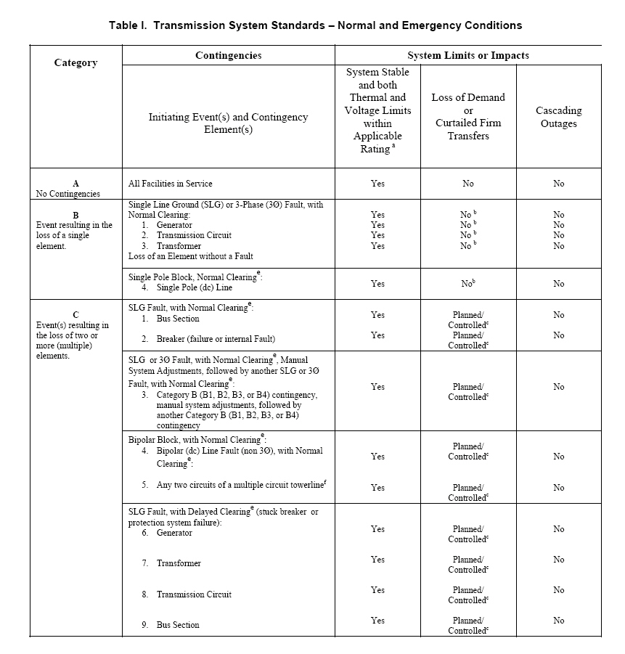
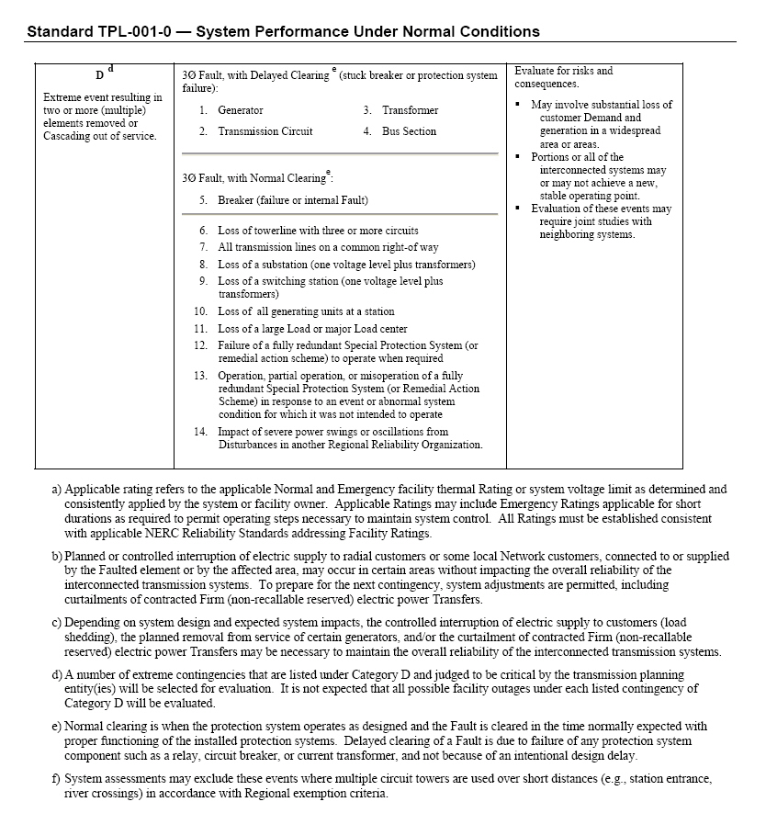

Study Assumptions

The annual transmission planning process starts with the development of power flow base cases that model WASN’s transmission system within Northern California as well within the WECC reliability area. This section discusses the assumptions used in developing the power flow base cases for this study.

A. Base Cases Developed for Transmission System Assessment

Power flow base cases for this annual assessment are base cases developed by PG&E for their and the California Independent System Operator (CAISO) transmission planning assessments. For the years 2010-2013, PG&E base cases representing Northern California were used. For years 2014 & 2019, PG&E base cases representing the whole of the Western Electricity Coordinating Council (WECC) were used.

The base cases were developed through review and any required revision by WASN, those entities that supply and receive power over WASN’s transmission system and other utilities within Northern California. The cases representing 2014 and 2019 are based on base cases (2013 HS1a and 2018 hs1a) initially developed by WECC with review and revision by WECC members. The transmission system configuration has been updated to reflect, according to the projected year of operation, new planned transmission system reinforcements expected to be approved and become operational.

Historically, maximum power flow through WASN’s transmission system has occurred during summer peak load and high hydroelectric power generating conditions when pre-dominate power flow through the 500 kV transmission system in California is from North to South.

However, there are system conditions that occur during other seasons or load conditions that warrant investigation. This includes summer off-peak conditions when loads are lower, hydro power is lower and the direction of pre-dominate power flow through the 500 kV transmission system in California can be in a South to North direction and Winter Peak conditions when loads and hydro power is lower, some thermal units are off-line for annual maintenance and the load pattern is different from summer and reflects winter heating demands.

Base cases that were utilized for this annual transmission assessment are summarized in Table 1.

Table 1: List of Study Base Cases PG&E Annual Assessment Base cases
2010 Summer Peak – Northern California
2011 Summer Peak – Northern California
2012 Summer Peak – Northern California
2013 Summer Peak – Northern California
2014 Summer Peak – WECC
2014 Summer Off-Peak – WECC
2014 Winter Peak – WECC
2015 Summer Peak - WECC
2019 Summer Peak – WECC

See Attachment 1 for a basic diagram of the WASN system within Northern CA.

All transmission projects that are planned and expected to become operational are modeled as submitted for inclusion in WECC base cases. Some specific projects modeled include the Sacramento Voltage Support Project (in 2011), the Redding Business Park Development Projects (in 2011), the Folsom Loop Project (completed October 2009) and the Re-configuration of the Shasta 230 kV Bus Project (completed in August 2009).

B. Electric Demand and Power Factor Assumptions Methodology

Base case assumptions for electric demand and power factor represented projected summer peak load conditions as reported by WASN’s planning area Load Serving Entities (LSE) consistent with the California Energy Commission’s (CEC) Integrated Energy Policy Report (IEPR) which includes load projections for all of Northern California as well as separately for public and privately owned electric utilities and independent power producers generation. Reactive Power resources are modeled and put on-line as required to ensure that adequate reactive resources are available to meet system performance. Electric demand and power factor assumptions for the WECC system-wide base cases will incorporate a 1-in-5 year adverse weather assumption based on ambient temperature. Similarly, the North Valley area base cases incorporate a 1-in-10 year adverse weather assumption. Additional information on the electric demand forecast is listed below:

Forecasted Load in MW
Year | 2010 | 2014 | 2019
SMUD | 3181 | 3221 | 3485
City of Redding | 280 | 294 | 307
City of Roseville | 382 | 450 | 506
MID | 706 | 768 | 873
WAPA Direct Service(1) | 230 | 230 | 230
Total Northern California Area Load (2) | 25,212 | 26,649 | 31,331
(1) Includes the Tracy Pumping Plant, City of Shasta Lake,
Lawrence Livermore Lab
(2) Includes - PG&E, SVP, SMUD, MID, TID, WAPA Direct Svc,
LMUD, NCPA, Roseville, Redding, CDWR and Other Muni's

C. Import-Export and Major Path Assumptions

The summer peak base cases modeled 4,800 MW of north-to-south flow on the California-Oregon Intertie, COI (Path 66). The flow on the Midway-Vincent 500 kV lines (Path 26) at Midway Substation was modeled at 4,000 MW (North-to-South), but varied as necessary to balance loads and resources in Northern California. Table 2 summarizes the major path flow assumptions.

Table 2: Major Intertie and Path Flow Summary
Path or Intertie |  |  | Path Flow (MW) |  | Path Rating (MW)
 | Summer Peak | Summer Off-Peak |  | Winter Peak
Path 66  (COI) | 4,800  (North to South) | 3,675  (South to North) |  | 3,768  (North-South) | 4,800  (North to South)  3,675  (South to North)
Path 26  (Midway-Vincent 500 kV) | 4,000  (North to South) | ~1500 (South-North) and Varied to balance loads and resources in No. California |  | 2747 (North-South) and Varied to balance loads and resources in No. California | 4,000  (North to South)  3,000  (South to North)
Path 15 | Varied to balance loads and resources in No. California | 5,300  (South to North |  | 51  (South to North) | 3,265  (North to South)  5,400  (South to North)
PDCI | 3,100  (North to South) | 1,900  (South to North) |  | 3000  (North-South) | 3,100

D. Generation Assumptions

Assumptions on existing generation facilities such as capability and output levels was developed based on historical generation dispatch data for Northern California. Northern California hydro generation was assumed available at historical output (about 86%) during peak system demand conditions. Both hydro and thermal generation within local areas, and generation external to a local area that has an effect on local area reliability will be varied as necessary to identify the most restrictive system conditions and related reliability problems.

The generation pattern and level of generation modeled in power flow base cases will be representative of recent utility information provided for both PG&E and WECC seasonal base cases representing peak and off-peak load conditions.

By studying different study years and seasons, various generation patterns that could influence system reliability was analyzed.

Study Scope

The assessment process tested the WASN transmission system against NERC Planning Standards TPL-001 thru TPL-004 and their requirements. The study included analysis of contingencies related to the WASN transmission system. This assessment included evaluating the transmission grid for the following:

- Thermal Loading and Voltage Limits
- Voltage Stability – Post Transient Voltage
- Dynamic and Transient Stability

The contingencies studied are listed in Attachment 2

A. Thermal Loading and Voltage Limits

A thermal loading assessment will be performed on all WASN transmission facilities. This analysis will examine thermal loadings under normal and contingency conditions. Should a WAPA transmission facility be determined to exceed its thermal capability normally or during contingency conditions, WAPA will address the thermal loading with a mitigation plan.

WASN will examine system voltages to determine if they stay within acceptable post transient and steady state limits. As with the thermal loading assessment, the analysis will include examining base case (normal) conditions and contingency conditions.

Voltage Stability – Post Transient Voltage

Voltage stability studies will be performed in accordance with the Guide to WECC/NERC Planning Standards I.D: Voltage Support and Reactive Power under normal and contingency conditions. The voltage stability assessment consisted of an assessment of reactive margin under normal and contingency conditions. When analyzing voltage stability, the WECC requires a 5% increase in load for single contingencies (Category B) and 2.5% for double contingencies (Category C).

Post-transient voltage analysis was conducted at points where the WASN transmission system connects to customer load-serving points such as for the Cities of Redding and Roseville as well as connections to the Sacramento Municipal Utility District (SMUD) and USBR Pumps at Tracy as well as recognition of the 500 and 230 kV connections to PG&E’s system at Cottonwood and Tracy Substations.

Specifically, the following points in WASN’s transmission system will be analyzed for Category B and C contingencies:
- Airport
- Cottonwood
- Elverta
- Roseville
- Tracy

Transient Stability

The transient stability assessment was conducted in accordance with WECC Stability Standards for selected contingency conditions. The scope of these studies was sufficient to establish the existence of any stability problems. The analysis followed the latest transient stability modeling methodology recommended by WECC. Most transient stability analysis modeled a three-phase fault with normal clearing times and any associated remedial actions. The analysis included evaluation of damping and swing voltage (amount and duration).

While Table 1 within the NERC Planning Standards TPL-001 thru 004, a 3-phase fault was simulated for Category B and C3 contingencies. A single phase to ground fault was simulated for Category C1, C2 and C6 thru 9. Transient stability studies focused on both the 500 kV system (California/Oregon Transmission Project) and the 230 kV systems between Olinda, Cottonwood, O’Banion, Roseville and Elverta Substations as determined by their location between generation resources and load centers as well as being between sub-regional generation resources such as Northern California hydro and San Francisco Bay Area thermal generation.

System Assessment

The annual transmission assessment (near-term and long-term) begins with establishing study assumptions. The primary study assumptions are included in power flow base cases that are routinely developed through Pacific Gas & Electric Company (PG&E), the California Independent System (ISO) and the Western Electricity Coordinating Council (WECC). Power flow base cases included in the annual assessment, spanning the next ten years, cover various seasonal load levels and include projected firm transfers and existing and planned facilities. Based on previous analysis it is clear that any potential system problems would occur and be seen under summer peak load conditions. To assure capturing any potential reliability problems under other system conditions, summer off-peak and winter peak load conditions were also analyzed. These seasonal periods capture both high and low load conditions, high and local area and regional generation levels, bi-directional power flow over the 500 kV system running through Northern California as well as a different load pattern associated with winter and the use of electric area heating. The base cases are well coordinated in advance with input/comment and review for accuracy from adjacent utilities and balancing authorities, power producers and market participants. A similar approach is used for the development of data used for short-term seasonal operational studies such as those studies performed within the Sacramento Valley Study Group (SVSG). Through a combination of the annual transmission assessment and short-term operational studies, reliability of the WASN transmission system is maintained. The annual assessment includes evaluating steady-state thermal facility loadings, voltages, post-transient reactive margin and dynamic stability. Assessment results are compared with previous years study results which include the expected impact of planned transmission reinforcement projects. If necessary, additional analysis is performed to validate any unexpected study results. As required to mitigate any reliability problems discovered, proposed measures are identified with their required operational date. The lead time required to implement mitigation measures are considered and sufficient lead time established to meet the required operational date. The annual assessment is documented in a study plan and annual report.

There were no reliability problems identified associated with NERC Planning Standard TPL-001(System Performance Under Normal Conditions).

Studies show that the thermal loading and Sacramento Area import capability continue to be increased with the Sacramento Voltage Support (SVS) Project (new 230 kV lines from O’Banion Substation to Elverta and Natomas Substations) in operation. Without the project, reliance on dropping the Sutter Power Plant for certain outages will continue to increase. Presently, the plant must be dropped immediately upon an outage of only one of the O’Banion-Elverta 230 kV lines. In future years, the transmission system to import power into the Sacramento Area will be thermally insufficient without the two new transmission lines that form the SVS Project. In addition, maintaining reliable and sufficient import capability is dependent on the Sacramento Municipal Utility District’s (SMUD) continuing effort to install reactive voltage support as their load grows. This project is identified with meeting NERC Planning Standards TPL-002 and TPL-003.

The only potential problem not resolved with a potential mitigation plan and is identified with NERC Planning Standard TPL-002 (System Performance Following Loss of a Single Bulk Electric System (BES) Element) was that upon an outage of the O’Banion-Natomas 230 kV line, the Natomas-Hurley 230 kV line may load 4% above its emergency rating. The line in question is owned by the Sacramento Municipal Utility District (SMUD) and will be resolved by them within their more thorough annual investigation of their transmission system.

An outage of both the Shasta-Cottonwood 230 kV lines can cause the Shasta-Flanagan and Flanagan--Keswick 230 kV lines to exceed their emergency ratings. To date, reduction of the loading on these lines has been accomplished through an operating procedure and was not a reliability problem due to the past configuration of the Shasta 230 kV bus where this double line outage was not connected to all of the Shasta units. In 2009, the Shasta 230 kV bus was re-configured into one bus and therefore with an outage of both lines to Cottonwood, Shasta generation can be too high for the remaining transmission out of Shasta. An actual outage of both of these lines has not occurred in the past, but to guard against the overload condition, it is recommended that a Special Protection System (SPS) be put in place to more quickly reduce Shasta Power plant generation and therefore reduce the line loadings to below their emergency ratings when the operating procedure can be used to further reduce the line loadings to below their continuous normal ratings. It is projected that a SPS can be in operation by Spring 2010.

Using a 2015 peak summer base case developed for another study and including future planned voltage support within the SMUD Area, an outage of both RanchoSeco-Bellota 230 kV lines in combination with the Sutter Power Plant off-line will cause the Tracy-Hurley 230 kV lines # 1and #2 to load to ~98% and ~100% respectively of their emergency ratings. This limiting contingency is consistent with Sacramento Area operation as outlined each year by the Sacramento Valley Study Group (SVSG). This group produces an annual assessment defining operating limits and reliable load serving capability for the Sacramento Municipal Utility District and City of Roseville service areas. Based on this information, a project to mitigate the potential overloading May need to be in place prior to 2015 summer. Alternatives can be to continue to use a nomogram for Sacramento area load, generation in that area and imported power and therefore, as required and allowed by NERC Planning Standard TPL-003, reduce or drop load in the Sacramento area upon an outage of both Rancho Seco-Bellota 230 kV lines or reconductor the lines with a larger ampacity conductor.

There is a contingency associated with NERC Planning Standard TPL-004 that will lead to overloading several 115 kV lines connected to the Keswick Substation as well as the Keswick 230/115 kV transformer banks. This contingency includes the loss of four 230 kV lines out of the Keswick Substation. There has been an operating procedure in place that outlines the reduction in hydro generation connected to Keswick and therefore prevention of exceeding the emergency ratings of any of these lines.

All dynamic stability simulations were stable and damped. All post-transient simulations showed margin beyond the operation point and included increasing load by 5% and 2.5% for single and multiple contingencies.

In addition to the various plots included in the attachments to this report, additional plots are available upon request, for example, thermal loading results from the analysis of 2014 off-peak summer and 2014-25 peak winter conditions as well as some analysis of single-phase to ground faults to assure that these contingencies continue to be less severe than 3-phase faults.

Category A (NERC Planning Standard TPL - 001): All Facilities in Service, (N-0)

WASN’s transmission system has been planned such that, with “All Transmission Facilities in Service” and with normal (pre-contingency) operating procedures in effect (WASN OP50 & 57), the Network can be operated to supply projected customer demands and projected Firm (non- recallable reserved) Transmission Services at all Demand levels over the range of forecast system demands, under the conditions defined in Category A of Table I within the TPL - 001 NERC Planning Standard.

As verification, the projected state of WASN’s transmission system related to TPL - 001 is shown by power flow, post-transient and dynamic stability plots included in Attachment 3 of this report. For the power flow base cases listed in Table 1 within the section on Study Assumptions, no thermal or voltage problems associated with WASN transmission facilities were found. The power flow plots (Attachment 3, Figures 3-1 thru 3-8) illustrate the MW flow and MVar on WASN transmission facilities as well as bus voltages that are within acceptable limits. The post-transient plots (Attachment 3, Figures 3-9 & 3-10) show available MVar margin and the dynamic stability plots (Attachment 3, Figures 3-11 thru 3-14) show stable system performance. Therefore, with no reliability problems found, no new mitigation measures are required.

This steady-state thermal and voltage analysis was conducted on the 10 years of power flow cases listed in Table 1 on page 9 in this report. Post-transient and stability analysis was conducted on the 5 year (2014) and 10 year (2019) base cases. They demonstrate compliance with NERC Planning Standard TPL - 001 over a 10 year future period.

Category B (NERC Planning Standard TPL - 002): Single Element Outage, (N-1)

There are no WASN transmission system un-mitigated single element contingencies and related reliability problems. For example, an outage of one of two O’Banion-Elverta 230 kV lines could overload the remaining line, but there is a Special Protection System (SPS) in place such that the Sutter Power Plant would be dropped upon the outage and therefore the remaining line would not experience an overload. In 2010, the line could load to 152% of its emergency loading, but with the SPS, the loading drops to 87% of its normal rating (see Attachment 4, Figures 4-1 & 4-1). In 2011, the Sacramento Voltage Support project is scheduled for operation by that summer. This project adds a new 230 kV line from O’Banion to the Elverta Substation as well as a new 230 kV line from O’Banion to the Natomas Sub. With this project in operation, dropping the Sutter Power Plant will no longer be necessary.

The only potential problem not resolved with a potential mitigation plan and is identified with NERC Planning Standard TPL-002(System Performance Following Loss of a Single Bulk Electric System (BES) Element) was that upon an outage of the O’Banion-Natomas 230 kV line, the Natomas-Hurley 230 kV line may load 4% above its emergency rating in 2011. The line in question is owned by the Sacramento Municipal Utility District (SMUD) and will need to be resolved by them (see Attachment 4, Figure 4-3).

The study results demonstrate that no post-transient problems were discovered and that reactive margin exists when the Northern California load was increased by 5% for a single contingency per WECC reactive margin requirements (see Attachment 4, Figures 4-4 & 4-7).

The study results demonstrate that no dynamic stability problems were discovered and that simulations were damped (see Attachment 4, Figures 4-8 thru 4-15).

The contingency analysis plots contained in the figures in Attachment 4 is a sampling of the contingency studies conducted, but cover critical points within the WASN transmission system. As can be seen in Attachment 2, many more contingencies were analyzed and there results were consistent with what is reported here. Plots for those contingencies are available upon request.

This steady-state thermal and voltage analysis was conducted on the power flow cases listed in Table 1 on page 9 in this report. Post-transient and stability analysis were conducted on the 5 year (2014) and 10 year (2019) base cases. They demonstrate compliance with NERC Planning Standard TPL - 002 over a 10 year future period.

Category C (NERC Planning Standard TPL - 003): Double Element Outages, (N-2)

In Attachment 5 are figures illustrating the results of steady-state thermal and voltage analysis for NERC Category C contingencies per NERC Planning Standard TPL - 003. Several potential reliability problems were found, but all are already mitigated with existing operating procedures and one can be mitigated with a new Special protection System (SPS) and one will be mitigated with a new transmission project.

Specifically, an outage of both Shasta – Cottonwood 230 kV lines can cause the Shasta-Flanagan-Keswick 230 kV line to load above its emergency rating (Attachment 5, Figure 5-1). To date, reduction of the loading on these lines has been accomplished through an operating procedure and was not a reliability problem due to the past configuration of the Shasta 230 kV bus where this double line outage was not connected to all of the Shasta units. In 2009, the Shasta 230 kV bus was re-configured into one bus and therefore with an outage of both lines to Cottonwood, Shasta generation can be too high for the remaining transmission out of Shasta. Also, an actual outage of both of these lines has not occurred in the past. Due to maintenance on the Shasta units, their output has also been increased from 125 MW to 140 MW each. With this additional potential generation capability, the post-contingency loading on the Shasta-Flanagan and Flanagan-Keswick 230 kV lines increase. Because of this, an SPS is now required to drop sufficient Shasta generation quicker to bring the line loading within its normal rating (Attachment 5, Figure 5-2). This SPS will be developed and put in operation at Shasta prior to Spring 2010 when Shasta Power Plant generation would be expected to be high during Spring run-off conditions. In the mean time, Shasta generation along with the flow on the 230 kV lines to Cottonwood will continue to be monitored per an operating procedure such that a post-contingency overload above emergency rating limits will not happen until an SPS is in place. Since Shasta generation is typically much lower during the Fall and Winter seasons, curtailment of Shasta generation is not expected prior to having the SPS in operation.

An outage of part of the WASN portion of Elverta Substation (the East section) can result in overloading the Hurley-Natomas and the Hurley-Elverta 230 kV lines (Attachment 5, Figure 5-3). The Hurley-Elverta 230 kV line overload is mitigated by an SPS already in operation to drop Sutter Power Plant generation (Attachment 5, Figure 5-4). The Hurley-Natomas line loads to 103% of its emergency rating of 319 MVA. Completion and operation of the Sacramento Voltage Support Project (new 230 kV lines from O’Banion to Natomas and SMUD’s side of the Elverta Substation mitigates this overload (Attachment 5, Figure 5-5). This project is progressing on schedule for operation in Spring 2011.

Thermal loading and Sacramento Area import capability continue to be increased (~200 MW) with the Sacramento Voltage Support (SVS) Project (new 230 kV lines from O’Banion Substation to Elverta and Natomas Substations) in operation. Without the project, reliance on dropping the Sutter Power Plant for certain outages will continue to increase. Presently, the plant must be dropped immediately upon an outage of only one of the O’Banion-Elverta 230 kV lines. In future years, the transmission system to import power into the Sacramento Area will be thermally insufficient without the two new transmission lines that form the SVS Project. In addition, maintaining reliable and sufficient import capability is dependent on the Sacramento Municipal Utility District’s (SMUD) continuing effort to install reactive voltage support as their load grows. This project is identified with meeting NERC Planning Standards TPL-002 and TPL-003. The pre SVS system and performance is captured in Figures 5-6 thru 5-8). Figure 5-6 is the normal system, Figure 5-7 includes an outage of one of two O”Banion-Elverta 230 kV lines and Figure 5-8 includes an outage of one of two O”Banion-Elverta 230 kV lines 230 kV lines along with dropping Sutter Power Plant generation. Figure 5-9 represents the system with the SVS Project in operation and Figure 5-10 shows the SVS Project along with an outage of both Rancho Seco-Belotta 230 kV lines. A Power versus Voltage (PV) analysis was conducted and showed that with sufficient voltage support maintained within the SMUD area, the ability to import power into the SMUD and Roseville areas can be increased by ~200 mw with the SVS Project. In addition to annual transmission assessments, reliability within the Sacramento area is maintained on a yearly basis through the operational studies conducted by the Sacramento Valley Study Group where their study for 2009 shows the Sacramento Area imports limited by voltage stability. This group defines nomogram operation within operating procedures for maintain reliable operation.

Using a 2015 peak summer base case developed for another study and including future planned voltage support within the SMUD Area, an outage of both RanchoSeco-Bellota 230 kV lines (Attachment 5, Figure 5-11) in combination with the Sutter Power Plant off-line (Attachment 5, Figure 5-12) will cause the Tracy-Hurley 230 kV lines # 1and #2 to load to ~98% and ~100% respectively of their emergency ratings (Attachment 5, Figure 5-13). This limiting contingency is consistent with Sacramento Area operation as outlined each year by the Sacramento Valley Study Group (SVSG). This group produces an annual assessment defining operating limits and reliable load serving capability for the Sacramento Municipal Utility District and City of Roseville service areas. Based on this information, a project to mitigate the potential overloading may need to be in place prior to 2015 summer. Alternatives can be to continue to use a nomogram for Sacramento area load, generation in that area and imported power and therefore, as required and allowed by NERC Planning Standard TPL-003, reduce or drop load in the Sacramento area upon an outage of both Rancho Seco-Bellota 230 kV lines or reconductor the lines with a larger ampacity conductor.

The study results demonstrate that no post-transient problems were discovered and that reactive margin exists when the Northern California load was increased by 2.5% for a double contingency (Attachment 5, Figures 5-14 thru 5-17 ).

The study results demonstrate that no dynamic stability problems were discovered and that simulations were damped (Attachment 5, Figures18 thru 25).

As verification, the projected state of WASN’s transmission system related to TPL -003 is shown by power flow, post-transient and dynamic stability plots included in Attachment 5 of this report. The contingency analysis plots contained in these attachments is a sampling of the contingency studies conducted, but cover critical points within the WASN transmission system such that it can be expected that other contingencies at other points would produce similar results. This is based on WASN’s 2008 Annual Transmission Assessment as well as previous years studies conducted within the Sacramento Valley Study Group. The post-transient plots in Attachment 5 show available MVar margin with load increased by 2.5% per WECC reactive margin requirements. The dynamic stability plots in Attachment 5 show stable system performance.

This steady-state thermal and voltage analysis was conducted on the power flow cases listed in Table 1 on page 9 in this report. Post-transient and stability analysis was conducted on the 5 year (2014) and 10 year (2019) base cases. They demonstrate compliance with NERC Planning Standard TPL - 003 over a 10 year future period.

Dynamic stability analysis was primarily conducted modeling a 3-phase fault which is more severe than a single-phase to ground fault with normal clearing times, but analysis was conducted to assess the impact of a single-phase to ground fault with delayed clearing times. Based on comparing the results of 3-phase faults and single-phase to ground faults where all the simulations were stable, it can be concluded that no instability and less post-contingency impact to the system would be found if all contingencies were run modeling single-phase to ground faults.

Category D (NERC Planning Standard TPL - 004): Extreme Events (N-2 plus)

Attachment 6 contains power flow, post-transient and dynamic stability plots illustrating the impact of NERC Category D contingencies per NERC Planning Standard TPL - 004.

As can be seen, one combination of outages (over-lapping outages of the Keswick-Olinda, Keswick-O’Banion, Keswick-Airport and Keswick Flanagan 230 kV lines) at the Keswick substation can cause a number of 115 kV transmission lines connected to Keswick Substation to overload as well as causing the Keswick 230/115 kV transformer banks to overload (Attachment 6, Figure 6-1). WASN Operating Procedure OP-17 outlines the procedure for reducing hydro generation at Keswick, J.F.Carr and Spring Creek Power Plants to prevent and or relieve overloads upon an outage of one of these lines (Attachment 6, Figure 6-2). The potential impact of this contingency was also shown in WASN’s 2008 Annual Transmission Assessment. The solution to mitigating any overloads has been implemented through OP-17..

No cascading operating conditions associated with Category D contingencies were found and any loss of load is limited to the local area. WASN will study and analyze the merit of any required new operating procedures or other feasible mitigation plans during the coming year. The potential reliability problems associated with Category D (TPL - 004) extreme contingency events have not been seen historically, but WASN will continue to assess the need and viability for implementing operating procedures or other mitigation measures.

As verification, the projected state of WASN’s transmission system related to TPL-004 is shown by power flow, post-transient and dynamic stability plots included in Attachment 6 of this report. The contingency analysis plots contained in these attachments is a sampling of the contingency studies conducted, but cover critical points within the WASN transmission system such that it can be expected that other contingencies at other points would produce similar results. This is based on previous years studies conducted within the Sacramento Valley Study Group. The post-transient plots in Attachment 6 show available MVar margin with load increased by 2;.5% per WECC reactive margin requirements (Figures 6-3 thru 6-6) . The dynamic stability plots in Attachment 6 (Figures 6-7 thru 6-10) show stable system performance.

This steady-state thermal and voltage analysis was conducted on the 10 years of power flow cases listed in Table 1 on pages 7 and 8 in this report. Post-transient and stability analysis was conducted on the 5 year (2014) and 10 year (2019) base cases. They demonstrate compliance with NERC Planning Standard TPL - 004 over a 10 year future period.

Attachment 1: Diagram of the Western Area Power Administration – Sierra Nevada Region Transmission System
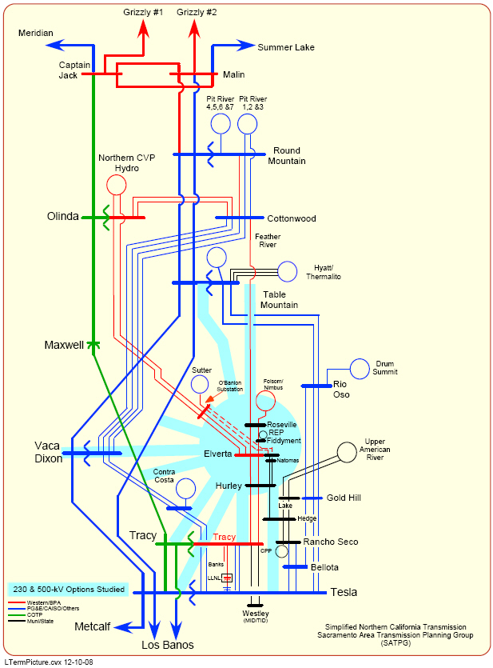

Attachment 2: Contingencies Studies

The following list of contingencies were included for thermal, voltage, post-transient and transient stability. For transient stability analysis and while Table 1 within the NERC Planning Standards TPL-001 thru 004 allow for simulating a single-line to ground(SLG) fault for certain contingencies, this WASN transmission assessment was conducted simulating 3-phase faults for all of the contingencies studied, but included SLG faults for some contingencies to verify that this type of fault would produce less of an impact to system reliability. The fault was applied on the leading bus. For example, a 3-phase fault was applied at Captain Jack for a fault on the Captain Jack to Olinda 500 kV line that’s results in an outage of the line after the fault is cleared in 4 cycles.

Event resulting in the loss of a single element – NERC Level B
- Captain Jack – Olinda 500 kV
- Olinda – Tracy 500 kV
- Folsom Power Plant Units 1, 2 or 3
- Nimbus Power Plant Units 1 or 2
- Roseville Generation Units Rep1, 2 or 3
- Roseville Generation CT’s 1 or 2
- Sutter Power Plant Units 1, 2, or 3
- Airport – Cottonwood 230 kV
- Cottonwood – Round Mountain 230 kV
- Cottonwood – Roseville 230 kV
- Cottonwood – Shasta 230 kV overlapping with Shasta Units 1 & 2
- Cottonwood – Shasta 230 kV overlapping with Shasta Units 3 & 4
- Elverta WAPA – Hurley 230 kV
- Fiddyment – Elverta WAPA 230 kV
- Fiddyment – Roseville 230 kV
- Flanagan – Keswick 230 kV
- Folsom – Lake 230 kV
- Folsom – Nimbus 115 kV
- Folsom – Orangevale 230 kV
- Folsom – Roseville 230 kV
- Goldhill – Lake 230 kV
- Keswick – Airport 230 kV
- Keswick – JF Carr 230 kV
- Keswick – O’Banion 230 kV
- Keswick – Spring Creek 230 kV overlapping with Spring Creek Unit 1
- O’Banion – Elverta WAPA 230 kV
- O’Banion – Natomas 230 kV
- Olinda – Cottonwood 230 kV
- Olinda – Keswick 230 kV
- Olinda – O’Banion 230 kV
- Rancho Seco – Bellota 230 kV
- Roseville – Elverta WAPA 230 kV
- Roseville – Folsom 230 kV
- Shasta – Flanagan 230 kV
- Sutter – O’Banion 230 kV and Sutter Power Plant
- Trinity – JF Carr 230 kV overlapping with Trinity Units 1 & 2
- Tracy – Hurley 230 kV
- Tracy – Lawrence Livermore 230 kV
- Tracy – Tesla 230 kV
- Tracy – Wesley 230 kV
- Olinda 500/230 kV Transformer Bank
- Roseville 230/60 kV Transformer Bank
- Tracy 500/230 kV Transformer Bank

Event(s) resulting in the loss of two or more (multiple) elements – NERC Level C
- Cottonwood 230 kV bus section
- Elverta 230 kV bus section
- Keswick 230 kV bus section
- Tracy 230 kV bus section
- Cottonwood – Shasta #1 & #2 230 kV
- Elverta - Hurley #1 & #2 230 kV
- O’Banion – Elverta #1 & #2 230 kV
- O’Banion – Elverta and O’Banion – Keswick 230 kV
- O’Banion – Elverta and O’Banion – Natomas 230 kV
- Olinda – Cottonwood #1 & #2 230 kV
- Olinda-Cottonwood 230 kV & Captain Jack-Olinda 500 kV
- Olinda-OBanion 230 kV & Olinda-Tracy 500 kV
- Rancho Seco – Bellota #1 & #2 230 kV
- Roseville – Elverta & Fiddyment – Elverta 230 kV
- Roseville – Elverta & Fiddyment – Roseville 230 kV
- Sutter-O’Banion – Keswick- O’Banion 230 kV
- Tracy – Hurley #1 & #2
- Tracy-Hurley 230 kV & Olinda-Tracy 500 kV
- Tracy – Tesla #1 & #2 230 kV
- Keswick – JF Carr #1 & #2 230 kV
- Over-lapping Tracy 500/230 kV transformer & Olinda 500/230 kV transformer

Extreme event resulting in two or more (multiple) elements removed of Cascading out of service – NERC Level D
- Sutter Power Plant Units 1, 2, and 3 entire power plant outage
- Shasta – Cottonwood #1 & #2 and Shasta – Flanagan and Flanagan – Keswick 230 kV
- Keswick – Airport and Flanagan – Keswick and Keswick – Olinda and Keswick – O’Banion
- Keswick – Olinda and Keswick – O’Banion and Shasta – Cottonwood #1 & #2
- Cottonwood – Olinda #1 & #2 and Shasta – Cottonwood #1 & #2 230 kV and Captain Jack – Olinda 500 kV
- Cottonwood – Olinda #1 & #2 and Keswick – O’Banion 230 kV and Captain Jack – Olinda 500 kV
- Cottonwood – Olinda #1 & #2 and Keswick – O’Banion 230 kV and Olinda – Tracy 500 kV
- O’Banion – Elverta #1 & #2 and Cottonwood – Roseville 230 kV
- Cottonwood – Roseville and Roseville – Elverta and Fiddyment – Elverta 230 kV
- O’Banion – Elverta #1 & #2 and Roseville – Elverta and Fiddyment – Elverta 230 kV
- Tracy – Hurley #1 & #2 230 kV and Olinda – Tracy 500 kV

Attachments 3, 4, 5, and 6 are separate documents containing power flow, post-transient and dynamic stability plots. The plots included represent the overall study results. Plots for contingencies not included in the attachments are available upon request.

Study results seen in this 2008 Assessment are reflective of the improvement in reliabilityfrom implementing WASN transmission projects such as the Sacramento Voltage Support and Folsom Loop Projects.

