Western Area Power Administration Sierra Nevada Region

2009
Annual Ten-Year Transmission Plan Assessment Report

Report Attachment 6
NERC Planning Standard TPL-004

October 30, 2009

For information or questions regarding this Transmission Assessment Report, please contact Larry Tobias via (916) 353-4766 or email at Tobias@wapa.com

Attachment 6: Category D (NERC Planning Standard TPL-004): Extreme Events Outages (N-2 plus) Power Flow , Post-Transient and Dynamic Stability Plots

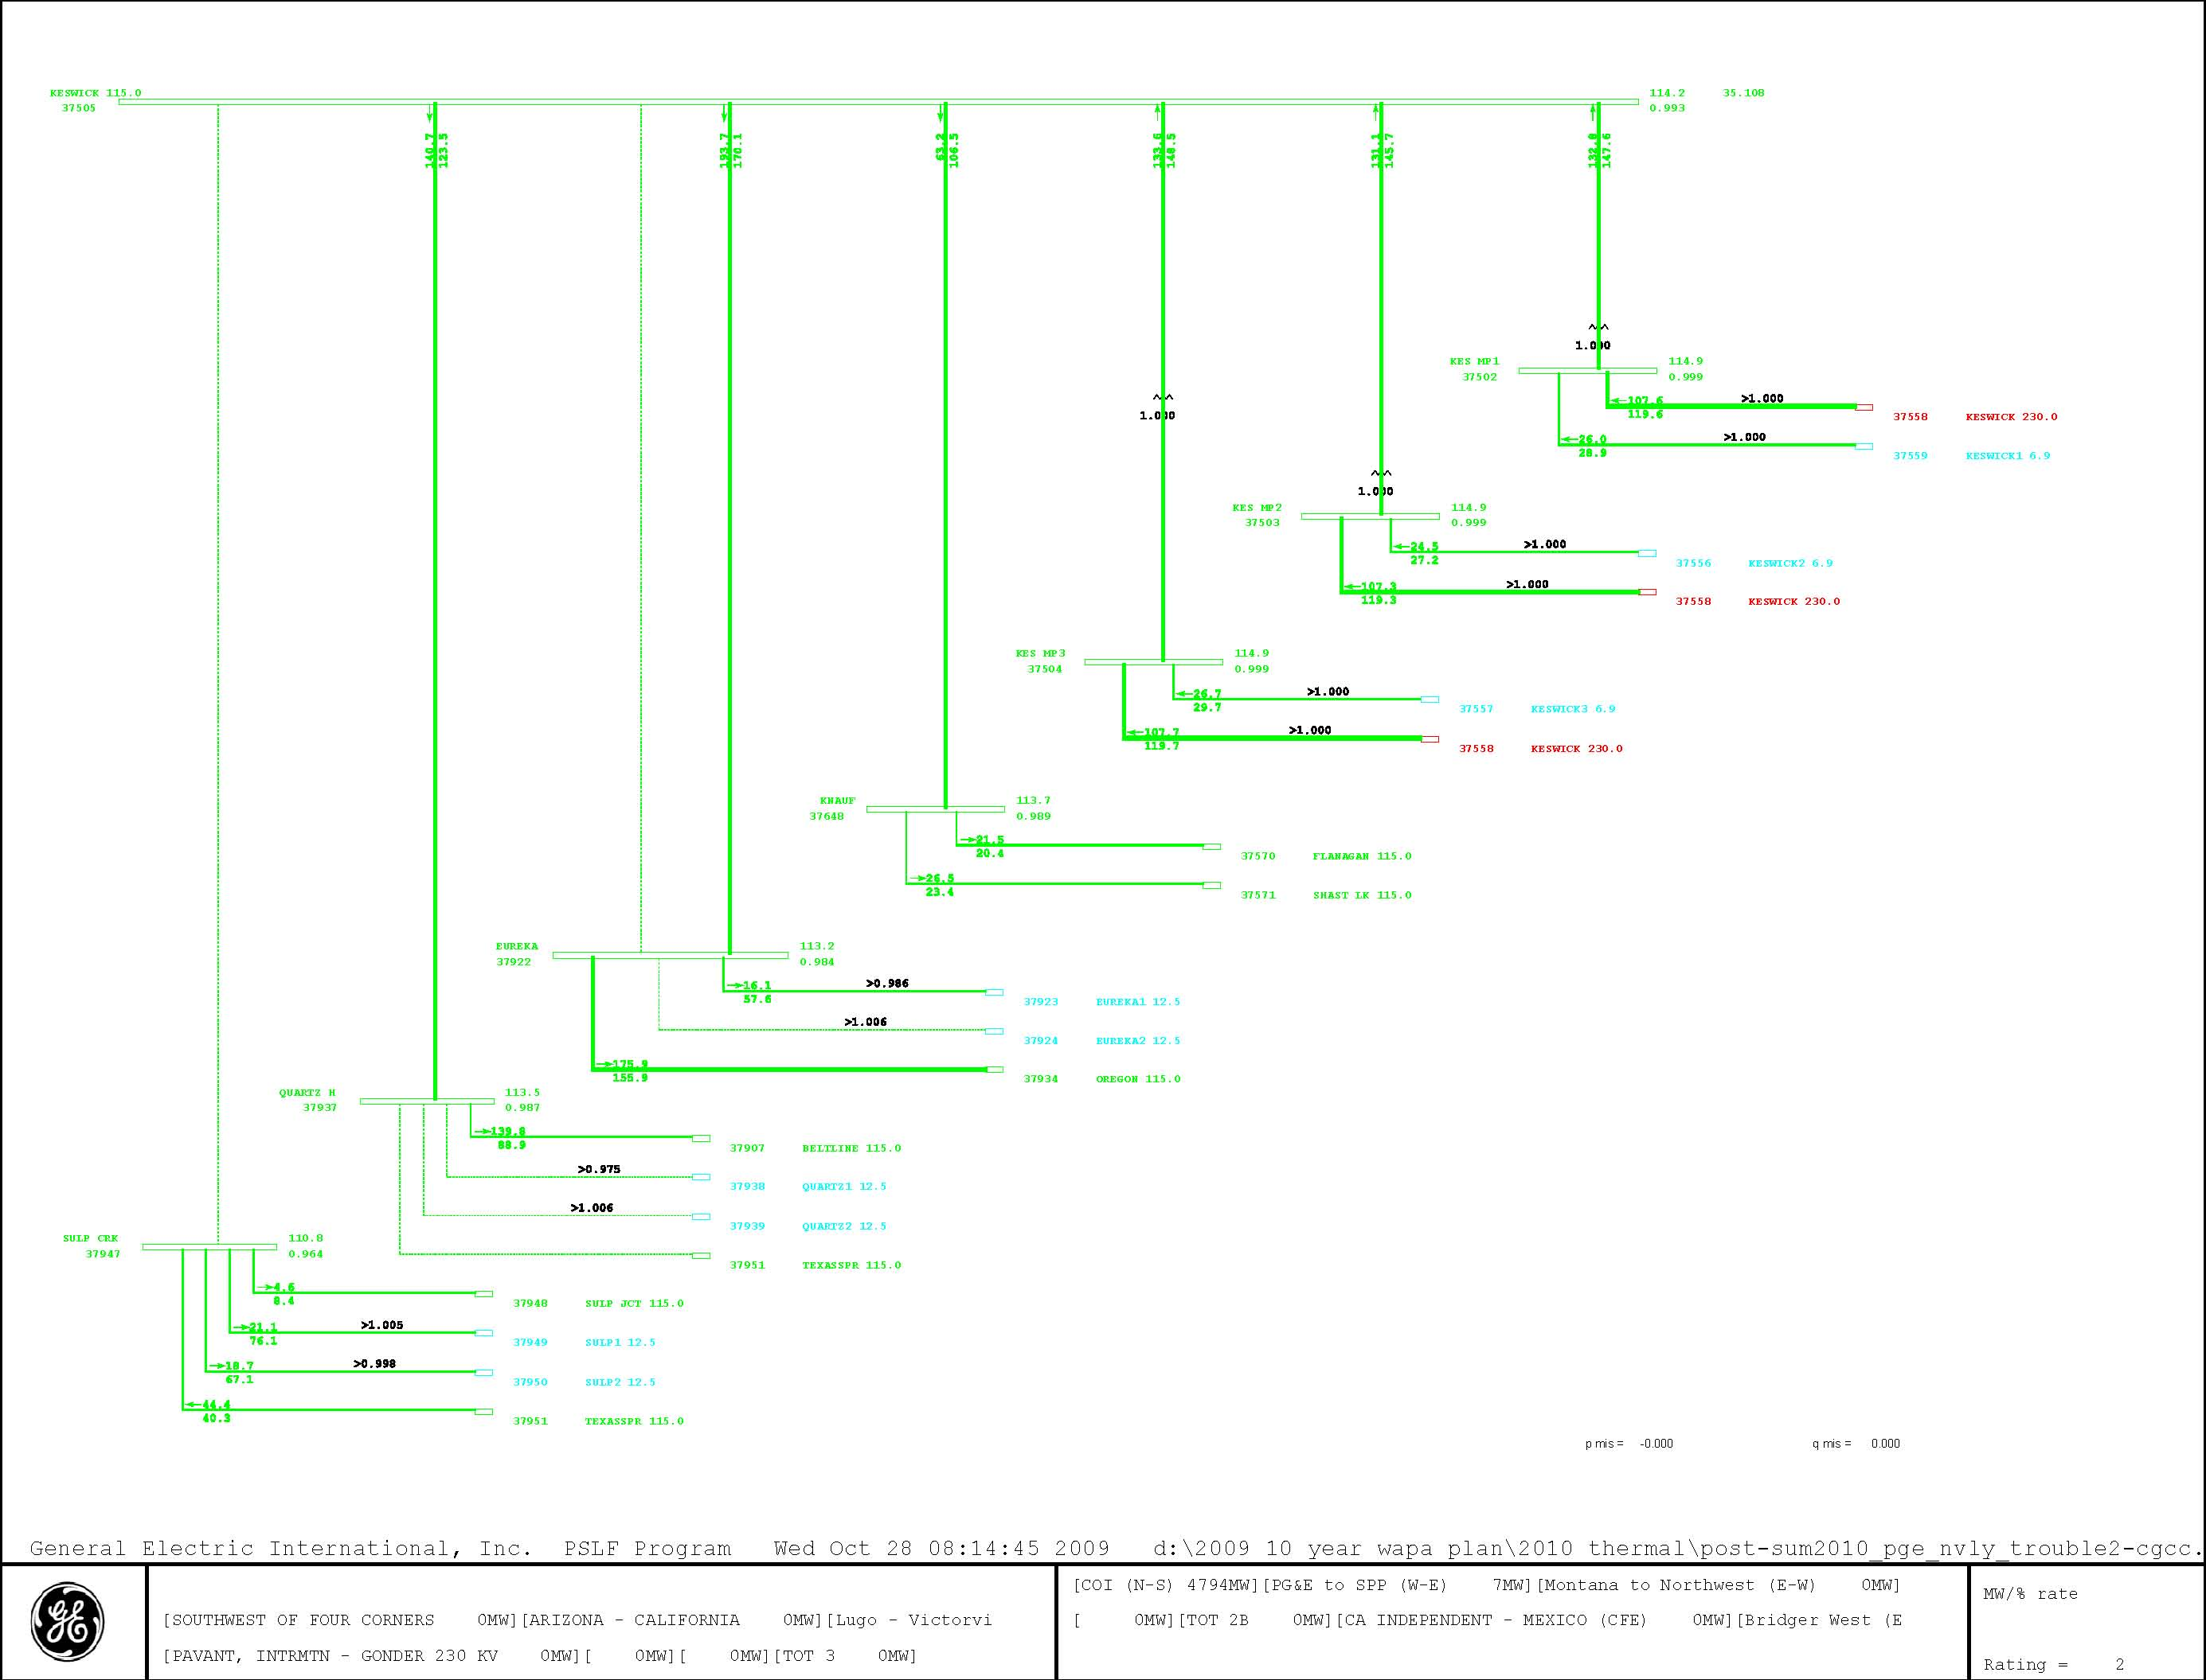
Figure 6-1
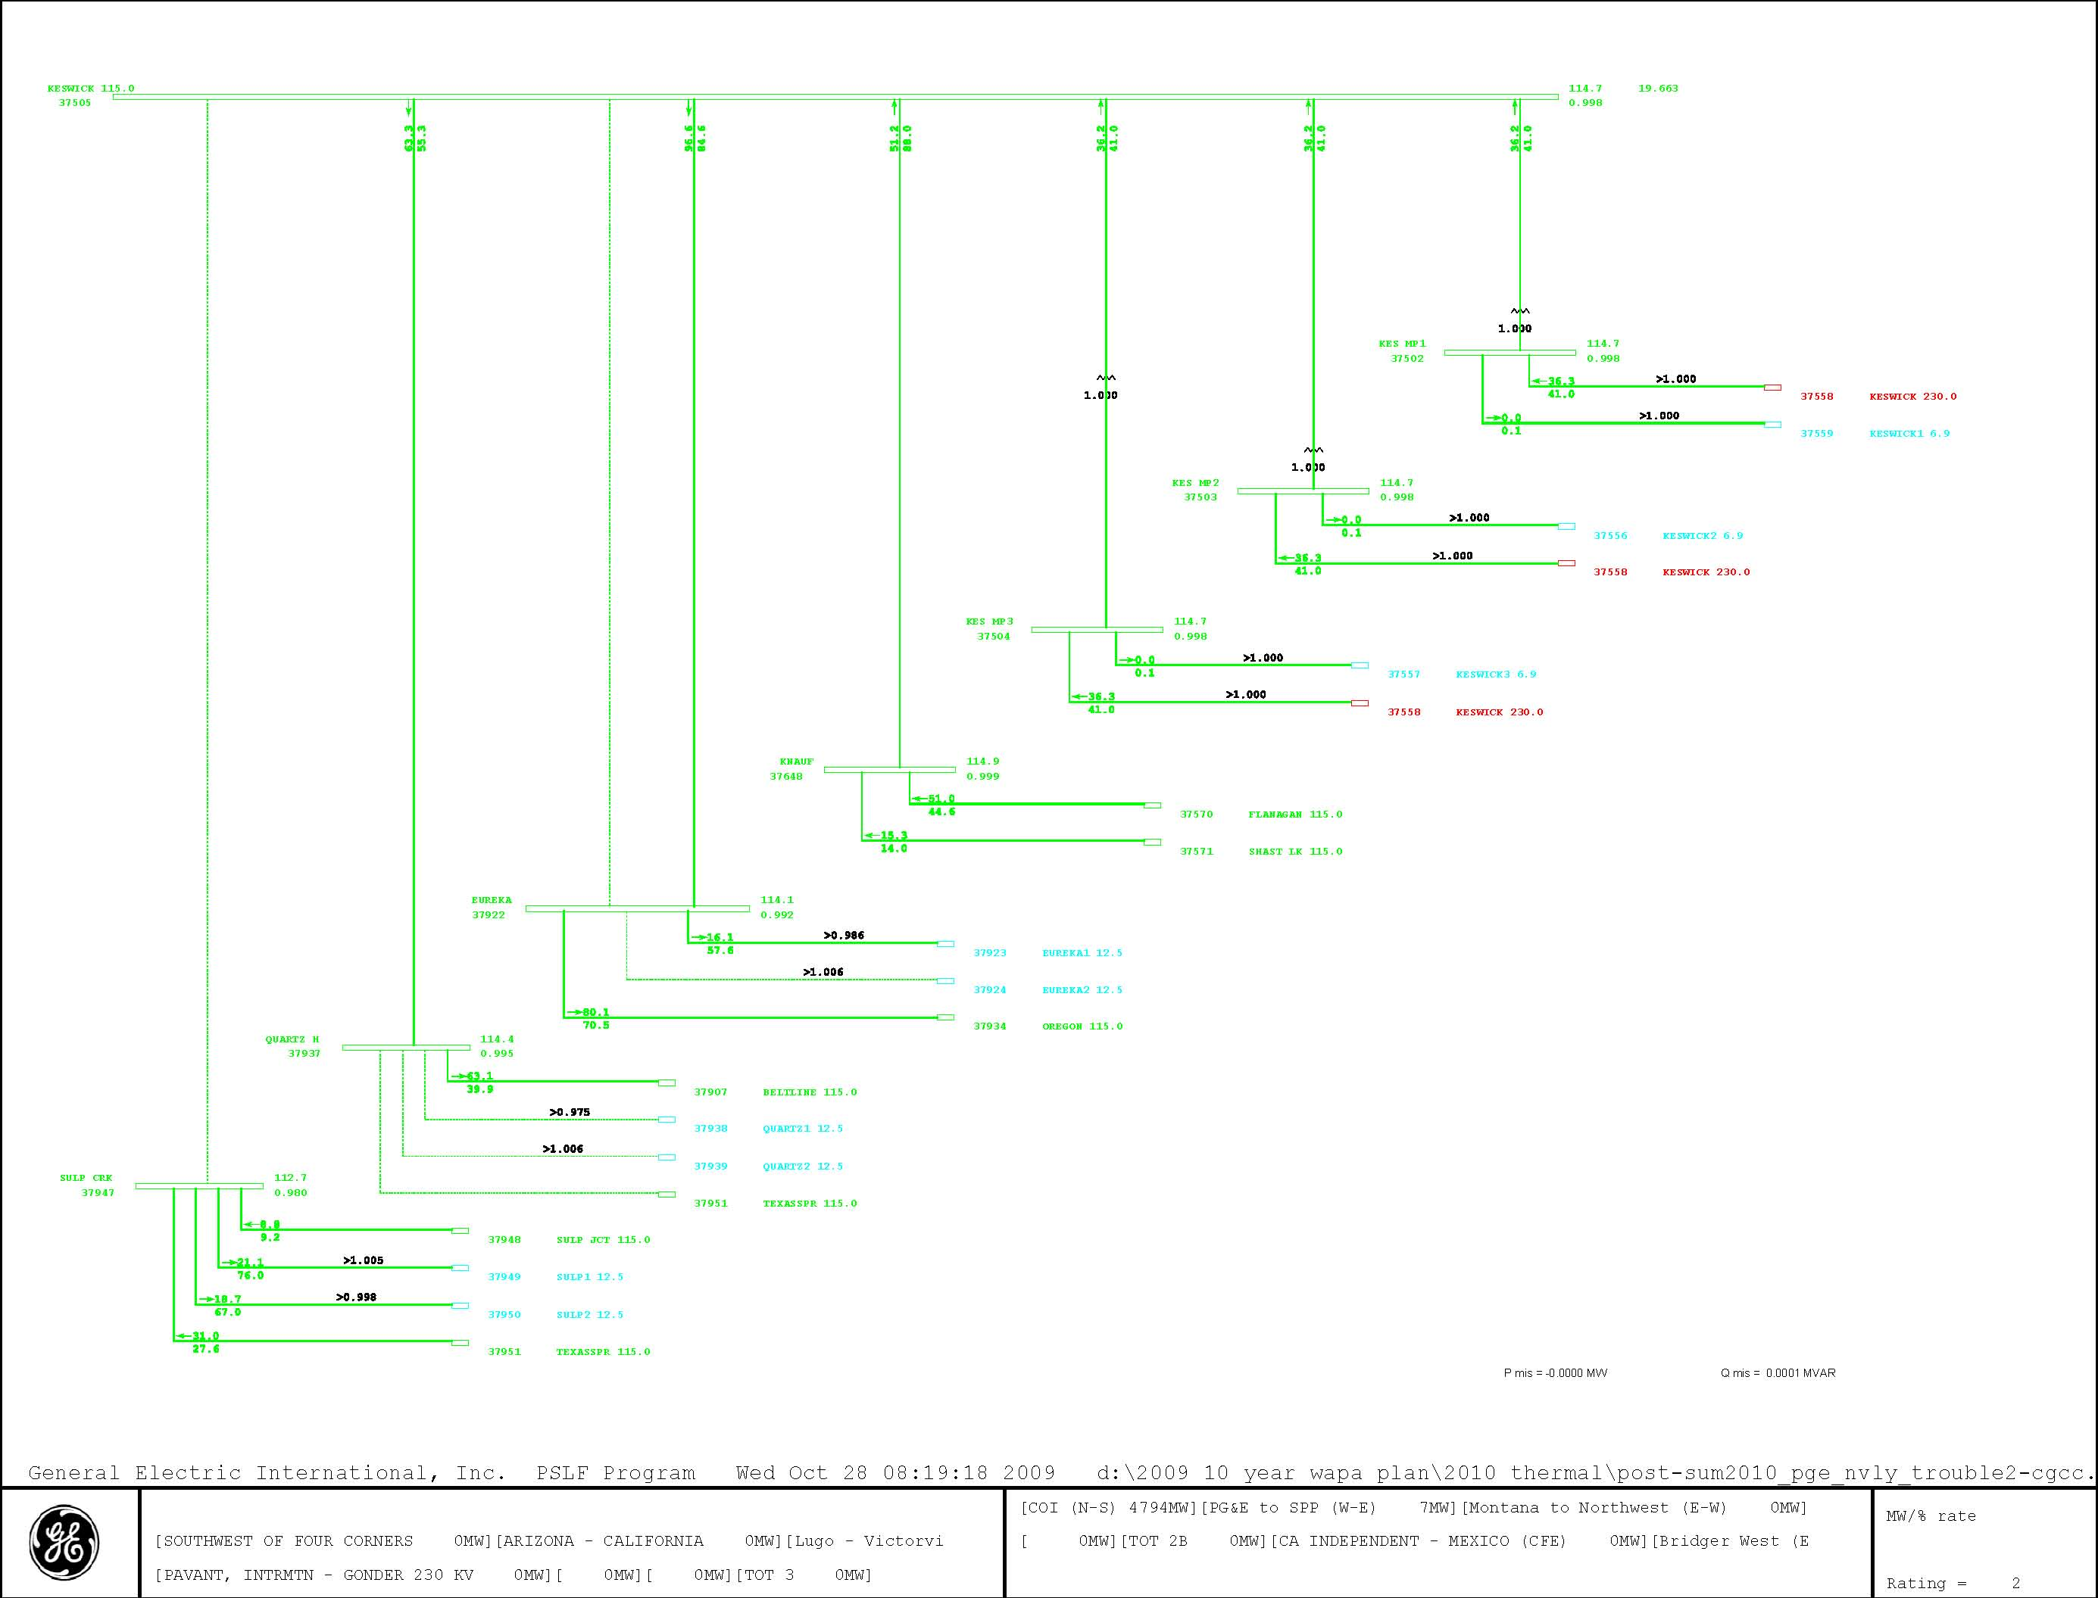
Figure 6-2
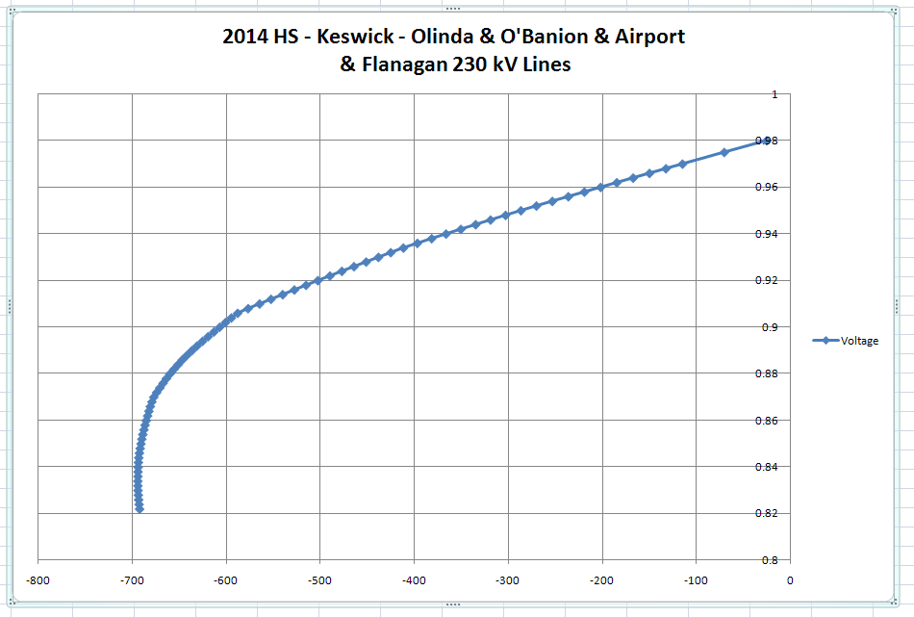
Figure 6-3 ElvertaW 230 kV Voltage
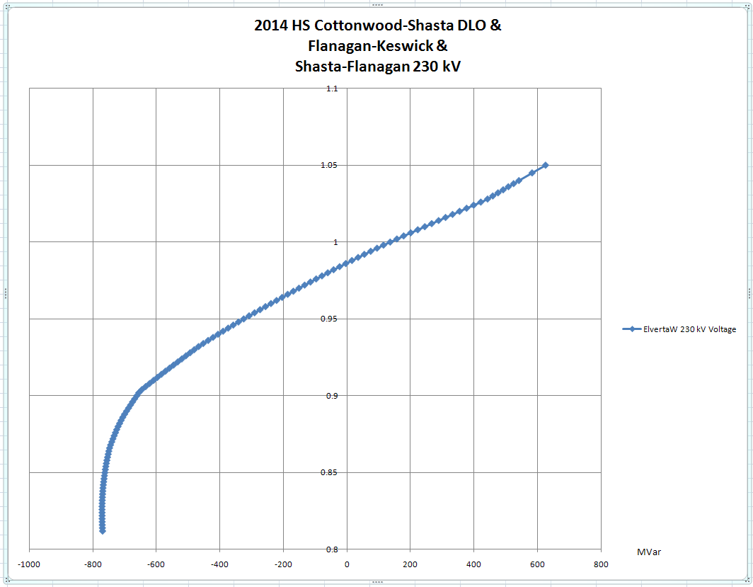
Figure 6-4 ElvertaW 230 kV Voltage
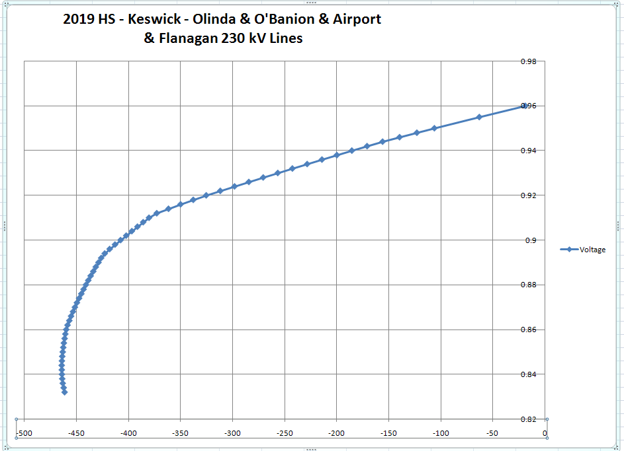
Figure 6-5 ElvertaW 230 kV Voltage
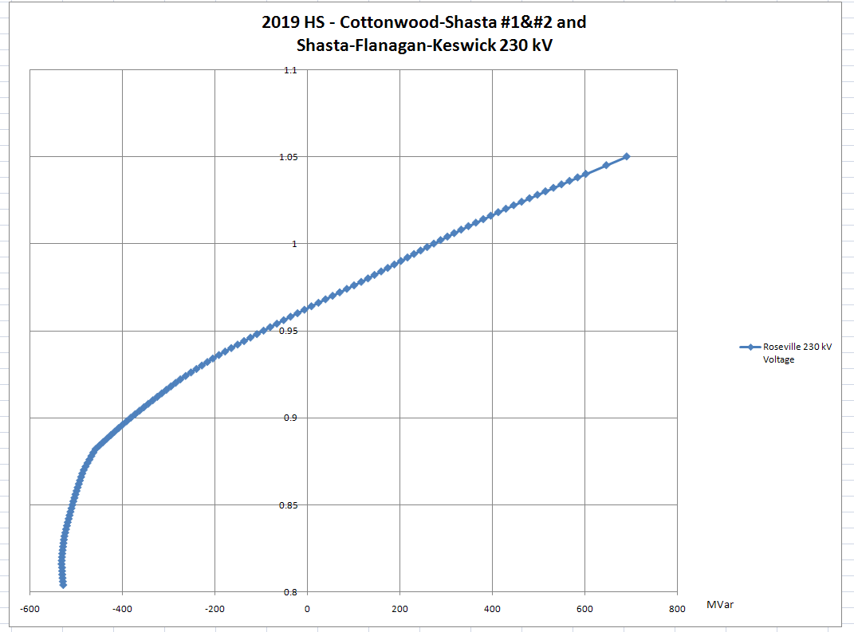
Figure 6-6 Roseville 230 kV Voltage

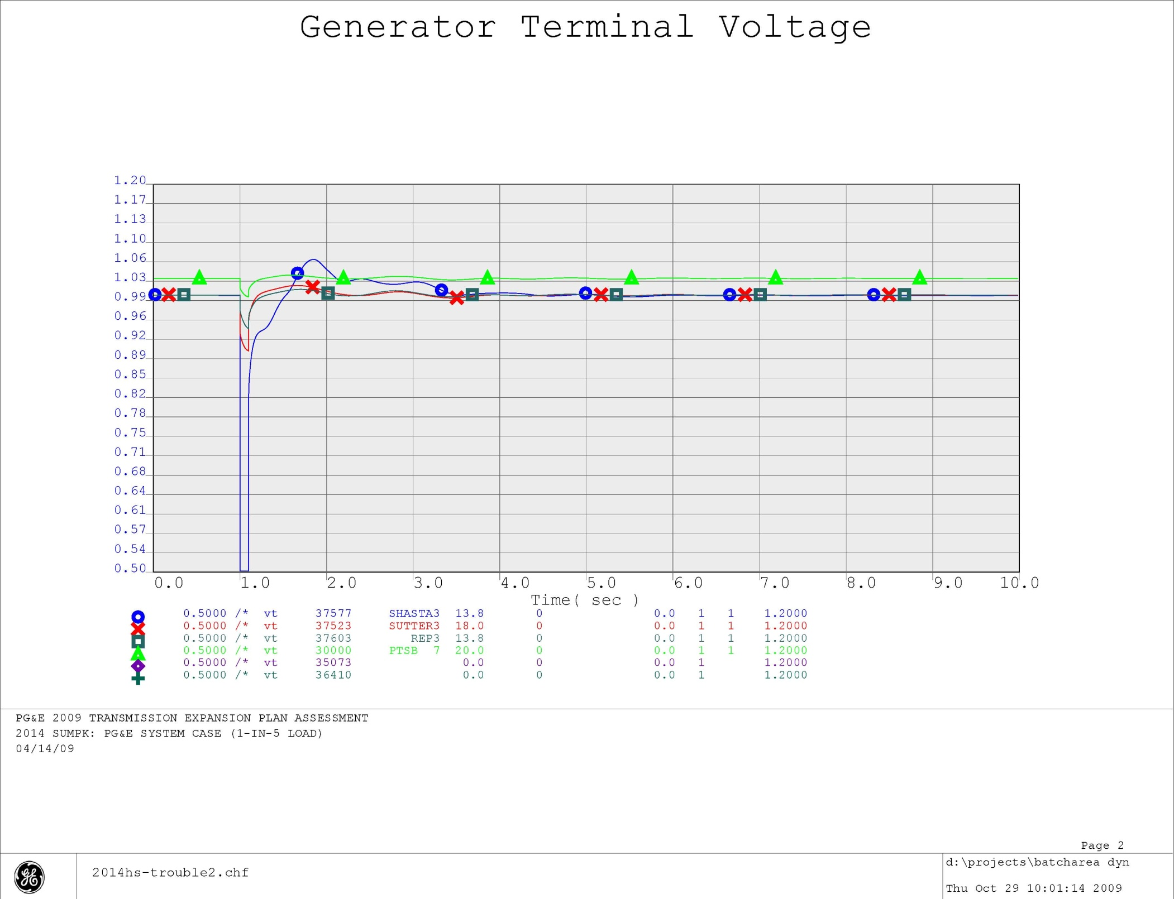
Figure 6-7 2014 HS - Keswick - Olinda & O'Banion & Airport & Flanagan 230 kV Lines
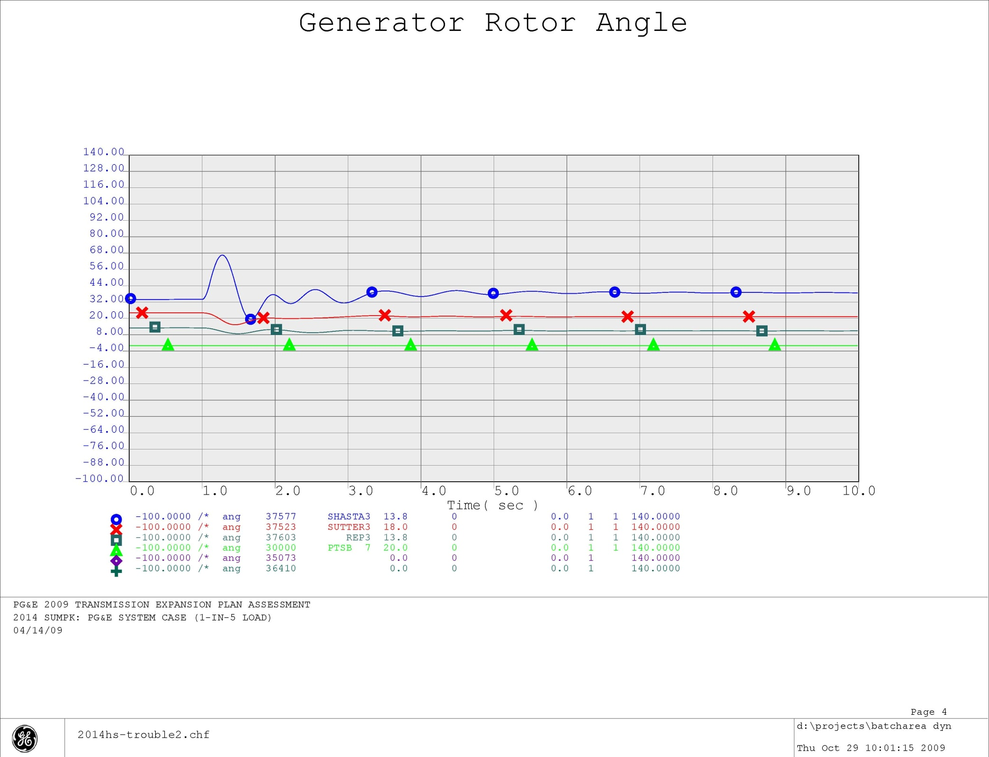
Figure 6-8 2014 HS - Keswick - Olinda & O'Banion & Airport & Flanagan 230 kV Lines
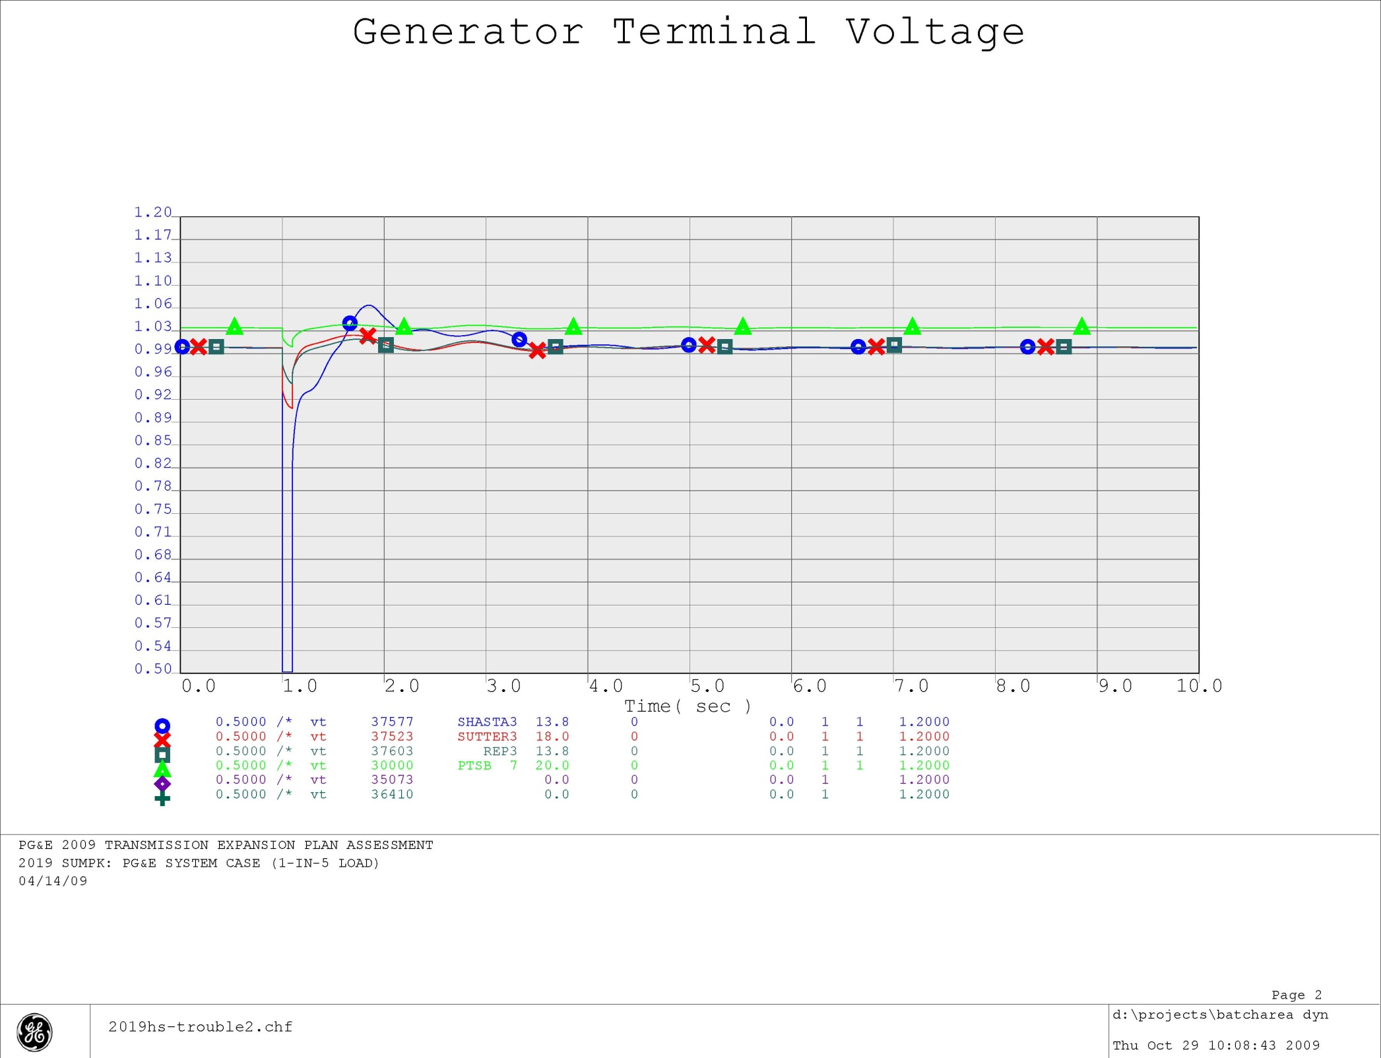
Figure 6-9 2019 HS - Keswick - Olinda & O'Banion & Airport & Flanagan 230 kV Lines
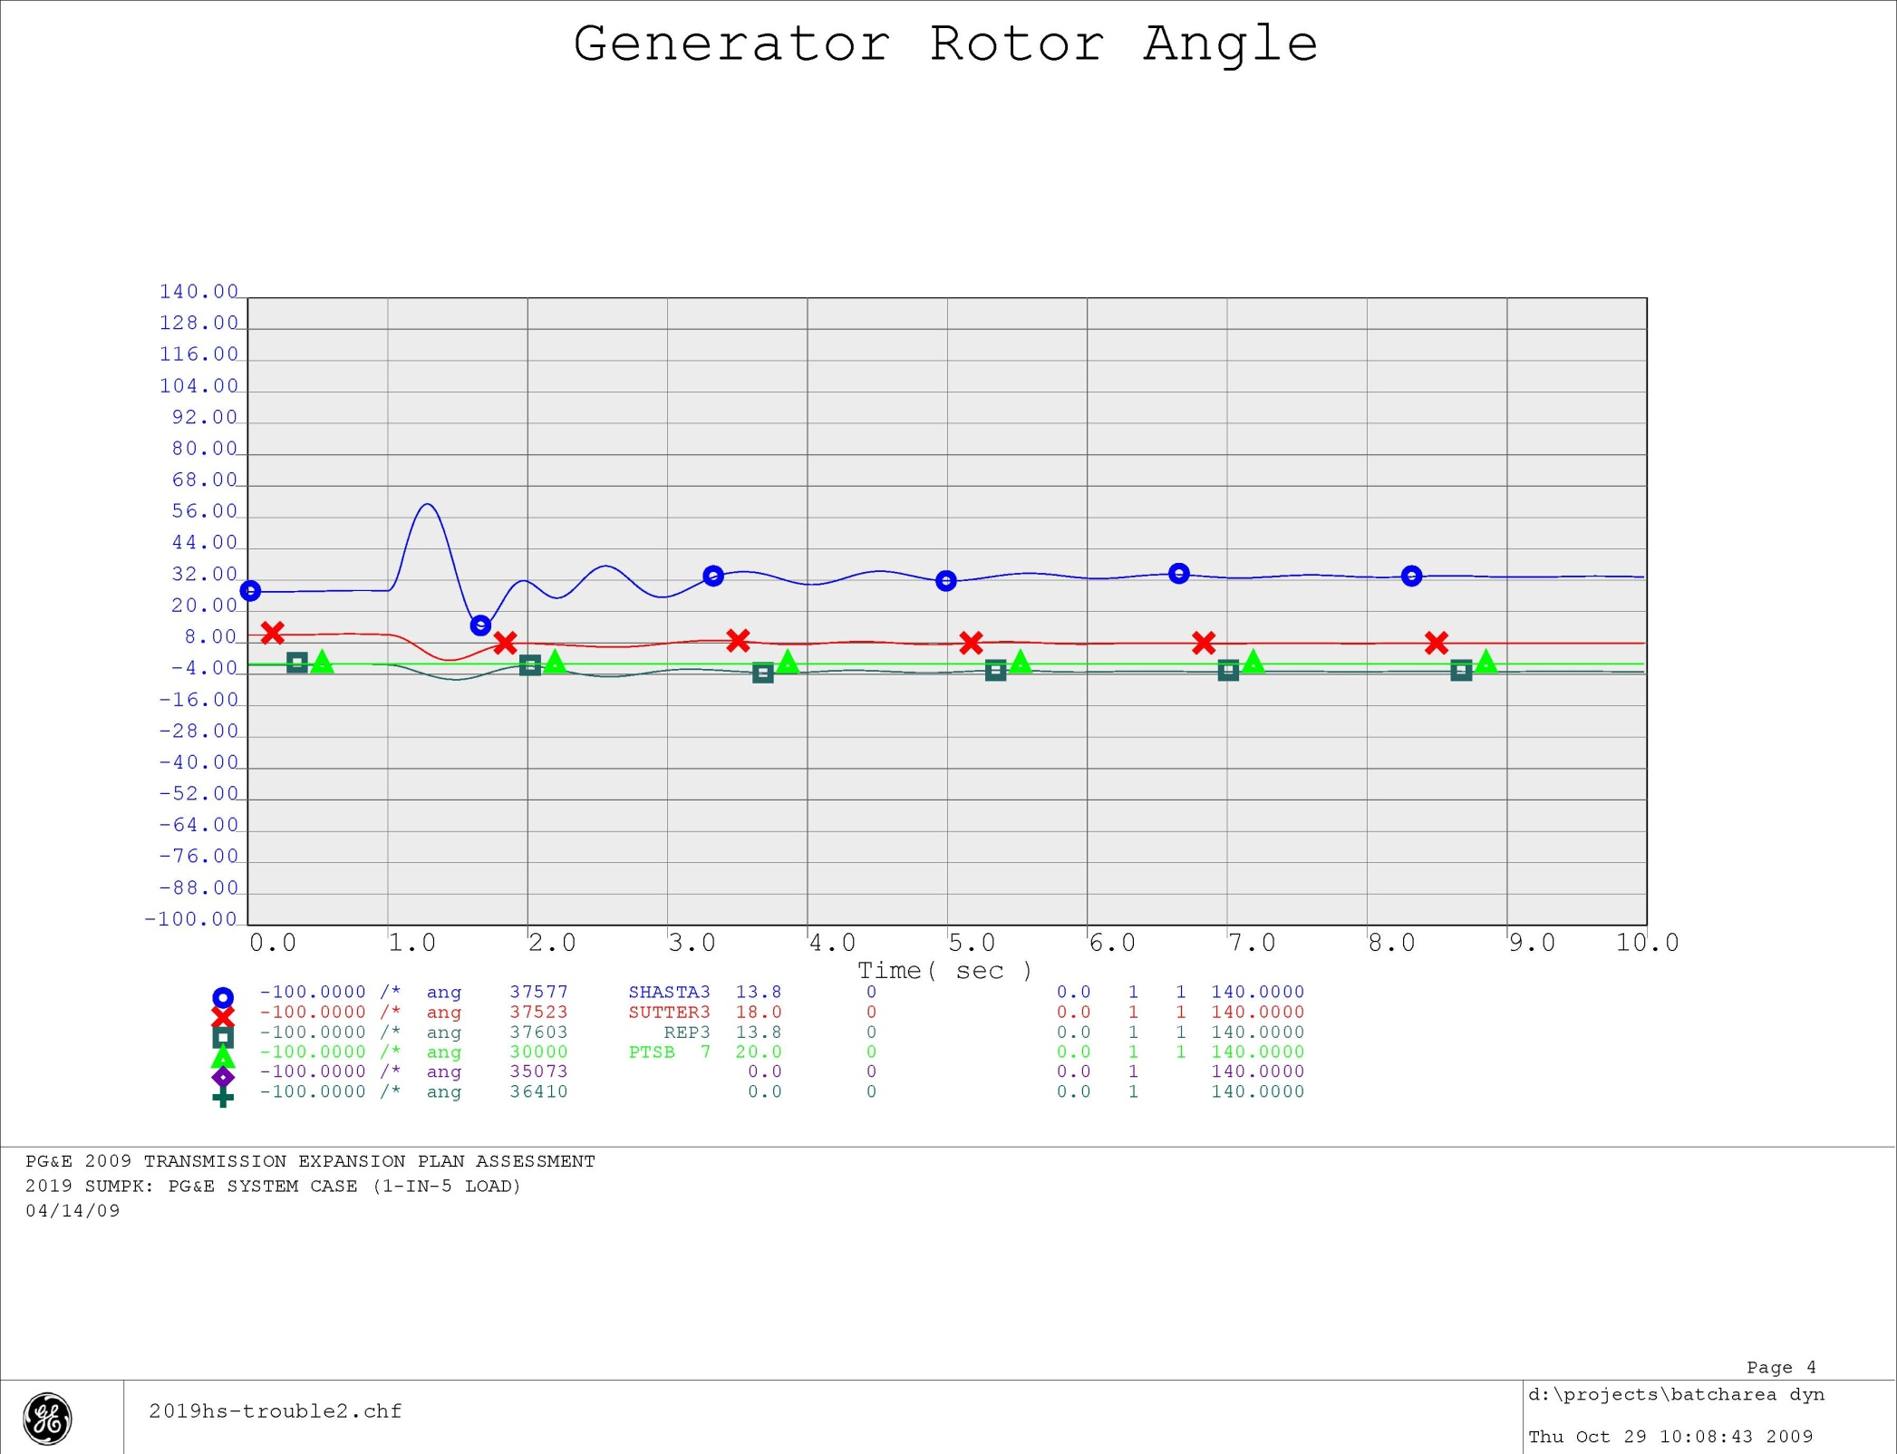
Figure 6-10 2019 HS - Keswick - Olinda & O'Banion & Airport & Flanagan 230 kV Lines

