Western Area Power Administration Sierra Nevada Region

2009
Annual Ten-Year Transmission Plan Assessment Report

Report Attachment 4
NERC Planning Standard TPL-002

October 30, 2009

For information or questions regarding this Transmission Assessment Report, please contact Larry Tobias via (916) 353-4766 or email at Tobias@wapa.com

Attachment 4: Category B (NERC Planning Standard TPL-002): Single Element Outage, (N-1) Includes Power Flow, Post-Transient and Dynamic Stability Plots

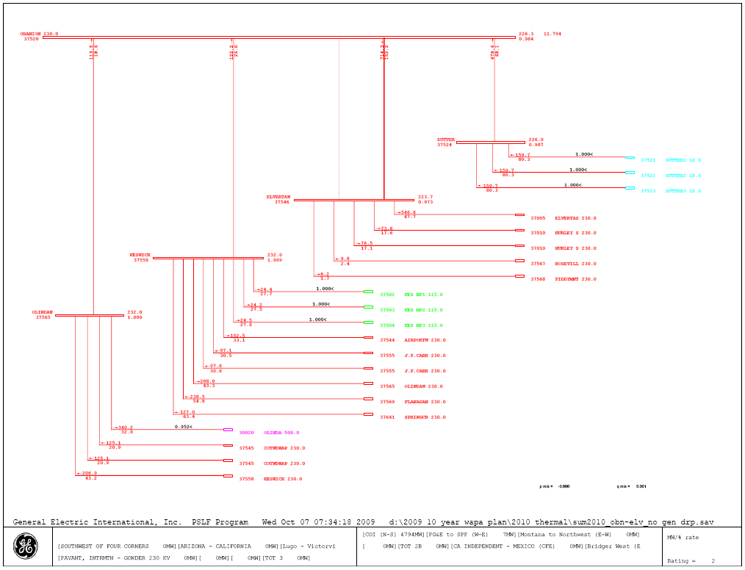
Figure 4-1
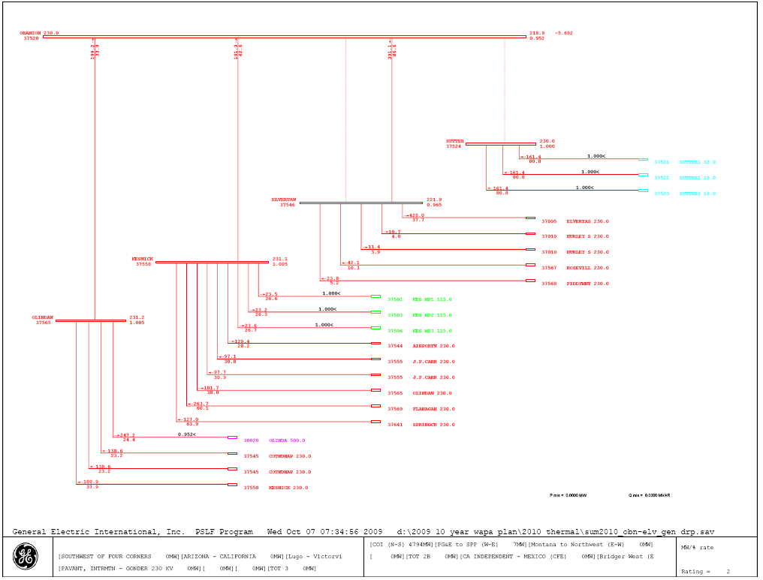
Figure 4-2

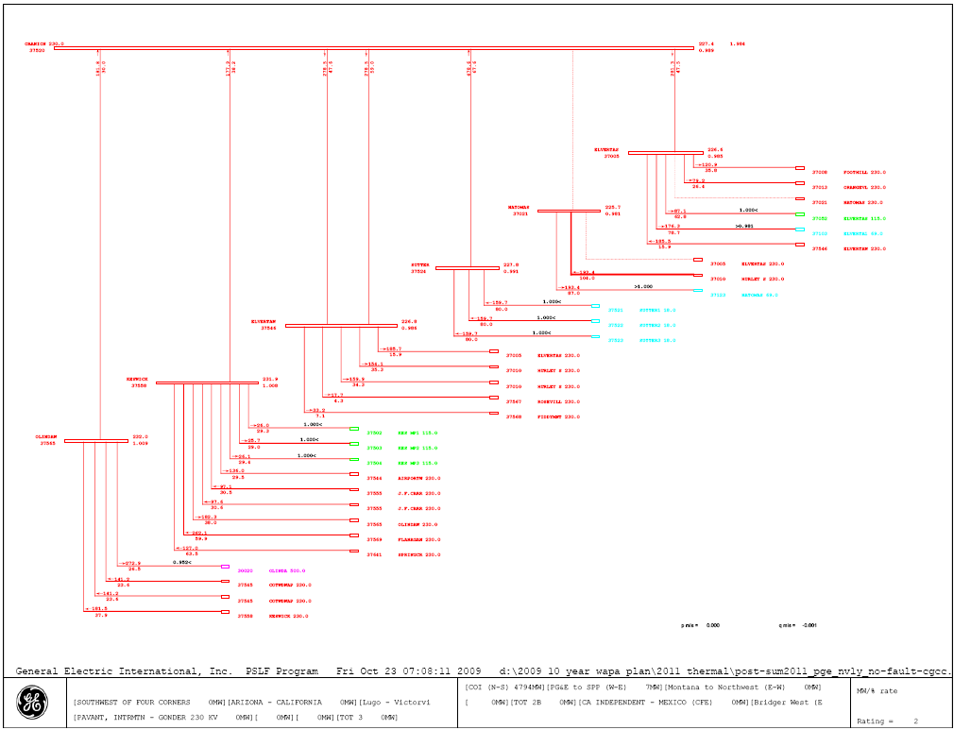
Figure 4-3
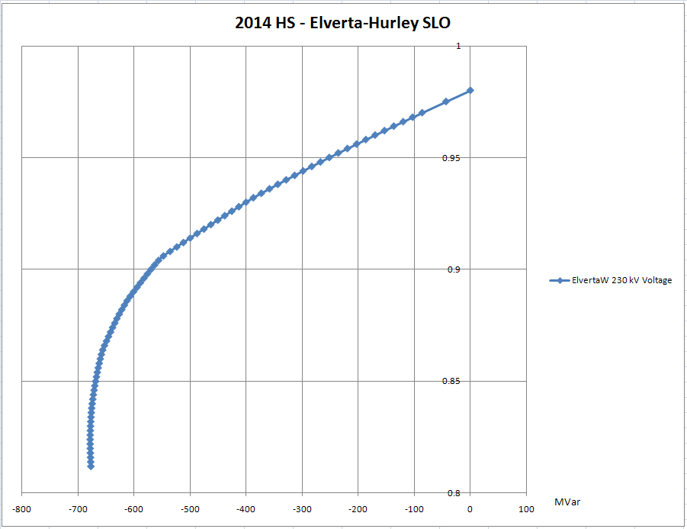
Figure 4-4 ElvertaW Voltage
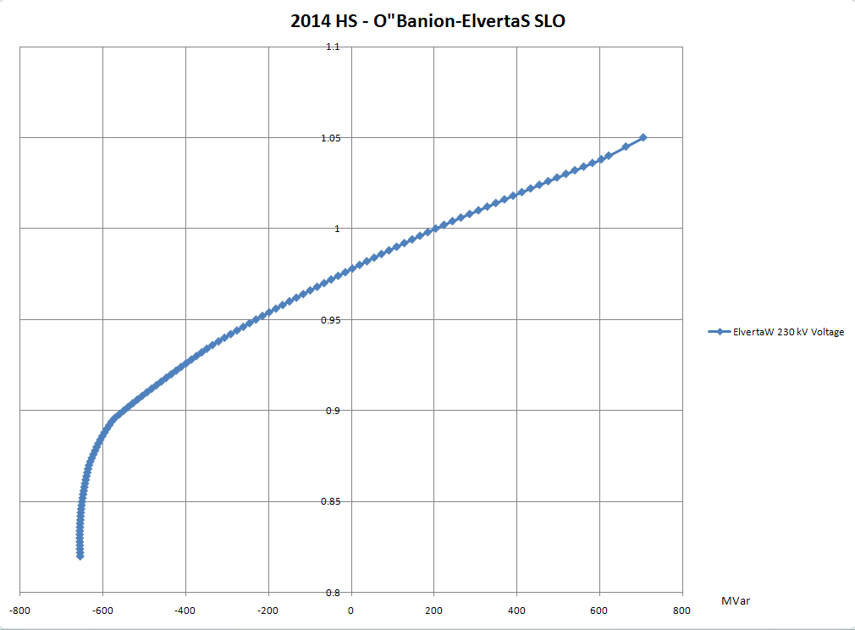
Figure 4-5 ElvertaW Voltage
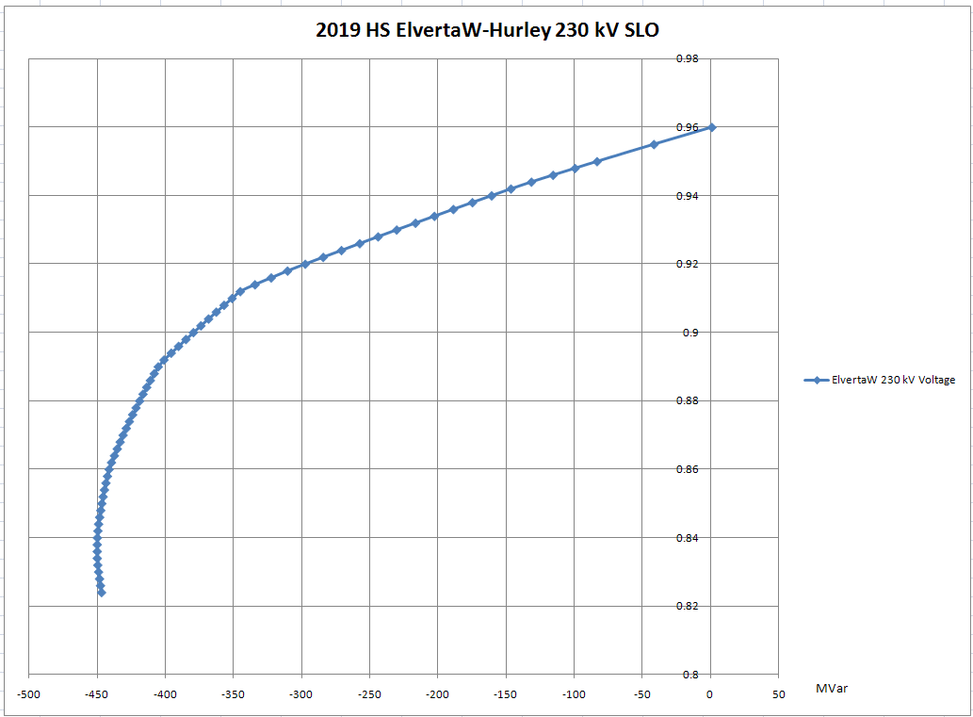
Figure 4-6 ElvertaW Voltage
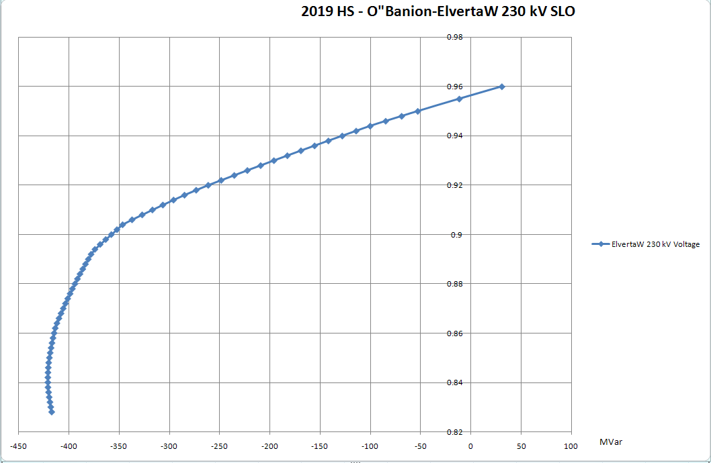
Figure 4-7 ElvertaW Voltage
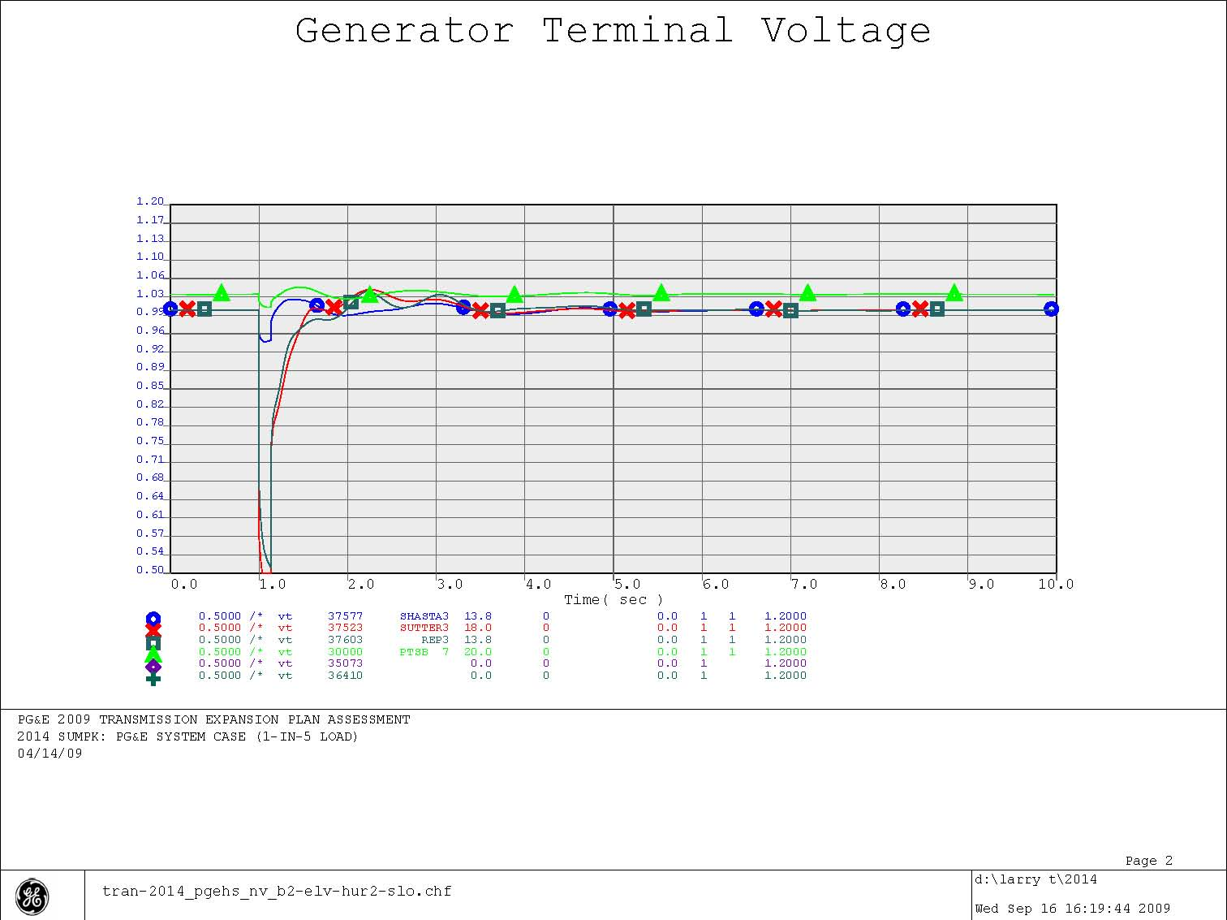
Figure 4.8
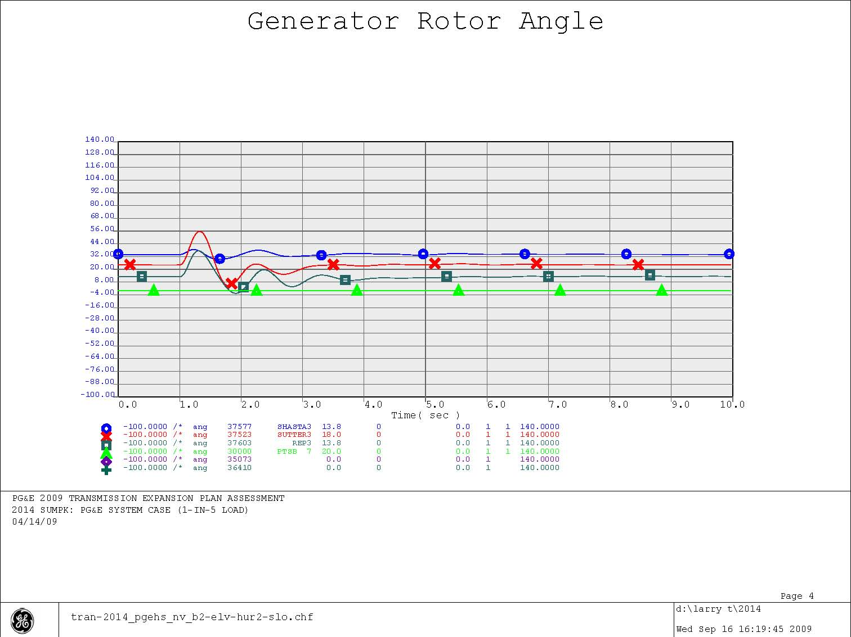
Figure 4-9

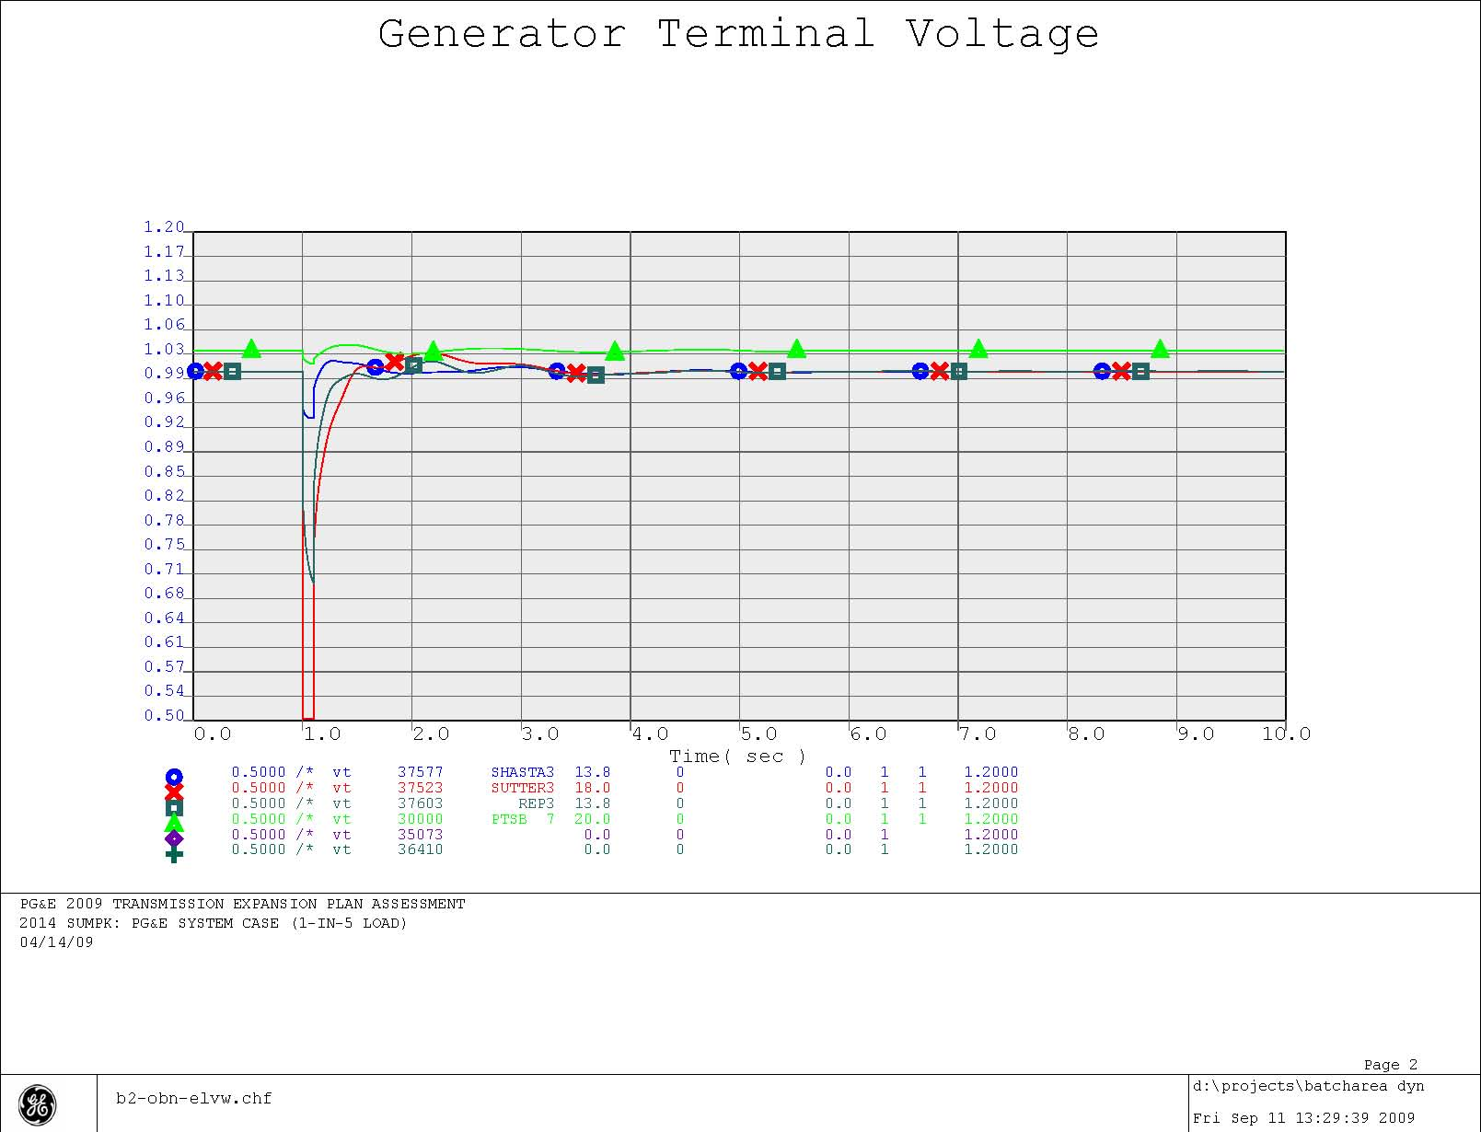
Figure 4-10
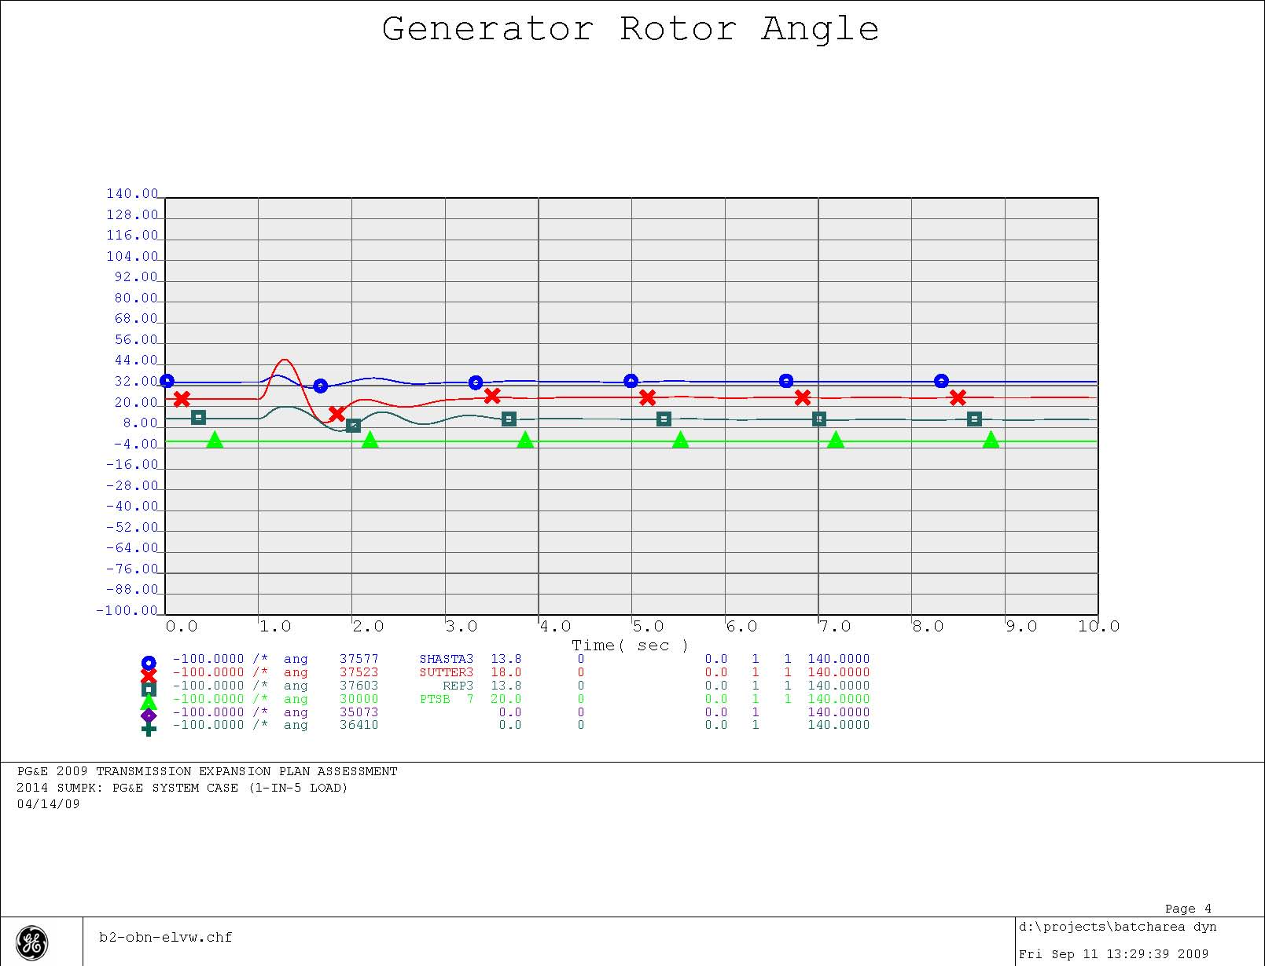
Figure 4-11
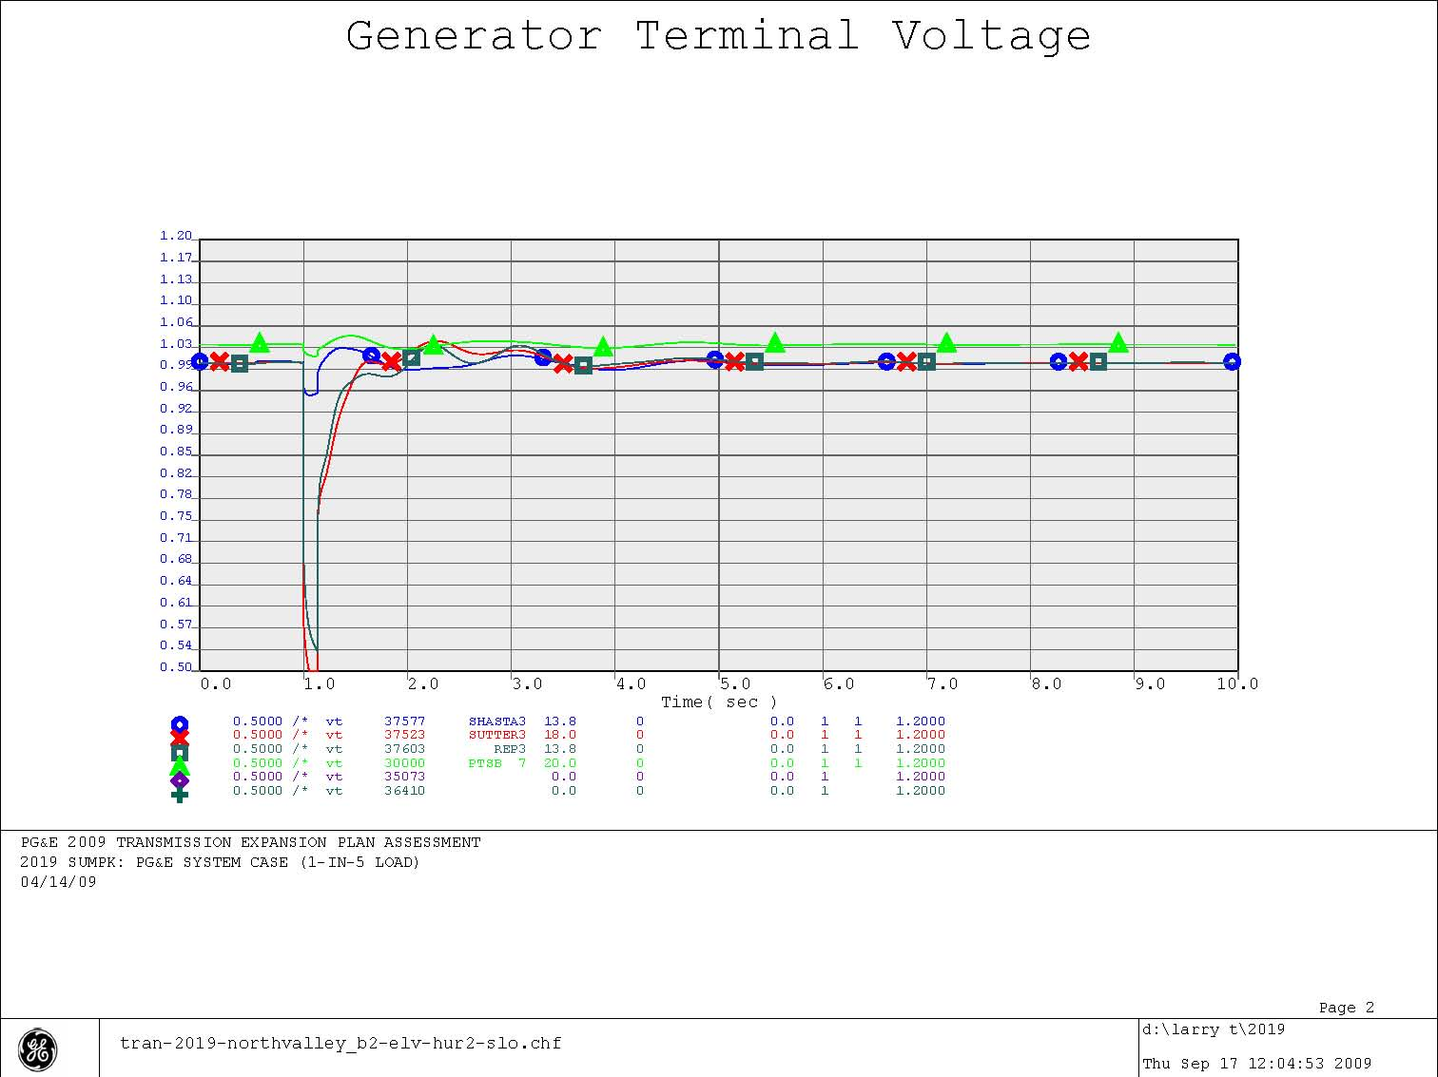
Figure 4-12

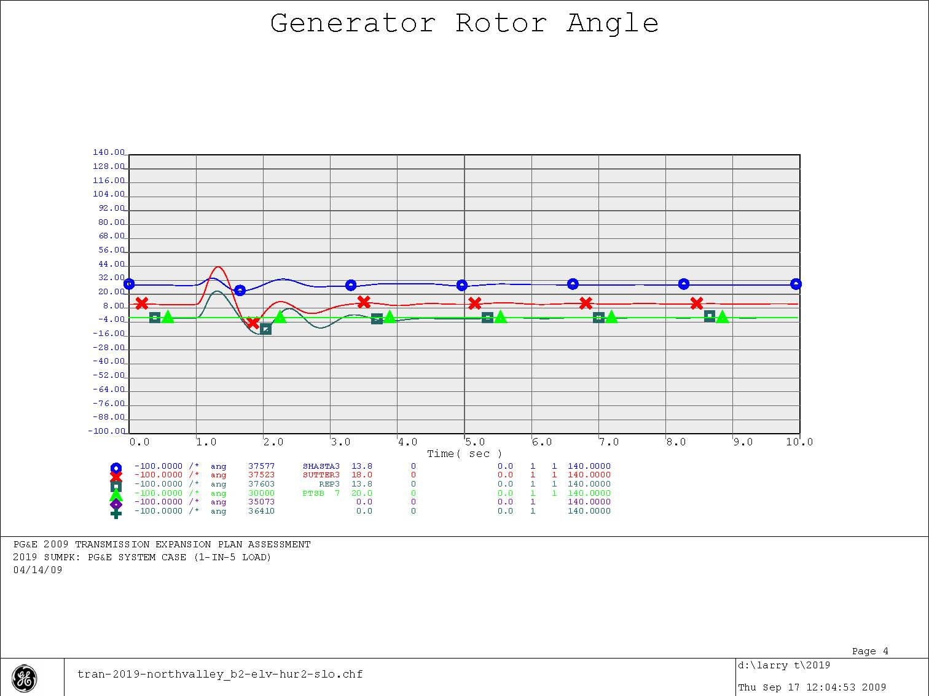

Figire 4-13
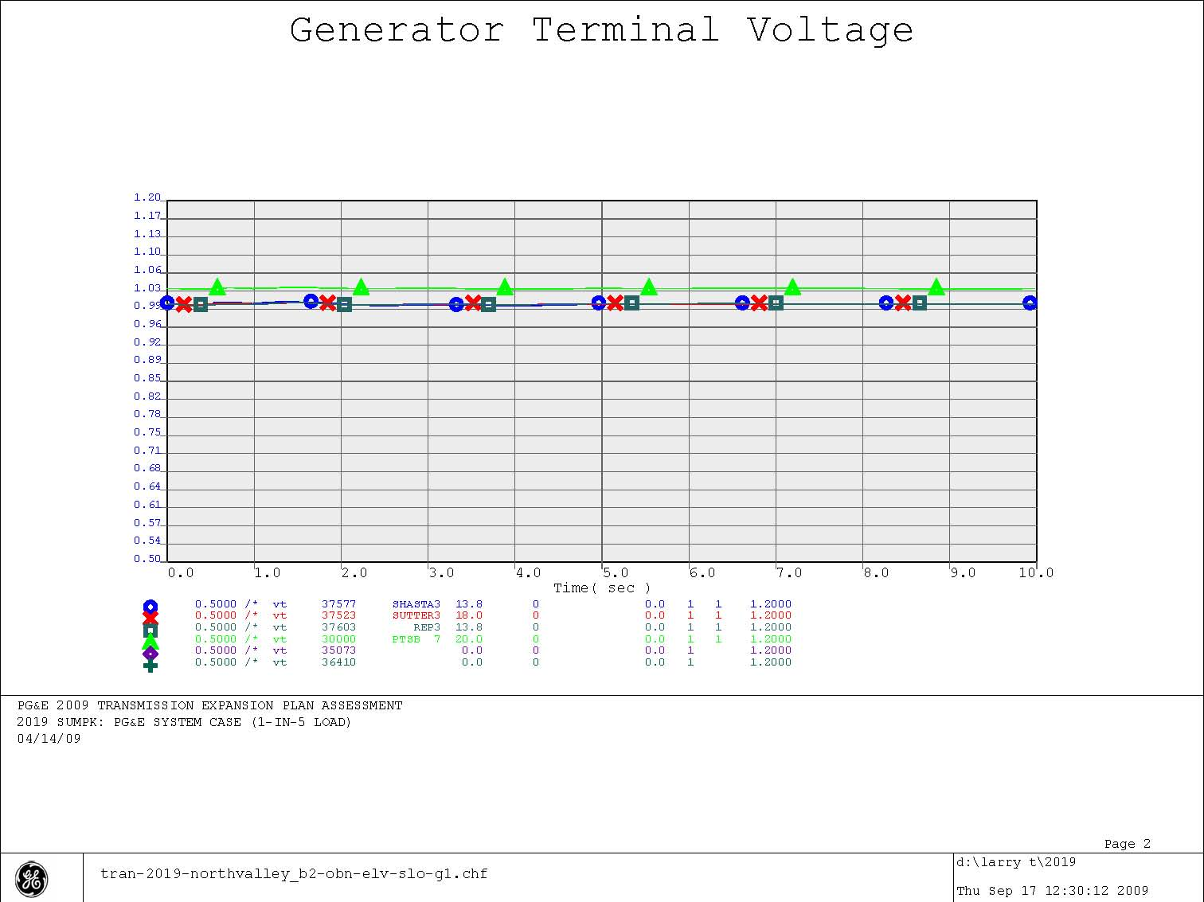
Figure 4-14

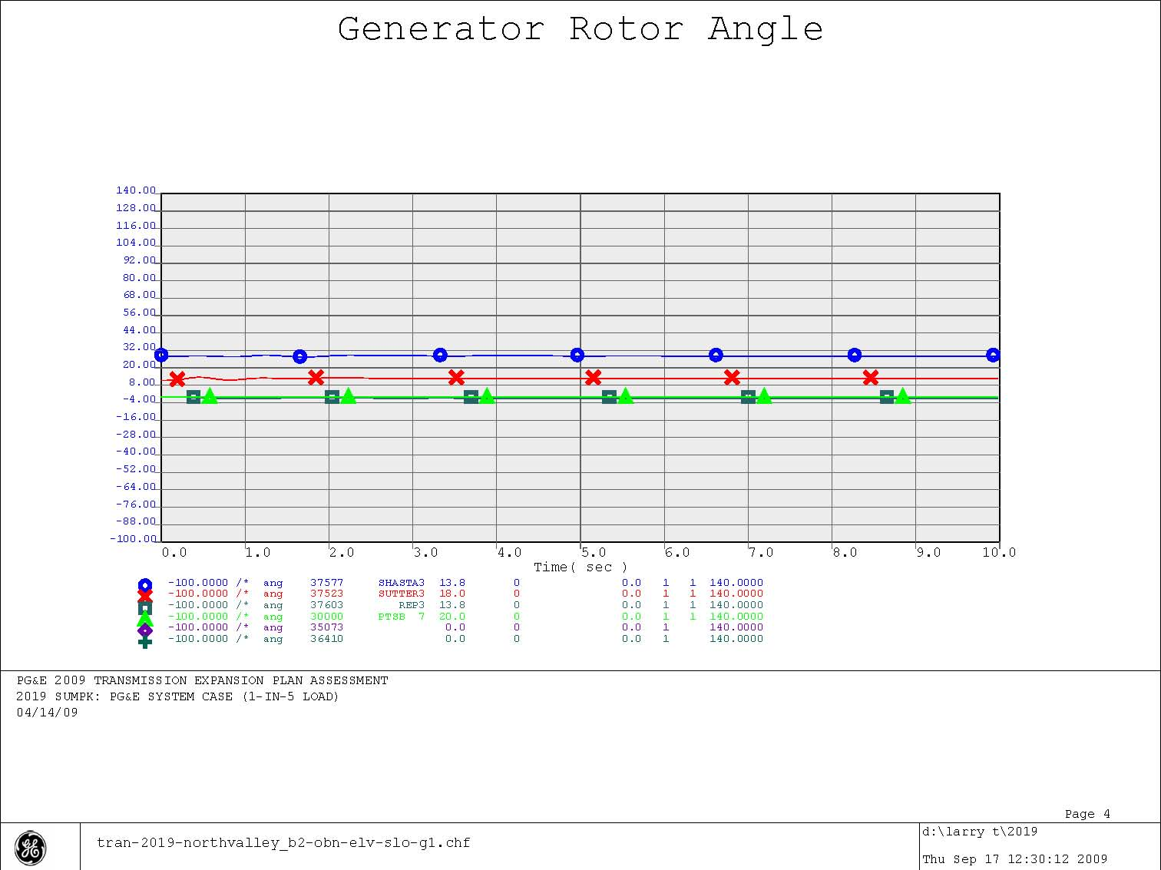
Figure 4-15

