Customer Guide for Submitting Requests for New or Additional Service on NITS on OASIS

Revision History Chart

Version | Revised By | Description of Modifications | Revision Date
1.0 | SPP Staff | Transmission Customer Process document for submitting new requests on NITS on OASIS | 4/19/2018

Table of Contents
Revision History Chart 2
Process Overview 5
Purpose 5
Requirements 5
Process Flowchart 5
New NITS Application 6
Section 1: When Is A New NITS Application Is Required? 6
Section 2: Creating a “New Application” 6
Section 2a: Field Requirements for “New Application” 9
Section 2b: Optional Fields for “New Application” 9
Section 2c: Do Not Change Fields for “New Application” 9
Adding Service Elements to the New NITS Application 10
Adding New Load 11
Section 3: Adding New Load to the NITS Application 11
Section 3a: Field Requirements for “Add/Modify Load” 14
Section 3b: Optional Fields for “Add/Modify Load” 14
Section 3c: Do Not Change Fields for “Add/Modify Load” 14
Adding A Network Resource 15
Generation Details 15
Section 4: Adding Generation Information for the Network Resource 15
Section 4a: Field Requirements for “Add/Modify Generation” 18
Section 4b: Optional Fields for “Add/Modify Generation” 18
Section 4c: Do Not Change Fields for “Add/Modify Generation” 18
Resource Details 19
Section 5: Adding Resource Information for the Network Resource 19
Section 5a: Field Requirements for “Add/Modify Resource” 22
Section 5b: Optional Fields for “Add/Modify Resource” 22
Section 5c: Do Not Change Fields for “Add/Modify Resource” 22
Designating the Resource 23
Section 6: Designating the Network Resource 23
Section 6a: Field Requirements for “Add NITSDNR” 25
Section 6b: Optional Fields for “Add NITSDNR” 25
Section 6c: Do Not Change Fields for “Add NITSDNR” 25
View NITS Application Summary 26
Application Summary 26
View Designated Network Resources (DNRs) Summary 28
DNR Summary 28
Deficient Requests 30
Correcting a Deficient Request 30

Process Overview

Purpose
This document defines the necessary steps required for a network transmission customer to create a new request for Network Integrate Transmission Service (NITS) using the NITS on OASIS templates. Timing requirements and required fields are outlined as well.

Requirements
- Access to OASIS:
  - https://www.oasis.oati.com/cgi-bin/webplus.exe?Script=/woa/woa-login.wml

Process Flowchart
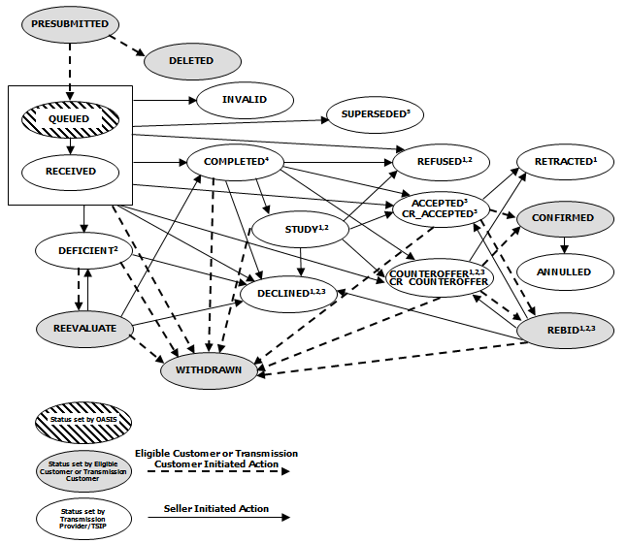

New NITS Application

Section 1: When Is A New NITS Application Is Required?
A new NITS application is required for new service that is not associated with an existing Network service agreement.

Section 2: Creating a “New Application”
- Log into OASIS: https://www.oasis.oati.com/cgi-bin/webplus.exe?Script=/woa/woa-login.wml
- In “Transactions” under NITS, select “Request Summary”
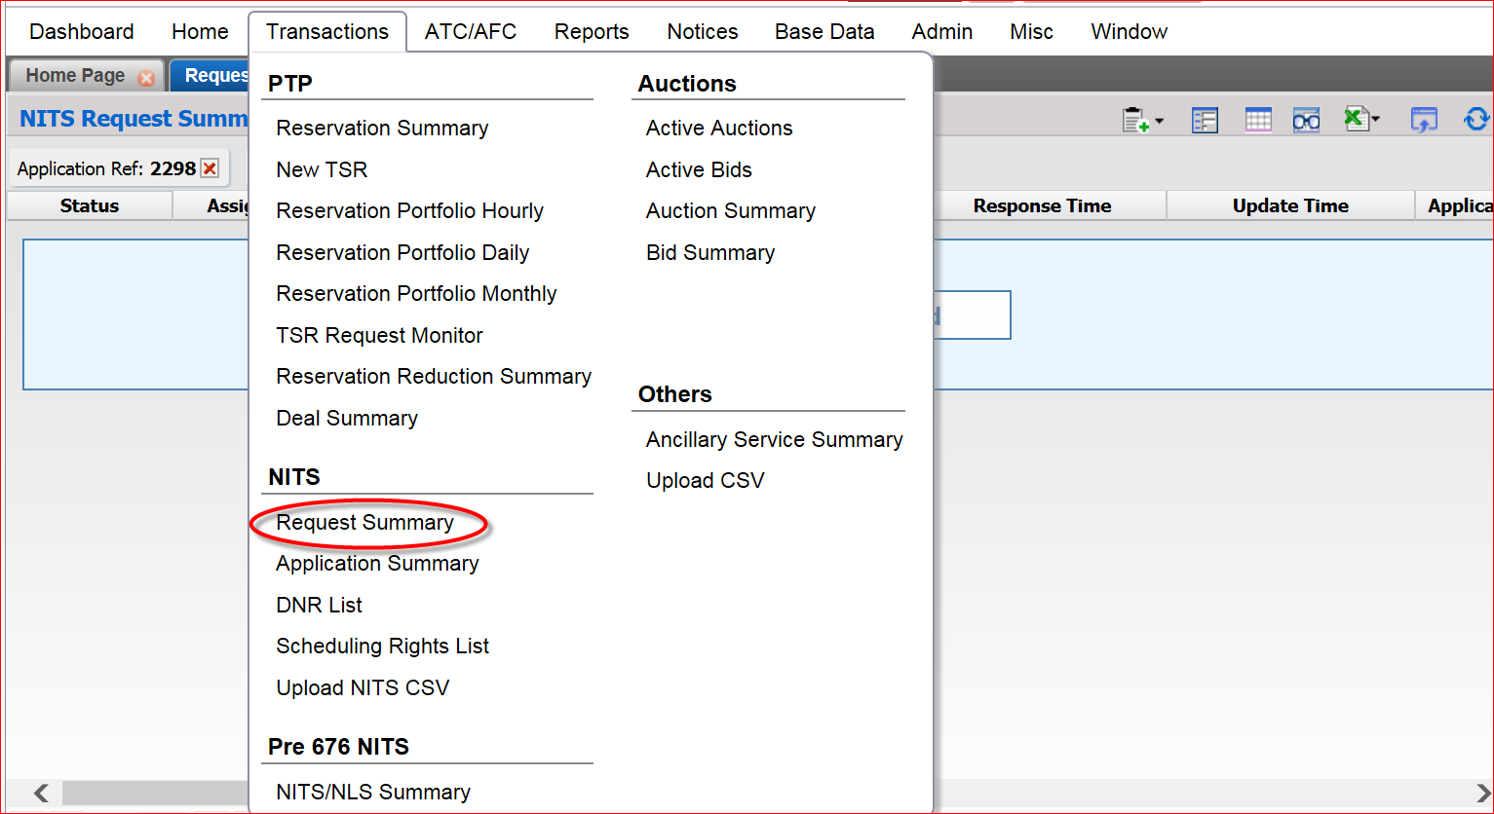
- Select the New Request icon in the upper, right-hand corner of the gray band above the field headers
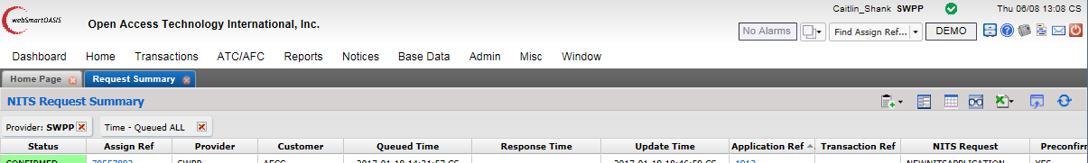
- Select “New Application”
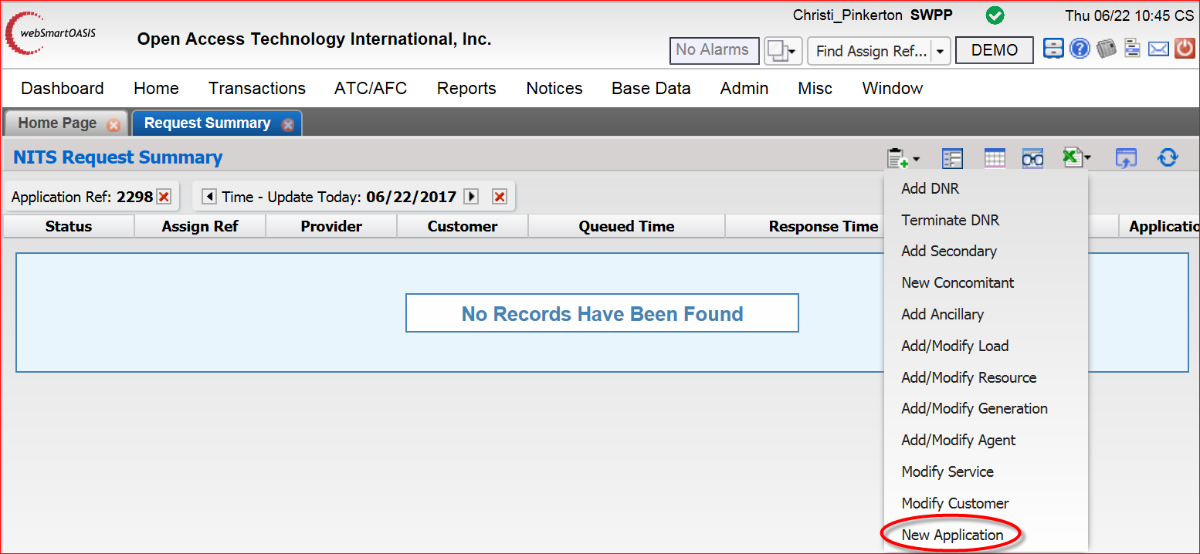

- Populate the Application fields:
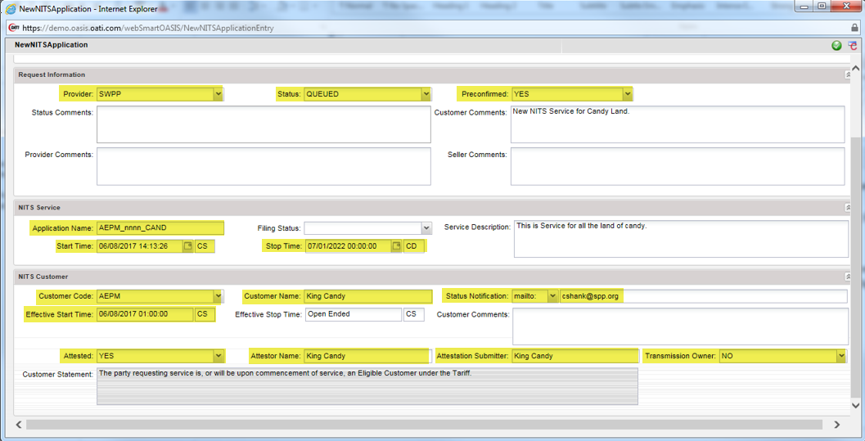
Figure 1: In this example, King Candy, from AEPM, has successfully completed all fields required for a new NITS application for Candy Land.
- When all required fields are completed, select the Submit at the upper, right-hand side of the template
- A “Save” window will open containing the new Application Ref (all service TSRs under a Service Agreement are associated with the same Application Ref) and the Assignment Ref (TSR number) related to the NewNITSApplication.
Figure 2: You will need the Application Ref for all other request templates related to this service (“Add/Modify Load,” “Add/Modify Generation,” “Add/Modify Resource” and “Add DNR”)

Section 2a: Field Requirements for “New Application”
- Provider: For SPP customers, this field will be “SWPP”
- Status:
  - Queued: If this option is selected, once you hit submit, the application will go into a queued state and if everything is completed correctly will automatically go to either an “Accepted” state or to a “Confirmed” state depending on your selection in the “Preconfirmed” field
  - Presubmitted: If this option is selected, when you hit submit, the application will be saved and the customer can continue working on it until it is ready to be submitted in a “Queued” state
- Preconfirmed:
  - No: Customer will need to “confirm” request once it has been accepted
  - Yes: Request will automatically go into a “Confirmed” state if everything is completed correctly
- Application Name: CustomerCode_SA#_Detail for ex: AEPM_1275_CAND; if SA is unknown it would be AEPM_nnnn_CAND
- Effective Start Time: Cannot be in the past
- Effective Stop Time: Cannot be less than 1 year after start date
- Attested: This field must be changed to “Yes”
- Attestor Name: Should be a person with the authority sign the Attestation form
- Attestation Submitter: Should be the user creating the Application in OASIS
- Transmission Owner: Default is “No”

Section 2b: Optional Fields for “New Application”
- Customer Comments: Any notes the customer would like to add to the request
- Filing Status: optional field
- Service Description: optional field

Section 2c: Do Not Change Fields for “New Application”
- Status Comments: Please do not populate this field
- Provider Comments: Please do not populate this field
- Seller Comments: Please do not populate this field
- Customer Statement: Please do not modify this field

Adding Service Elements to the New NITS Application
The following sections will describe the process for adding new Load and designating new Resources to your new NITS Application. You will need to know the “Application Ref” number in order to complete all of the following templates.

For all these examples, we will continue to use the NITS Application Ref # 2298 that was created in Section 2 of this document.

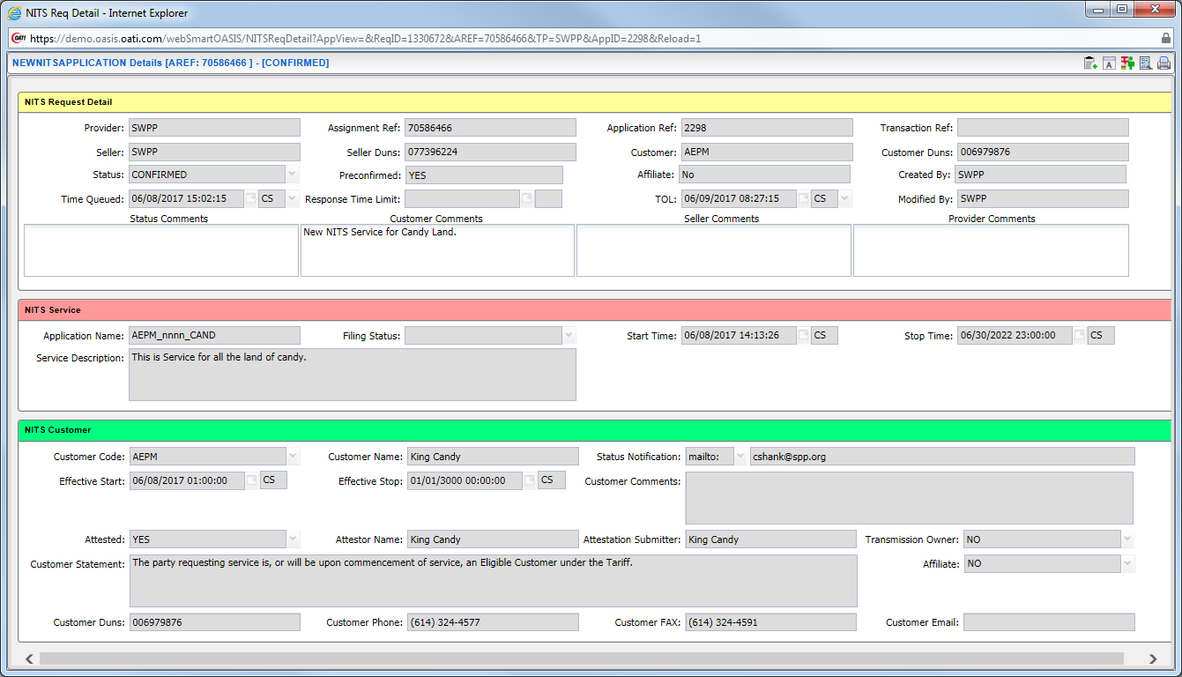

Adding New Load
You will need to know the “Application Ref” in order to complete this request template.

Section 3: Adding New Load to the NITS Application
- Log into OASIS: https://www.oasis.oati.com/cgi-bin/webplus.exe?Script=/woa/woa-login.wml
- In “Transactions” under NITS, select “Request Summary”
- Select the New Request icon in the upper, right-hand corner of the gray band above the field headers
- Select “Add/Modify Load”
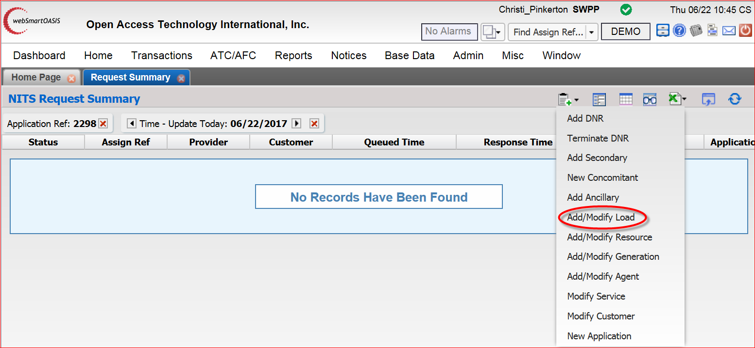
- Populate the Application fields:
  - “Select a Provider:”
    - Select “SWPP” in this field
  - “Application Ref:”
    - Enter your “Application Ref” here – for this example, we will use Application Ref # 2298
  - “Load Name *:”
    - Select the to Enter the new Load Name (see red arrow above)
    - The Load Name should include a description of the Point of Delivery and the Sink being added, for example:
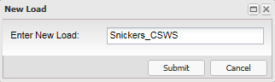
    - Select “Submit”
- Once you submit, the Load name will be populated in NITS Load Description section, and other items in the Application Fields are ready to be completed now:
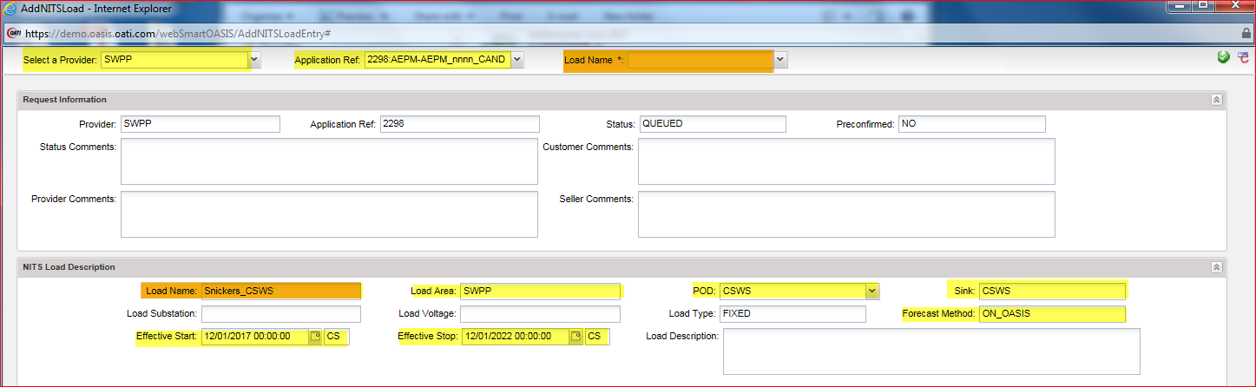
Figure 3: In this example, King Candy has created a Load Request for the Snickers City.
- When all required fields are completed, select the Submiticon at the upper, right-hand side of the template
- A “Save” window will open containing the “AddNITSLoad” Assignment Ref and the “Application Ref” it was added to.
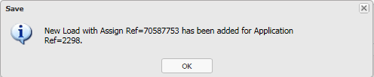

Section 3a: Field Requirements for “Add/Modify Load”
- Provider: For SPP customers, this field will be “SWPP”
- Application Ref: The Application Ref # associated with the load request
- Load Name: A name that will describe the load being added to the NITS application. Once you enter the load name and submit, the Load name will be populated in NITS Load Description section, and other items in the Application Fields should be completed now.
- Status:
  - Queued: If this option is selected, once you hit submit, the application will go into a queued state and if everything is completed correctly will automatically go to a “Study” state.
  - Presubmitted: If this option is selected, when you hit submit, the application will be saved and the customer can continue working on it until it is ready to be submitted in a “Queued” state
- Preconfirmed:
  - No: Customer will need to “confirm” request once it has been accepted
  - Yes: Request will automatically go into a “Confirmed” state if everything is completed correctly
- Load Area: If within SWPP footprint, use “SWPP,” otherwise, use the registered area in OASIS for the load
- POD: The OASIS Point of Delivery for the request
- Sink: The OASIS Sink for the Load request
- Forecast Method: Use “ON_OASIS” to place forecast in OASIS, otherwise use “OFF_OASIS”
- Effective Start Time: Must be submitted no later than 60 days in advance.
- Effective Stop Time: Cannot be less than 1 year after start date

Section 3b: Optional Fields for “Add/Modify Load”
- Customer Comments: optional field for customer use
- Load Description: optional field for Customer use.
- Load Substation: optional field
- Load Voltage: optional field

Section 3c: Do Not Change Fields for “Add/Modify Load”
- Status Comments: Please do not populate this field
  - This field will describe any errors encountered once the request has been submitted
- Provider Comments: Please do not populate this field
- Seller Comments: Please do not populate this field
- Load Type: Use Default (FIXED) – do not change

Adding A Network Resource

Generation Details
You will need to know the “Application Ref” in order to complete this request template.

Section 4: Adding Generation Information for the Network Resource
You will only need to submit this request for Owned Generation. For Purchases (PPAs) skip to Section 5.

- Log into OASIS: https://www.oasis.oati.com/cgi-bin/webplus.exe?Script=/woa/woa-login.wml
- In “Transactions” under NITS, select “Request Summary”
- Select the New Request icon in the upper, right-hand corner of the gray band above the field headers
- Select “Add/Modify Generation”
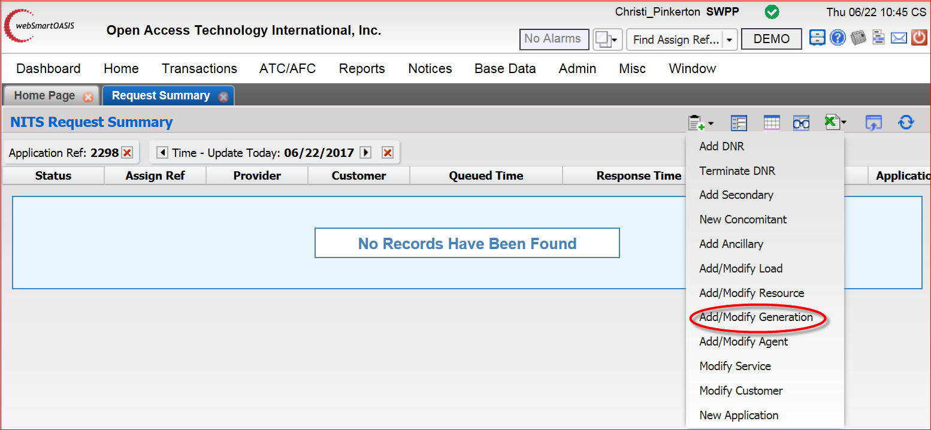
- Populate the Application fields:
  - “Select a Provider:”
    - Select “SWPP” in this field
  - “Application Ref:”
    - Enter your “Application Ref” here – for this example, we will use Application Ref # 2298
  - “Generation Name *:”
    - Select the to Enter the new Generation Name (see red arrow above)
    - The Generation Name should include Generator Name and Unit Number, for example:
    - Select “Submit”
- Once you submit, the Generator name will be populated in NITS Generation Description section, and other items in the Application Fields are ready to be completed now:
- 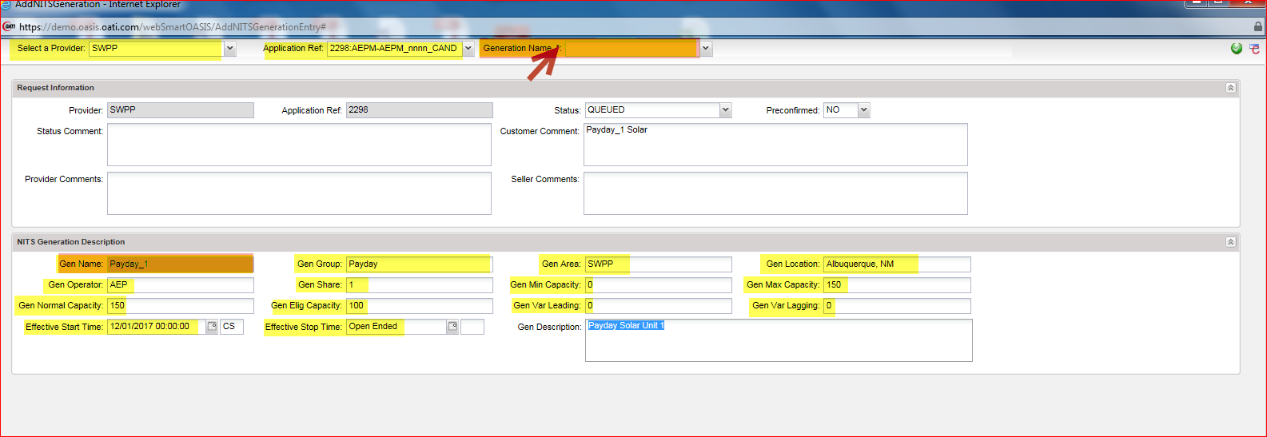
Figure 4: In this example, King Candy has created a Generation Request for Payday_1.
- When all required fields are completed, select the Submiticon at the upper, right-hand side of the template
- A “Save” window will open containing the “AddNITSGeneration” Assignment Ref and the “Application Ref” it was added to.
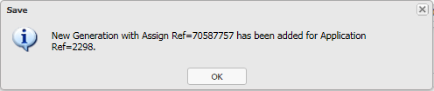

Section 4a: Field Requirements for “Add/Modify Generation”
- Provider: For SPP customers, this field will be “SWPP”
- Application Ref: The Application Ref # associated with the generation request
- Generation Name: A name that will describe the generation name and unit number being added to the NITS application, for example: Payday_1. Once you submit, the Generator name will be populated in NITS Generation Description section, and other items in the Application Fields are ready to be completed now:
- Status:
  - Queued: If this option is selected, once you hit submit, the application will go into a queued state and if everything is completed correctly, it will automatically go to either an “Accepted” state or to a “Confirmed” state depending on your selection in the “Preconfirmed” field
  - Presubmitted: If this option is selected, when you hit submit, the application will be saved and the customer can continue working on it until it is ready to be submitted in a “Queued” state
- Preconfirmed:
  - No: Customer will need to “confirm” request once it has been accepted
  - Yes: Request will automatically go into a “Confirmed” state if everything is completed correctly
- Gen Group: For example, all Payday units will be under Payday
- Gen Area: If within SWPP footprint, use “SWPP,” otherwise, use the registered area in OASIS for the generation
- Gen Location: City and State of unit
- Gen Operator: Customer Code of Operator
- Gen Share: Percentage of ownership of the unit (for 100% enter 1, for 50% enter 0.5)
- Gen Min Capacity
- Gen Max Capacity (Cannot be less than the “Gen Elig” Capacity)
- Gen Normal Capacity
- Gen Elig Capacity (Cannot be less than sum of the designated amounts)
- Gen Var Leading
- Gen Var Lagging
- Effective Start Time: Must be submitted no later than 24 hours in advance.
- Effective Stop Time: Cannot be less than 1 year after start date and must cover term of the intended designation

Section 4b: Optional Fields for “Add/Modify Generation”
- Customer Comments: optional field for customer use
- Generation Description: optional field for Customer use.

Section 4c: Do Not Change Fields for “Add/Modify Generation”
- Status Comments: Please do not populate this field
  - This field will describe any errors encountered once the request has been submitted
- Provider Comments: Please do not populate this field
- Seller Comments: Please do not populate this field

Resource Details
You will need to know the “Application Ref” in order to complete this request template.

Section 5: Adding Resource Information for the Network Resource
You will need to submit this request for both Owned Generation and for Purchases (PPAs).
- Log into OASIS: https://www.oasis.oati.com/cgi-bin/webplus.exe?Script=/woa/woa-login.wml
- In “Transactions” under NITS, select “Request Summary”
- Select the New Request icon in the upper, right-hand corner of the gray band above the field headers
- Select “Add/Modify Resource”
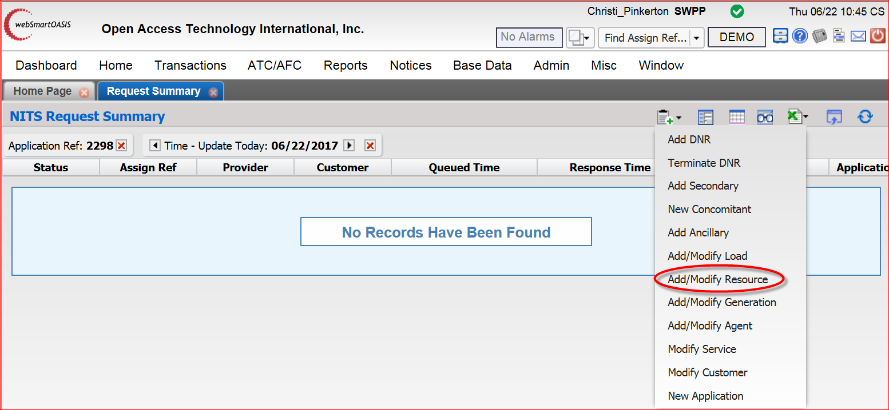
- Populate the Application fields:
  - “Select a Provider:”
    - Select “SWPP” in this field
  - “Application Ref:”
    - Enter your “Application Ref” here – for this example, we will use Application Ref # 2298
  - “Resource Name *:”
    - Select the to Enter the new Resource Name (see red arrow above)
    - The Resource Name will match the name you created for the Generator Details:
    - Select “Submit”
- Once you submit, the Resource Name will be populated in NITS Resource Description section, and other items in the Application Fields are ready to be completed now:
- Populate the Application fields:
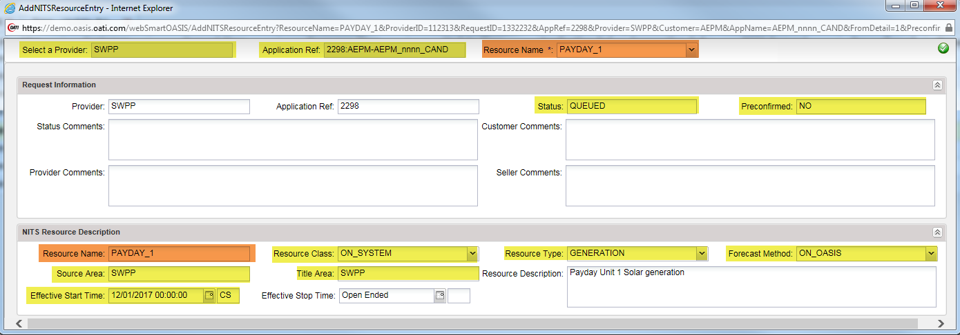
Figure 5: In this example, King Candy has created a Resource Request for Payday_1.
- When all required fields are completed, select the Submiticon at the upper, right-hand side of the template
- A “Save” window will open containing the new Resource “Assignment Ref” and the “Application Ref” it was added to.
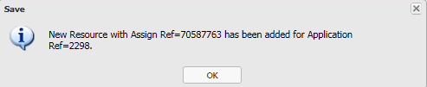

Section 5a: Field Requirements for “Add/Modify Resource”
- Provider: For SPP customers, this field will be “SWPP”
- Application Ref: The Application Ref # associated with the generation request
- Resource Name: The Resource Name will match the name you created in the Generator Details section, when you submit, the Resource name will be populated in NITS Resource Description section, and other items in the Application Fields are ready to be completed now:
- Status:
  - Queued: If this option is selected, once you hit submit, the application will go into a queued state and if everything is completed correctly will automatically go to either an “Accepted” state or to a “Confirmed” state depending on your selection in the “Preconfirmed” field
  - Presubmitted: If this option is selected, when you hit submit, the application will be saved and the customer can continue working on it until it is ready to be submitted in a “Queued” state
- Preconfirmed:
  - No: Customer will need to “confirm” request once it has been accepted
  - Yes: Request will automatically go into a “Confirmed” state if everything is completed correctly
- Resource Class:
  - ON_SYSTEM: For a resource in SPP footprint
  - OFF_SYSTEM: For a resource not in SPP footprint
- Resource Type:
  - GENERATION: For owned Generation
  - EXECUTED_PPA: For purchased Generation
- Forecast Method: Forecast is required, select “ON_OASIS”
- Source Area:
  - SWPP: For a resource in SPP footprint
  - Area Name: For a resource not in SPP footprint
- Title Area: Generally equal to Source Area
- Effective Start Time: Must be submitted no later than 24 hours in advance.
- Effective Stop Time: Cannot be less than 1 year after start date and must cover term of the intended designation

Section 5b: Optional Fields for “Add/Modify Resource”
- Customer Comments: optional field for customer use
- Resource Description: optional field for customer use.

Section 5c: Do Not Change Fields for “Add/Modify Resource”
- Status Comments: Please do not populate this field
  - This field will describe any errors encountered once the request has been submitted
- Provider Comments: Please do not populate this field
- Seller Comments: Please do not populate this field

Designating the Resource
You will need to know the “Application Ref” in order to complete this request template.

Section 6: Designating the Network Resource
You will need to submit this request for in order to designate your Network resource.
- In “Transactions” under NITS, select “Request Summary”
- Select “Add DNR” in Drop Down menu
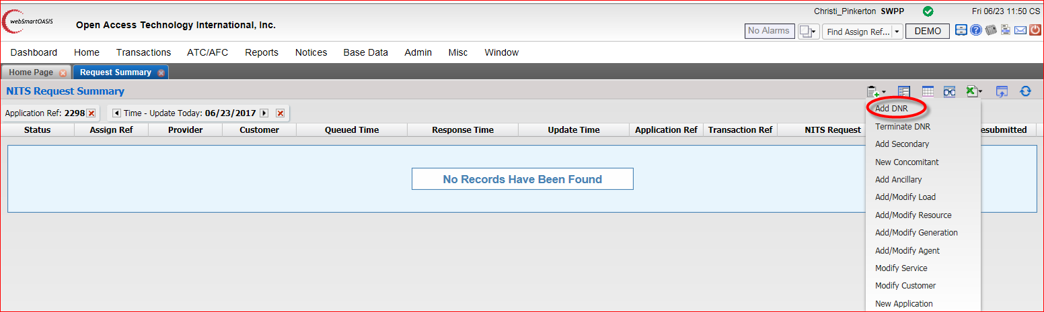

- Select Provider “SWPP”, Select Appropriate Application Ref and Select Appropriate Resource Name:
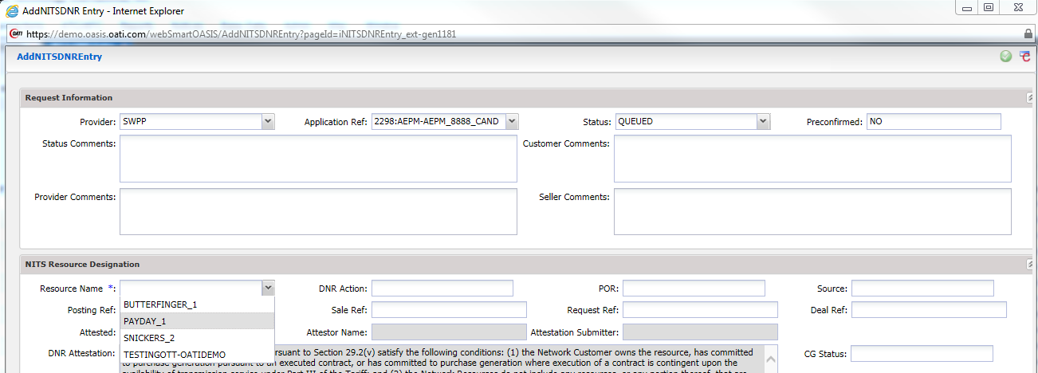
- The required fields are highlighted in Figure 6 below.
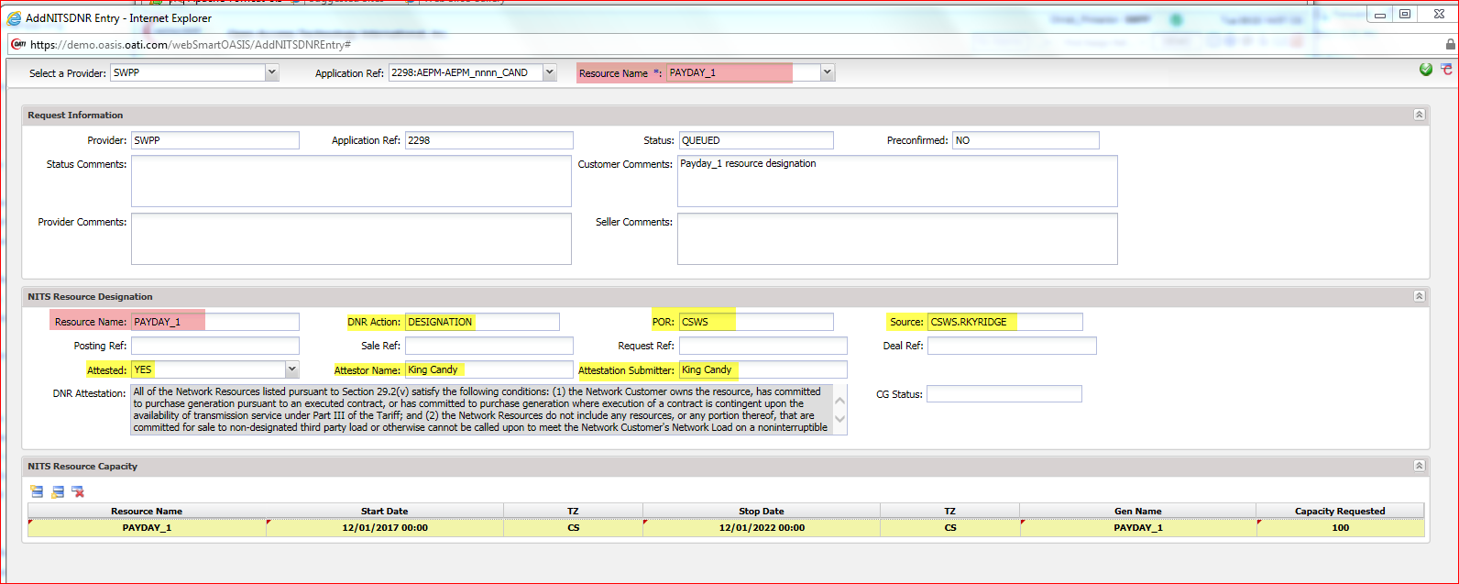
Figure 6: In this example, King Candy, from AEPM, has successfully completed all fields required for a new NITS DNR for Payday_1
- When all required fields are completed, select the Submit at the upper, right-hand side of the template
- A “Save” window will open containing the new Application Ref (all service TSRs under a Service Agreement are associated with the same Application Ref) and the Assignment Ref (TSR number) related to the NewNITSApplication.
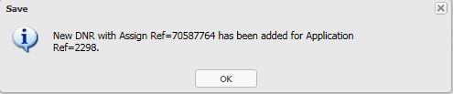
Figure 7: You will need the Application Ref for all other request templates related to this service (“Add/Modify Load,” “Add/Modify Generation,” “Add/Modify Resource” and “Add DNR”)

Section 6a: Field Requirements for “Add NITSDNR”
- Provider: For SPP customers, this field will be “SWPP”
- Application Ref: The Application Ref # associated with the generation request
- Resource Name: selected from drop-down menu
- Status:
  - Queued: If this option is selected, once you hit submit, the application will go into a queued state and if everything is completed correctly, it will automatically go to a “Study” state.
  - Presubmitted: If this option is selected, when you hit submit, the application will be saved and the customer can continue working on it until it is ready to be submitted in a “Queued” state
- Preconfirmed:
  - No: Customer will need to “confirm” request once it has been accepted
  - Yes: Request will automatically go into a “Confirmed” state if everything is completed correctly
- DNR Action: select “DESIGNATION”
- POR: Point of Receipt
- Source: Registered OASIS Source name
- Attested: This field must be changed to “Yes”
- Attestor Name: Should be a person with the authority sign the Attestation form
- Attestation Submitter: Should be the user creating the Application in OASIS
- Start Date: Cannot be in the past (no earlier than 6 months after start of Aggregate study)
- Stop Date: Cannot be less than 1 year after start date
- Gen Name: Must match the name you created in the Generator Details section
- Capacity Requested: Amount of capacity to be studied for service

Section 6b: Optional Fields for “Add NITSDNR”
- Customer Comments: Any notes the customer would like to add to the request
- Filing Status: optional field

Section 6c: Do Not Change Fields for “Add NITSDNR”
- Status Comments: Please do not populate this field
- Provider Comments: Please do not populate this field
- Seller Comments: Please do not populate this field
- Customer Statement: Please do not modify this field

View NITS Application Summary
To view all service details for Load, Generation Details and Resource Details associated with a NITS application, please use the following steps:

Please note: Requests in the following States will be available in the summary view:
- Confirmed
- Completed
- Study
- Deficient

Application Summary
- Log into OASIS: https://www.oasis.oati.com/cgi-bin/webplus.exe?Script=/woa/woa-login.wml
- In “Transactions” under NITS, select “Application Summary”
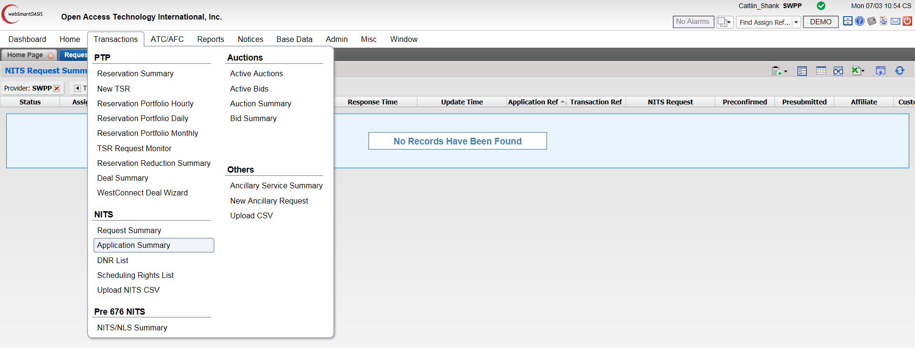
- Select the Server Filter Options icon in the upper, right-hand corner of the gray band above the field headers
- Using the “Customer” field and changing the “Time” to “Update” and “All” will be the easiest way to find the NITS Application you are looking for.
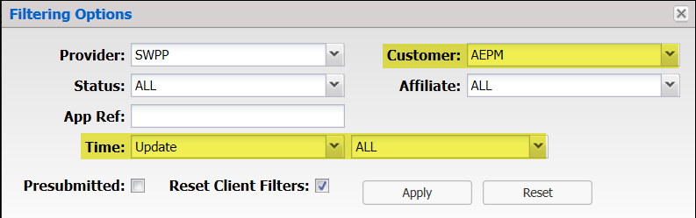
- Add filters and select “Apply”
- For this example, we will use Application Ref: 2298 since we built it in the prior examples.
- Select 2298 in the “Application Ref” column
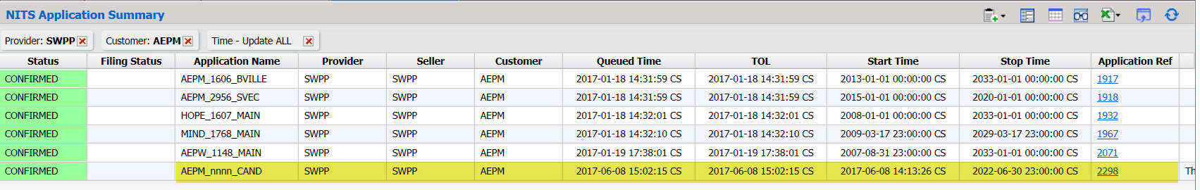
- The “NITS Application Detail” window will open displaying a summary of the Load, Generation Detail and Resource Details associated with the NITS Application.
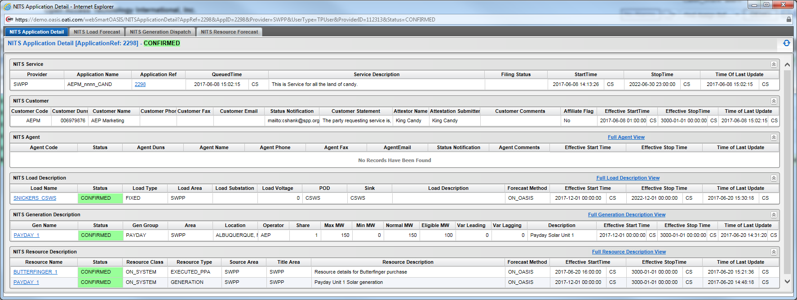

View Designated Network Resources (DNRs) Summary
To view all DNRs associated with a NITS application, please use the following steps:

Please note: Only requests in the “Confirmed” State will be available in this summary view.

For this example, we will continue to use Application Ref 2298.

DNR Summary
- Log into OASIS: https://www.oasis.oati.com/cgi-bin/webplus.exe?Script=/woa/woa-login.wml
- In “Transactions” under NITS, select “Application Summary”
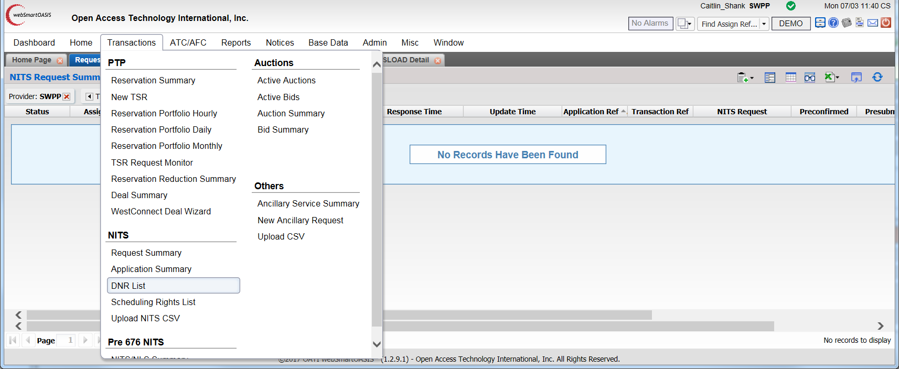
- Select the Server Filter Options icon in the upper, right-hand corner of the gray band above the field headers
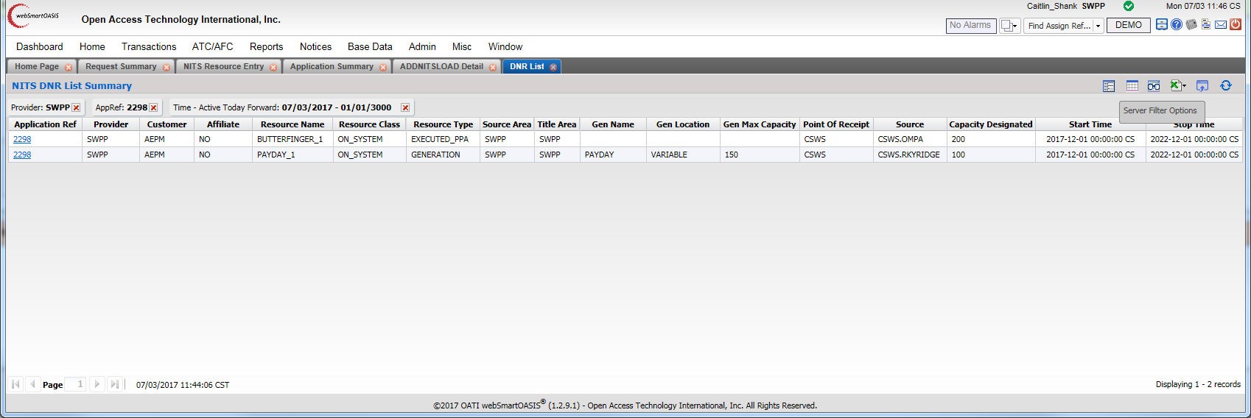
- Use the “Appl Ref” field and change the “Time” to “Active” and “Today Forward” and all “Confirmed” Designations will populate that are associated with the NITS Application.
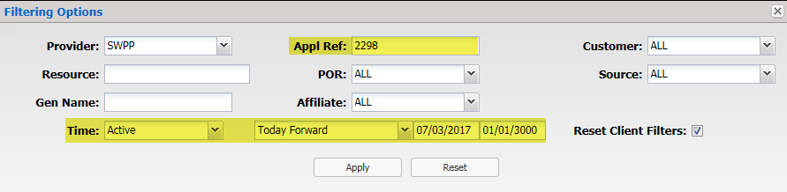
- Add filters and select “Apply”
- A high-level summary of all designations associated with Application Ref 2298 is now available.
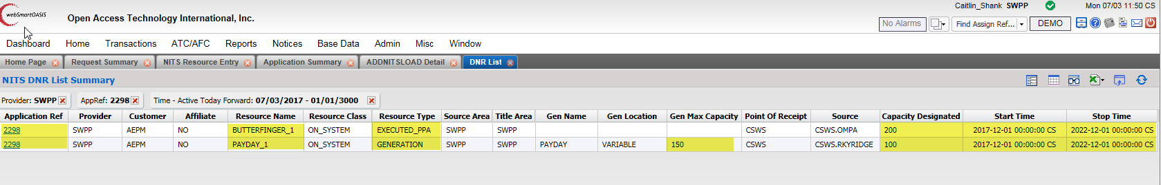

Deficient Requests
If a field is incorrectly populated when submitting a request in any of the NITS on OASIS templates, it will come back in a “Deficient” state.

Some items that will cause a template to fail are:
- Timing requirements have not been met
- NITS Application request was not “Attested” to correctly
- DNR request was not “Attested” to correctly
- DNR Designated Capacity amount > Generation Eligible Amount

If your request come back “Deficient” please review the “Field Requirement” section associated with the “Deficient” request.

To correct the error(s), the request can be edited and then submitted for “Re-Evaluation” by using the following steps:

Correcting a Deficient Request
- In “Transactions” under NITS, select “Request Summary”
- Select the Server Filter Options icon in the upper, right-hand corner of the gray band above the field headers
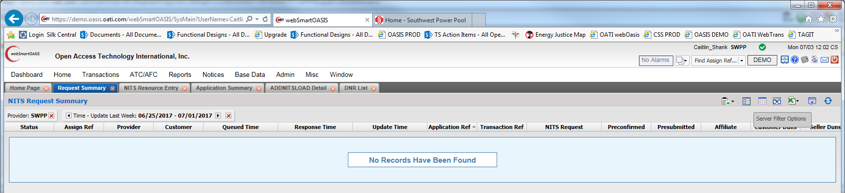
- Enter the Appl Ref associated with the Deficient request
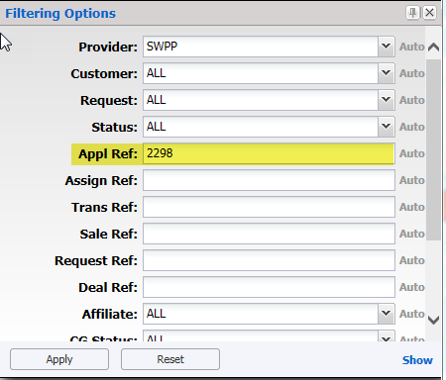
- Select “Apply”
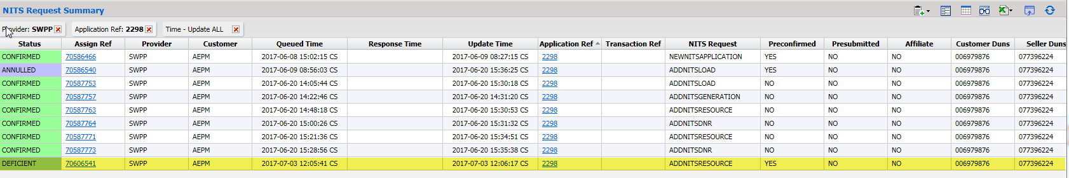
- Select the deficient request in the “Assign Ref” column
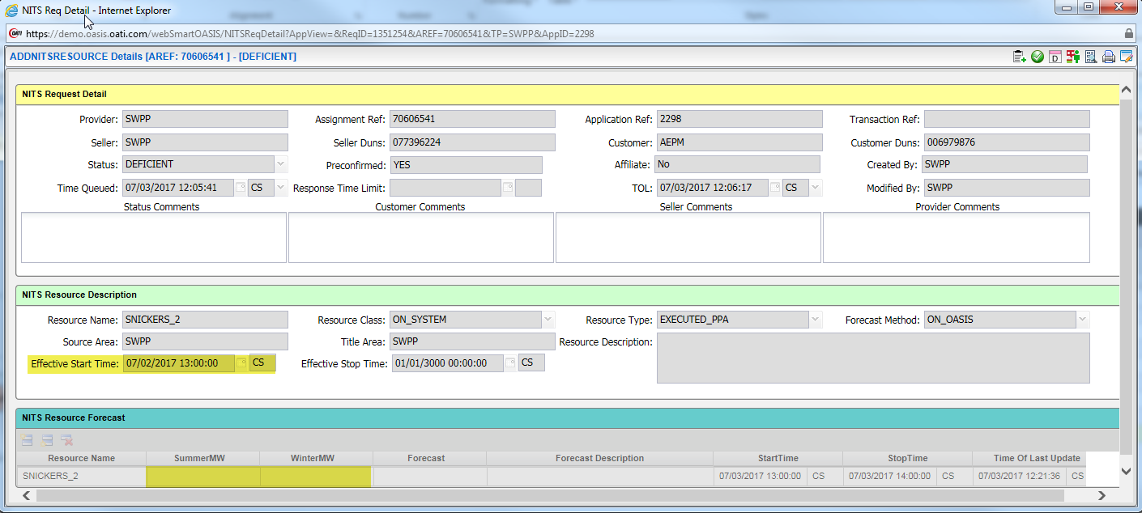
- The above request is deficient for 2 reasons:
  - Effective Start Time is in the past
  - No resource forecast was included with the request
- To correct the errors, select the Edit icon at the upper, right-hand side of the template
  - Update the “Effective Start Time” to be 24 hours after the queue time of the request
  - Add the Summer and Winter forecasts
    - Make sure the Start and Stop time are updated to reflect the span of the forecast being submitted
- Once these updates have been made, select the Submit icon at the upper, right-hand side of the template
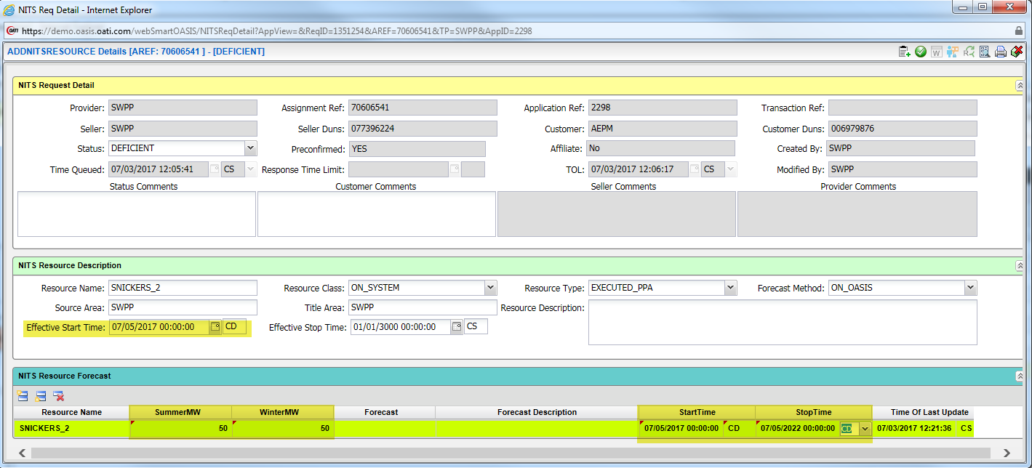
- Next, select the ReEvaluate icon at the upper, right-hand side of the template
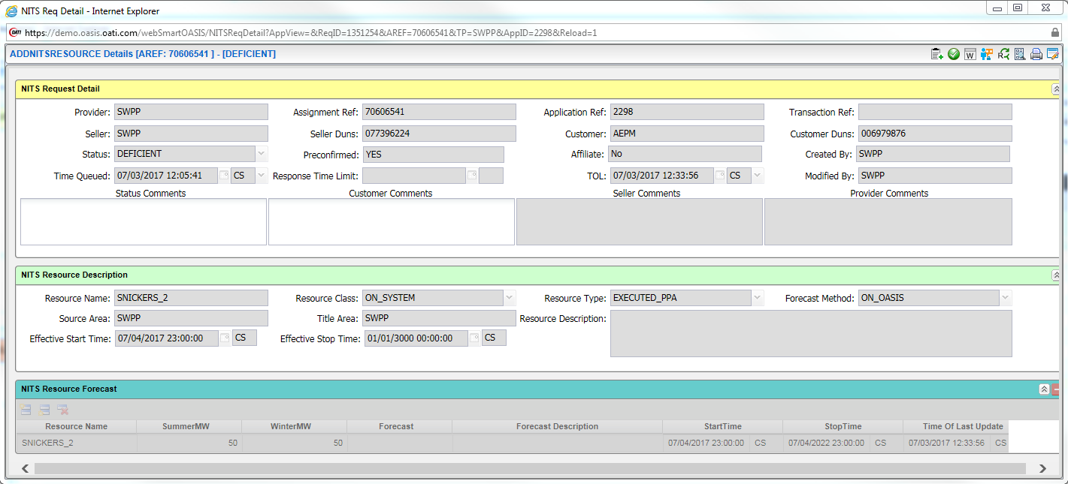
- The system OASIS system will revalidate the request and if there are no errors, it will move into one of the following states depending on the request type:
  - Study:
    - Add DNR
    - Add/Modify Load
  - Confirmed:
    - New Application
    - Add/Modify Generation
    - Add/Modify Resource

