Customer Guide for Correcting “Deficient” Requests on NITS on OASIS and Submitting for Re-Evaluation

Revision History Chart

Version | Revised By | Description of Modifications | Revision Date
1.0 | SPP Staff | Customer Process document for correcting Deficient requests in NITS on OASIS | 4/24/2018

Table of Contents
Revision History Chart 2
Process Overview 4
Purpose 4
Background 4
Requirements 4
Process Flowchart 4
Deficient Requests 5
Correcting a Deficient Request 5
New NITS Application 8
Required Fields for “New Application” 8
Adding New Load 8
Required Fields for “Add/Modify Load” 8
Adding A Network Resource 9
Required Fields for “Add/Modify Generation” 9
Required Fields for “Add/Modify Resource” 9
Required Fields for “Add NITSDNR” 9

Process Overview

Purpose
This document defines the necessary steps required for a network transmission customer to correct a “Deficient” request submitted for Network Integrate Transmission Service (NITS) in NITS on OASIS. Timing requirements and required fields are outlined as well to assist with this process.

Background

Requirements
- Access to OASIS:
  - https://www.oasis.oati.com/cgi-bin/webplus.exe?Script=/woa/woa-login.wml

Process Flowchart
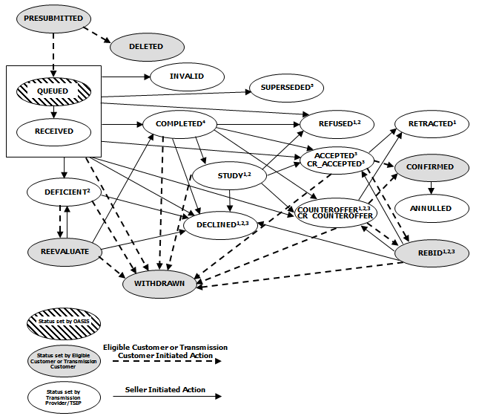

Deficient Requests
If a field is incorrectly populated when submitting a request in any of the NITS on OASIS templates, it will come back in a “Deficient” state.

Some items that will cause a template to fail are:
- Timing requirements have not been met
- NITS Application request was not “Attested” to correctly
- DNR request was not “Attested” to correctly
- DNR Designated Capacity amount > Generation Eligible Amount

If your request come back “Deficient” please review the “Field Requirement” section associated with the “Deficient” request.

To correct the error(s), the request can be edited and then submitted for “Re-Evaluation” by using the following steps:

Correcting a Deficient Request
- In “Transactions” under NITS, select “Request Summary”
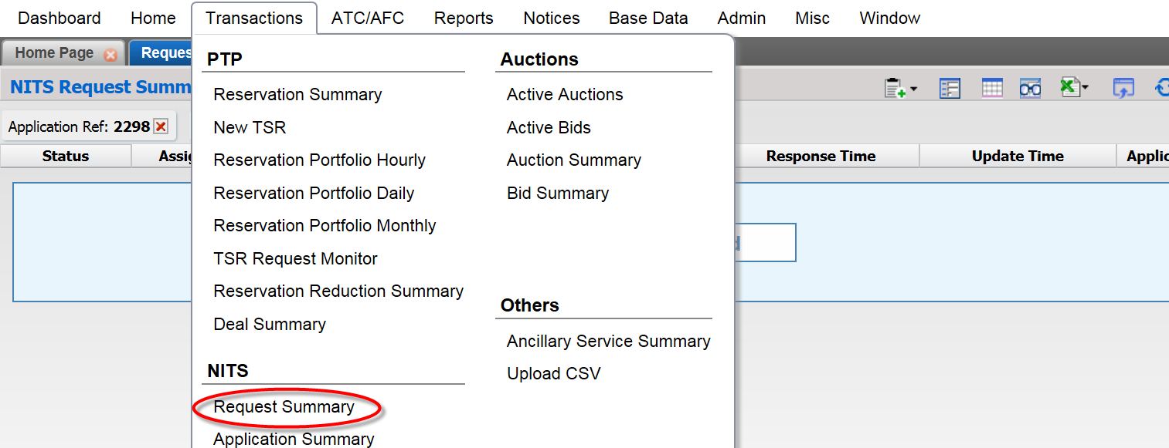
- Select the Server Filter Options icon in the upper, right-hand corner of the gray band above the field headers
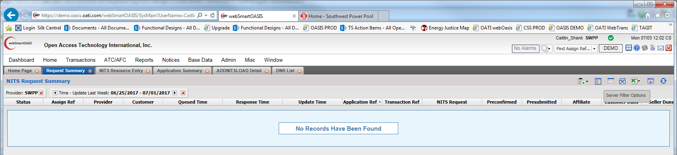
- Enter the Appl Ref associated with the Deficient request
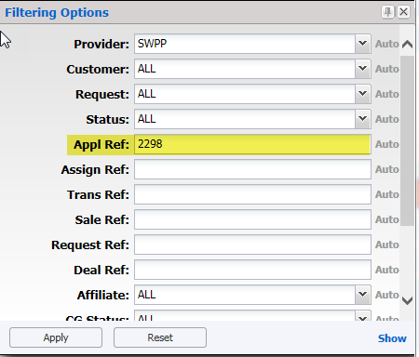
- Select “Apply”
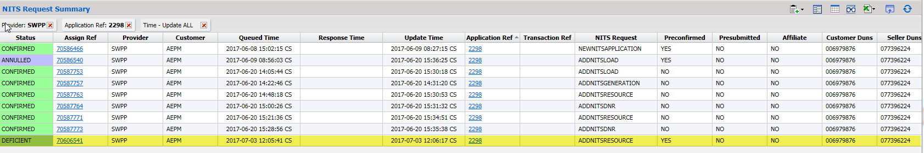
- Select the deficient request in the “Assign Ref” column
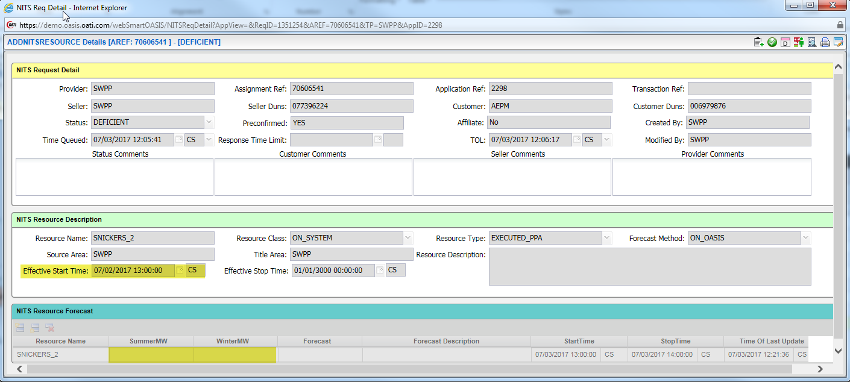
- The above request is deficient for 2 reasons:
  - Effective Start Time is in the past
  - No resource forecast was included with the request
- To correct the errors, select the Edit icon at the upper, right-hand side of the template
  - Update the “Effective Start Time” to be 24 hours after the queue time of the request
  - Add the Summer and Winter forecasts
    - Make sure the Start and Stop time are updated to reflect the span of the forecast being submitted
- Once these updates have been made, select the Submit icon at the upper, right-hand side of the template
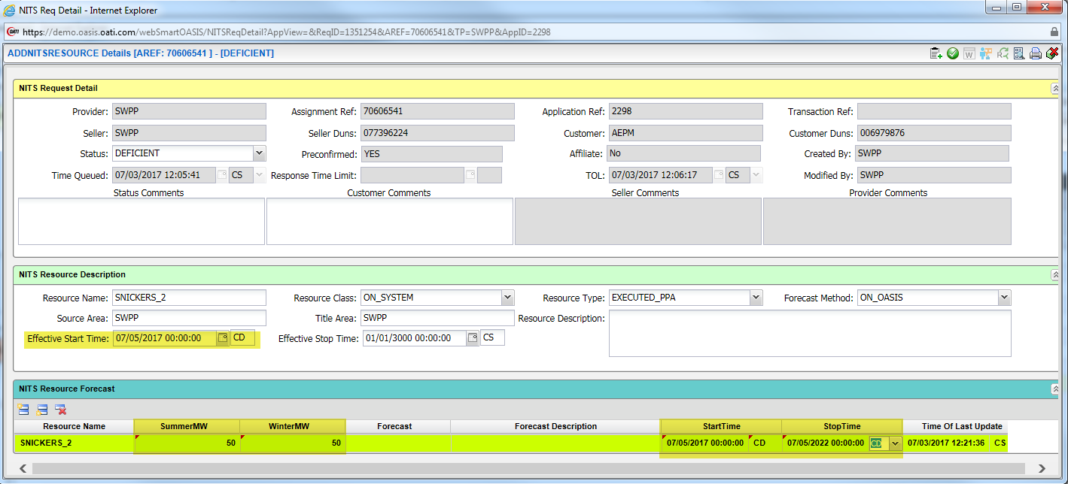
- Next, select the ReEvaluate icon at the upper, right-hand side of the template
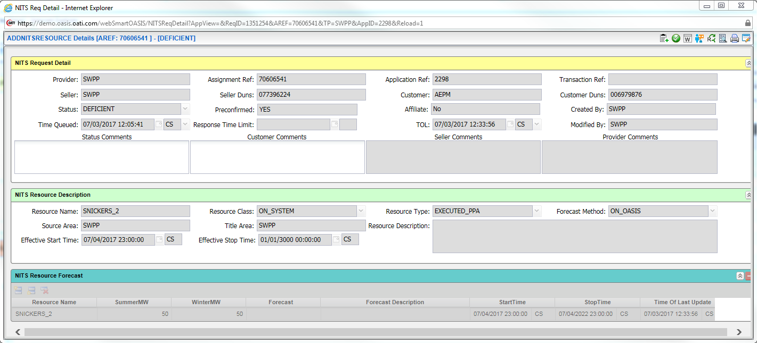
- The system OASIS system will revalidate the request and if there are no errors, it will move into one of the following states depending on the request type:
  - Study:
    - Add DNR
    - Add/Modify Load
  - Confirmed:
    - New Application
    - Add/Modify Generation
    - Add/Modify Resource

New NITS Application
Status Comments: This field will describe any errors encountered once the request has been submitted.

Required Fields for “New Application”
- Effective Start Time: Cannot be in the past
- Effective Stop Time: Cannot be less than 1 year after start date
- Attested: This field must be changed to “Yes”
- Attestor Name: Should be a person with the authority sign the Attestation form
- Attestation Submitter: Should be the user creating the Application in OASIS

Adding New Load
Status Comments: This field will describe any errors encountered once the request has been submitted.

Required Fields for “Add/Modify Load”
- Load Area: If within SWPP footprint, use “SWPP,” otherwise, use the registered area in OASIS for the load
- POD: The OASIS Point of Delivery for the request
- Sink: The OASIS Sink for the Load request
- Forecast Method: Use “ON_OASIS” to place forecast in OASIS, otherwise use “OFF_OASIS”
- Effective Start Time: Must be submitted no later than 60 days in advance.
- Effective Stop Time: Cannot be less than 1 year after start date
- Status Comments: Please do not populate this field
  - This field will describe any errors encountered once the request has been submitted
- Provider Comments: Please do not populate this field
- Seller Comments: Please do not populate this field
- Load Type: Use Default (FIXED) – do not change

Adding A Network Resource
Status Comments: This field will describe any errors encountered once the request has been submitted.

Required Fields for “Add/Modify Generation”
- Gen Area: If within SWPP footprint, use “SWPP,” otherwise, use the registered area in OASIS for the generation
- Gen Location: City and State of unit
- Gen Operator: Customer Code of Operator
- Gen Share: Percentage of ownership of the unit (for 100% enter 1, for 50% enter 0.5)
- Gen Min Capacity
- Gen Max Capacity (Cannot be less than the “Gen Elig” Capacity)
- Gen Normal Capacity
- Gen Elig Capacity (Cannot be less than sum of the designated amounts)
- Gen Var Leading
- Gen Var Lagging
- Effective Start Time: Must be submitted no later than 24 hours in advance.
- Effective Stop Time: Cannot be less than 1 year after start date and must cover term of the intended designation

Required Fields for “Add/Modify Resource”
- Resource Class:
  - ON_SYSTEM: For a resource in SPP footprint
  - OFF_SYSTEM: For a resource not in SPP footprint
- Resource Type:
  - GENERATION: For owned Generation
  - EXECUTED_PPA: For purchased Generation
- Forecast Method: Forecast is required, select “ON_OASIS”
- Source Area:
  - SWPP: For a resource in SPP footprint
  - Area Name: For a resource not in SPP footprint
- Title Area: Generally equal to Source Area
- Effective Start Time: Must be submitted no later than 24 hours in advance.
- Effective Stop Time: Cannot be less than 1 year after start date and must cover term of the intended designation

Required Fields for “Add NITSDNR”
- DNR Action: select “DESIGNATION”
- POR: Point of Receipt
- Source: Registered OASIS Source name
- Attested: This field must be “Yes”
- Attestor Name: Should be a person with the authority sign the Attestation form
- Attestation Submitter: Should be the user creating the Application in OASIS
- Start Date: Cannot be in the past (no earlier than 6 months after start of Aggregate study)
- Stop Date: Cannot be less than 1 year after start date (for long-term requests)
- Gen Name: If Owned Generation, must match the name you created in the Generator Details section, else, if PPA, this should be left blank.
- Capacity Requested: Amount of capacity to be studied for service

