Thursday, May 5, 2011

On Tuesday, May 3, 2011, the Federal Energy Regulatory Commission (FERC) issued a letter order related to docket ER11-2303. In this order letter, FERC accepted the changes to Attachment P of the SPP Open Access Transmission Tariff filed by SPP on March 22, 2011. The revisions to Attachment P were made effective May 1, 2011.

Included in the revisions were the definition and timing requirements of a new Daily Non-firm On-Peak and Daily Non-firm Off-Peak transmission service products. To allow ample time for Customer notification and SPP system configuration, SPP intends to make these new products available for request beginning Monday, May 9, 2011 at 0800, for service available Tuesday, May 10, 2011.

To request Non-firm Daily Off-Peak Service, choose the service labeled “SPP ND-3 OFF-PEAK”. Enter the Start date and Stop date, ensuring that the request is only one (1) day in duration and begins and ends at 00:00. Enter the capacity that is being requested for the Off-Peak hours in the “MW” field. Make sure the “Peak” box is checked in the Reservation Profile section and Click “Create”.
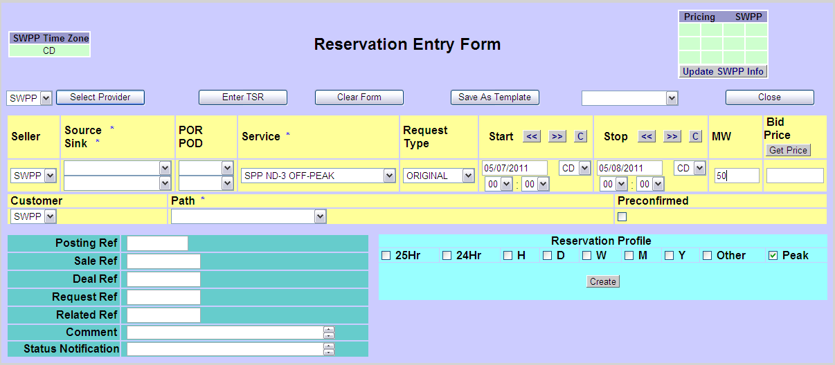
The OASIS will automatically populate the correct reservation profile.
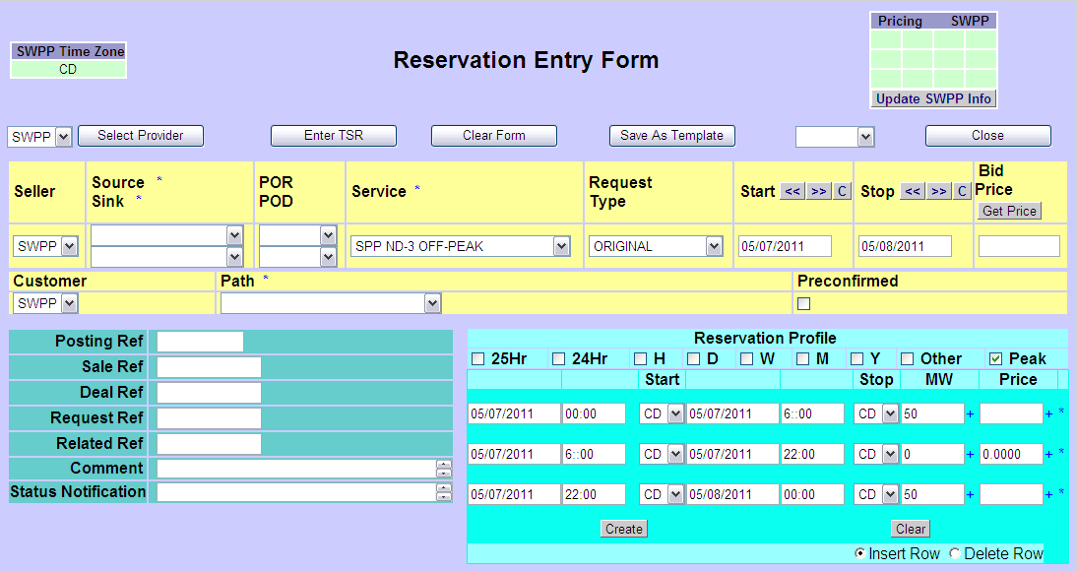

To request Non-firm Daily On-Peak Service, choose the service labeled “SPP ND-3 ON-PEAK”. Enter the Start date and Stop date, ensuring that the request is only one (1) day in duration and begins and ends at 00:00. Enter the capacity that is being requested for the On-Peak hours in the “MW” field. Make sure the “Peak” box is checked in the Reservation Profile section and Click “Create”.
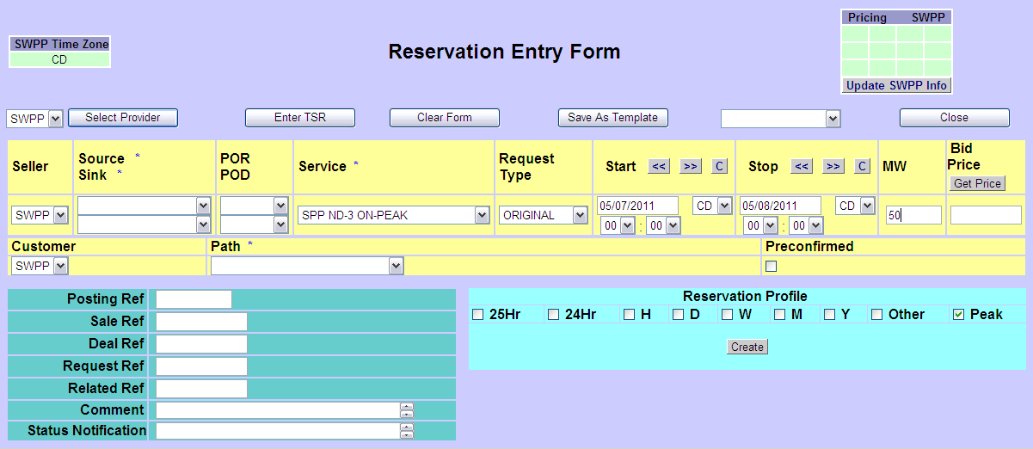
The OASIS will automatically populate the correct reservation profile.
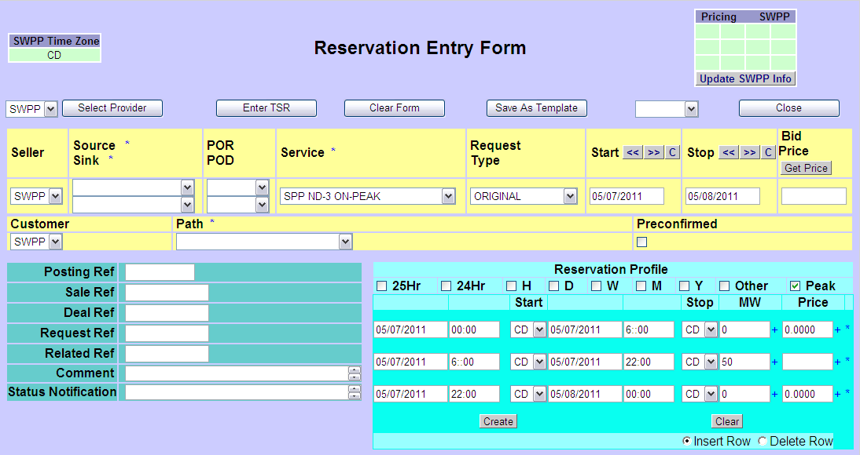

*Complete the remaining information such as Source, Sink, POR, and POD. And submit the TSR.
**The reservation profile must be a single value for the hours for which capacity is requested and the profile cannot deviate from the Attachment P specified profile, i.e. Off-Peak is 00:00-06:00 and 22:00-24:00; On-Peak is 06:00-22:00. Requests that do not meet these criteria will be deemed invalid.
*** Because these services are given a priority of ND-3, the customer will be billed the appropriate daily transmission service rate as specified in Attachment T of the SPP OATT and is determined by the day of the week for which service is being requested.

