Goshen Area Load Tripping RAS
For
Loss of 345 kV Source into Goshen

Prepared for
Idaho Stakeholders

Version 1
07/10/2015

Prepared by:
PacifiCorp

Table of Contents
Executive Summary 3
Background Information: 4
RAS Scope 7
General Requirements for the RAS: 8
Other Considered Options: 8
Potential Future Expansion: 9
Conclusions: 9
Appendix 1: RAS Logic Diagram 10

Executive Summary
The load in the Goshen area is currently served by two 345 kV lines and four underlying 161 kV transmission lines as shown in the one-line diagram in Figure 1.

Figure 1 : Goshen One-line Diagram
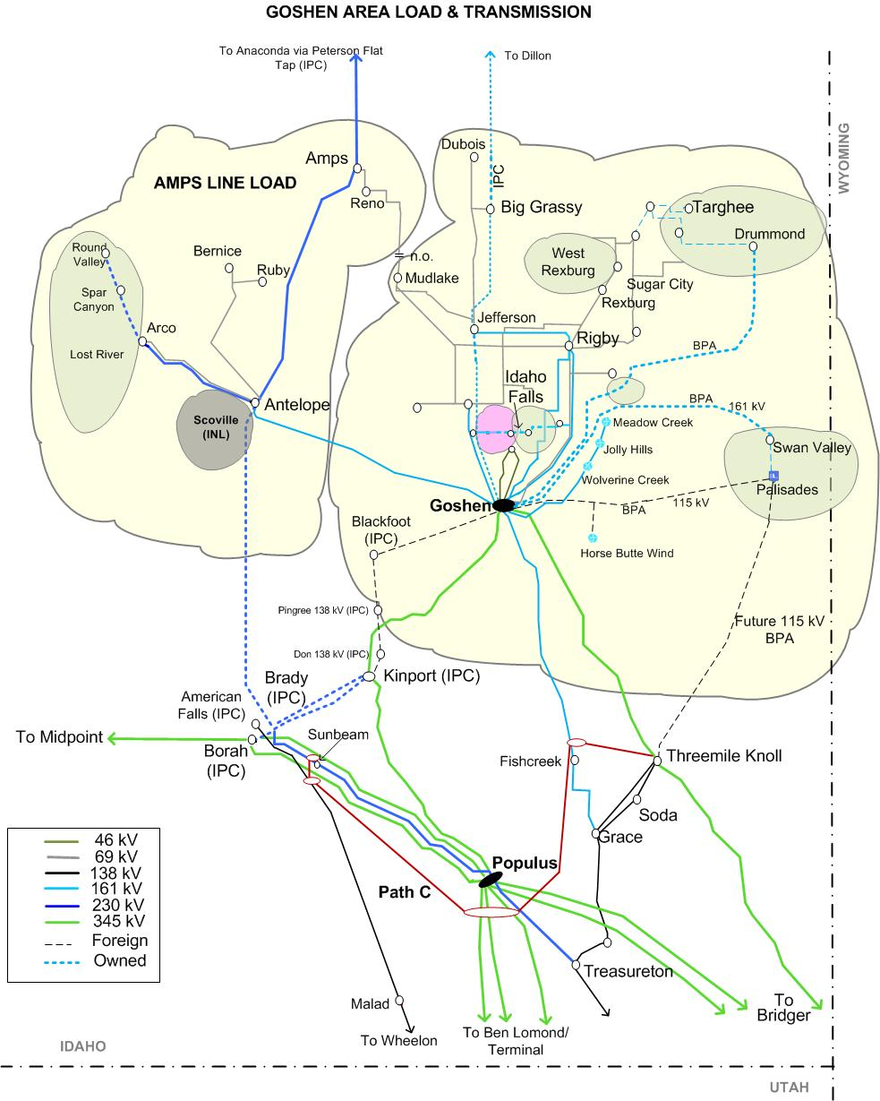

The 345 kV lines are the main source of power into the Goshen area. The loss of both 345 kV sources into Goshen could result in thermal overloads on the 161 kV transmission lines and could also result in low voltages in the Goshen area. Such an operating condition could ultimately result in loss of load in the Goshen area, which would be mitigated by the system protection scheme outlined in this document.

Even though having only one 345 kV line into Goshen is adequate to serve the load in the Goshen area, the outage of one of the 345 kV lines may require the PacifiCorp operator to shed load (pre-contingency load shedding) as required by North American Reliability Corporation (NERC) reliability standards and new PEAK Reliability Coordinator’s SOL methodology, in order to prepare the system for the next credible outage of the second 345 kV line, which could potentially result in overloading the remaining 161 kV lines. Pre-contingency load shedding was required during the December 4, 2013 outage in the Goshen area.

Based on outage statistics from 2000 until June 12, 2015 there has not been a single instance of simultaneous outage of both the 345 kV sources into Goshen. Currently there is adequate transmission capacity to serve the Goshen area load under normal system conditions. Due to the very low outage probability of both 345 kV sources and the new NERC requirement that would require PacifiCorp to pre-emptively shed load to plan and prepare the transmission system for the next feasible outage condition, PacifiCorp has proposed a Remedial Action Scheme (RAS) to prevent pre-contingency load shedding. A new 230 kV line from Kinport to Goshen was also considered that would provide another source into the Goshen area. This option would require a new right of way and other formalities that would result in delay of several years before it could be implemented. The cost of a new 230 kV line would also be significantly more than the proposed RAS alternative. Comparing the probability of an N-1-1 event, the economics and the time to implement this solution, the proposed RAS is a more efficient solution.

The proposed RAS will alleviate the impacts on the 161 kV transmission lines in the Goshen area for loss of the 345 kV source and will eliminate the need for pre-contingency load shedding in the Goshen area. The basic functions required of the proposed RAS are listed below.

- The proposed RAS will monitor thermal loading on the 161 kV transmission lines into Goshen.

- If one or more of these lines exceed the emergency rating, an alarm signal will be sent to a master controller at Goshen.

- Upon receipt of this alarm signal from any one of the 161 kV lines, the master controller will verify the loss of the 345 kV source in Goshen and issue a trip signal to breakers at Goshen and Rigby to shed load at Rigby, Sugarmill and the local Goshen area to alleviate thermal overloads on the 161 kV lines. The logic diagram for the RAS is shown in Appendix 1.

The loss of the 345 kV source into Goshen can happen either due to loss of both 345 kV lines into Goshen or loss of both 345/161 kV auto transformers at Goshen as an N-1-1 contingency. The outage of the Jim Bridger – Threemile Knoll 345 kV line along with an outage of the Goshen – Kinport 345 kV line could also result in loss of the 345 kV source at Goshen. These N-1-1 events are very low probability events. However, the loss of both 345 kV sources results in the Goshen area load being served by the underlying 161 kV transmission lines. Some of these 161 kV transmission lines may overload if the load in the Goshen area is high and the generation (Table 1) inside the Goshen area is low.

Technical study findings demonstrate that for loss of the 345 kV source at Goshen, with heavy Goshen area load and low local area generation, the underlying transmission lines are heavily overloaded, but do not result in regional instability. However, the overloads on the underlying transmission system are significant. For example, the overload on the Grace – Goshen 161 kV line was 178% of its emergency rating and the overload on the Blackfoot 161/138 kV auto transformer, owned by Idaho Power (IPC), was 140% of its emergency rating. Also, at present, in order to alleviate thermal overloads on the remaining underlying 161 kV transmission lines, PacifiCorp has implemented a tripping scheme that trips the 161 kV lines that are over their emergency ratings in two seconds, resulting in loss of the entire Goshen area load if all the remaining 161 kV lines were tripped due to thermal overload.

Background Information:
There are two 345 kV lines that are connected to the Goshen substation:
- Goshen – Three Mile Knoll (TMK) 345 kV line
- Goshen – Kinport 345 kV line.
These 345 kV lines are the major source of power for the Goshen area load. Generally, the majority of the power flow is from TMK toward Goshen. As shown in Figure 2, during most of the year, Goshen Net Transfers (GNT) are negative, which is an indication that load in Goshen area is greater than the internal generation. GNT is defined as:

GNT = Goshen Area Generation – Goshen Area Load

Figure 2: GNT for 2014
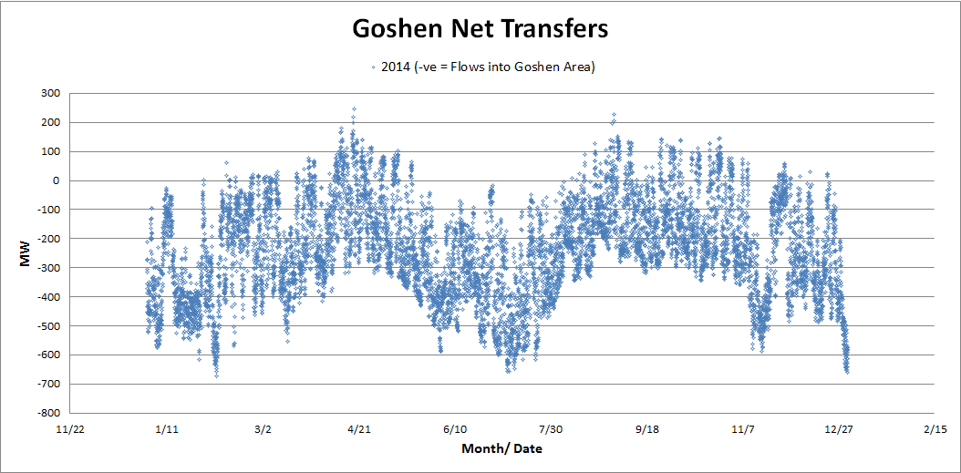
The total Goshen area load is supplied by the internal generation (Table 1) and the following tie-lines:
Main Source:
- Three Mile Knoll – Goshen 345 kV line
- Goshen – Kinport 345 kV line
Underlying Transmission Lines:
- Goshen – Grace 161 kV line
- Goshen – Blackfoot 161 kV line (owned by IPC)
- Goshen – Antelope 161 kV line
- Dillon – Big Grassy 161 kV line (This regional tie line does not directly connect to Goshen but connects to Jefferson 161 kV bus and then onto Goshen owned by IPC)

Table 1: List of Generators inside the Goshen bubble
 | Name | Type of Generation | Total capacity (MW)
1 | Palisades | Hydro | 128.7
2 | Gem State | Hydro | 25.0
3 | Idaho Falls Bulb Turbines | Hydro | 21.2
4 | Horse Butte Wind | Wind | 57.6
5 | Wolverine Creek Wind | Wind | 64.5
6 | Jolly Hills | Wind | 124.5
7 | Meadow Creek | Wind | 119.7
Total Generation |  |  | 541.2

Depending on internal generation, GNT could be either importing (load higher than internal generation) or exporting (load lower than internal generation).
Studies have shown that the first underlying transmission line that will thermally overload for the loss of the 345 kV source is dependent on Bridger West and Path C transmission path flows. The Bridger West and Path C are defined as below:
Bridger West Path:
Jim Bridger – Threemile Knoll 345 kV line (metered at Jim Bridger)
Jim Bridger – Populus # 1 & # 2 345 kV line (metered at Jim Bridger)
Path C:
Malad – American Falls 138 kV line (metered at American Falls)
Ben Lomond – Populus #1 & #2 345 kV line (metered at Populus)
Terminal – Populus 345 kV line (metered at Populus)
Treasureton – Sun Beam – Brady 230 kV line (metered at Brady)
Fish Creek – Goshen 161 kV line (metered at Goshen)
Threemile Knoll 345/138 kV transformers (metered on the 345 kV side)

If Path C flows are heavy northbound, the Grace – Goshen 161 kV line will overload before either the Don – Pingree 138 or Blackfoot 161/138 kV auto transformer. Likewise, if Path C flows are southbound, the Don-Pingree 138 kV line or the Blackfoot 161/138 kV auto transformer will overload first. Under heavy GNT imports, it is observed that both the Grace – Goshen 161 kV and the Don – Pingree 138 kV lines overload simultaneously, as both lines act as strong sources into the Goshen area.

After the December 4, 2013 event, the bus at the Goshen 345 kV switchyard was reconfigured as shown in Figure 3 to eliminate the possibility of losing both 345 kV lines out of Goshen due to a fault on one of the lines followed by a stuck breaker condition and subsequent loss of a second line. While the new Goshen 345 kV bus configuration (May 2014) alleviates the possibility of losing both 345 kV lines for an N-1 outage while a breaker is under maintenance, but there is still a potential of losing the entire 345 kV source under an N-1-1 outage condition.

Figure 3: New Goshen 345 kV bus configuration
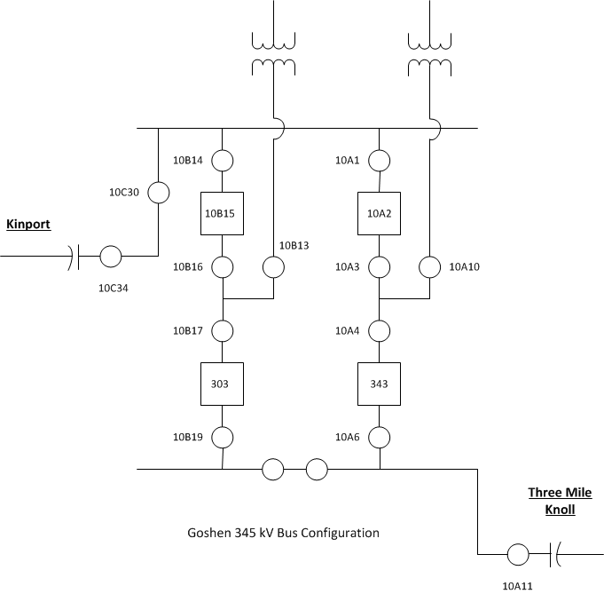

The study results demonstrate that an overload on IPC’s Don- Pingree 138 kV line or Blackfoot 161/138 kV auto transformer depend on system conditions. For example, an overload on the Blackfoot transformer is dependent on the season. For summer season, thermal overload is observed first on the Don – Pingree 138 kV line before the Blackfoot transformer, due to increased load at Pingree. In winter, the load at Pingree is very low and hence the thermal overload is observed first on the Blackfoot 161/138 kV transformer for the loss of 345 kV source into Goshen.

At present in absence of the proposed RAS, the Don – Pingree 138 kV line and the Blackfoot 161/138 kV auto transformer is protected against thermal overload using an operating procedure developed by IPC. Also thermal overloads on the remaining 161 kV lines into Goshen, the Grace – Goshen 161 kV, Antelope – Goshen 161 kV line, and Dillon – Big Grassy 161 kV line are alleviated using a 2 second tripping scheme. In this scheme, the above mentioned lines are tripped within 2 seconds of the thermal overload. The disadvantage of this existing scheme is that it results in the complete loss of the Goshen area load and transmission lines as compared to the proposed RAS which only drops a portion of the total Goshen area load to alleviate the thermal overloads and low voltage issues in the Goshen area.

Based on technical study findings it is recommended that for the permanent outage of any one 345 kV line into Goshen, the existing one second reclosing on the remaining line should be disabled. If the reclosing on the remaining 345 kV line is not disabled, outage and reclosing of that remaining line could impact the Gem State generator and the Idaho Falls bulb turbine generators exposing them to higher swings and potentially out-of-step synchronization. All other generators in the Goshen area would also be exposed to higher swings as well.

RAS Scope
The scope of the RAS scheme includes three steps:
- Identify and communicate thermal overloads on the 138 kV and 161 kV transmission lines listed in Table 2 in the event of loss of the 345 kV source to the Goshen area. Once a thermal overload is identified, communicate that information through an alarm signal to the master logic controller located at the Goshen 161 kV yard.

Table 2: 161 kV and 138 kV transmission elements monitored for thermal overload
No. | Monitored Element
1 | Grace – Fish Creek – Goshen 161 kV line
2 | Don – Pingree 138 kV line
3 | Blackfoot 161/138 kV auto transformer
4 | Antelope – Goshen 161 kV line

- The master logic controller confirms the loss of the 345 kV source by measuring flows across the two 345/161 kV transformers at Goshen.

- Once the master logic controller at Goshen receives the transfer trip signal from any one of the above mentioned transmission elements and confirms the flows across the two 345/161 kV transformers at Goshen is less than 10 MW (to prevent unnecessary trips due to noise) into Goshen 161 kV, it will trip the appropriate breakers to shed load in Goshen/ Sugarmill/ Rigby area to alleviate the overloads. This step will require tripping of breakers at Goshen, Rigby, Sugarmill & Westside (Cinder Butte).
The activation of this RAS could result in loss of the majority but not all, of the load in the Goshen area. The logic diagram for the RAS is shown in Appendix 1.

The advantages of this RAS are:

- It will not require pre-contingency load shedding for a low probability event.
- It will not result in complete loss of the Goshen area load and transmission system.
- It will keep the remainder of the transmission system inside the Goshen area intact.
The details for each of the RAS steps identified above are discussed in detail below.

General Requirements for the RAS:
- All the hardware and logic controllers that are related to this RAS scheme should be redundant such that failure of one component will not result in the RAS being non-functional.
- The design of the RAS should be such that the operator has the flexibility of turning the RAS off in an event of mis-operation, until the issue that caused the mis-operation is resolved.
- The RAS should have recording functionality such that an operator/planning engineer can check for the validity of the RAS operation.
- The RAS should have the capability of filtering random noise such that it will not result in a mis-operation due to a spike.
- The RAS should be designed such that the master controller could accommodate new inputs if the Threemile Knoll to Tincup 115 kV line is built by BPA. If built, the thermal loading on this line will be monitored and if it exceeds its emergency rating then a transfer trip signal (alarm signal) will be sent to the master controller.

Other Considered Options:
Options other than the proposed RAS that were also considered are as follows:

- Reconfiguration of the Goshen 161 kV bus was considered where all the underlying 161 kV sources and some load would be tied to the first operate bus, while the majority of the Goshen area load would be tied to the second operate bus. Both operate buses would be tied through with a bus-tie breaker. One of the 345/161 kV transformers would be connected to the first operate bus and the other one to the second operate bus. Under this option, the first N-1 would require operator intervention to open the bus tie breaker and other breakers at Goshen 345 kV substation such that when the next N-1 of the 345 kV line occurred, it would shed the load connected to the second operate bus while keeping the underlying transmission system intact. This option would also require B-stage keying at Threemile Knoll in order to ensure that the option will also work for the N-1-1 of Goshen – Kinport 345 kV line and Jim Bridger – Threemile Knoll 345 kV line. The rewiring of the bus differential relaying would be required for this option. This option is complicated and bears the risk of unwanted trips while rewiring the differential. While this feasible option was considered, due to the complexity of rewiring the bus differential relaying this option was not considered optimal.
- A new 230 kV line from Kinport to Goshen was also considered that would provide another source into the Goshen area. This option would require a new right of way and other formalities that would result in delay of several years before it could be implemented. Comparing the probability of an N-1-1 event, the economics and the time to implement this solution, the proposed RAS is a more efficient solution to the new 230 kV line.

Potential Future Expansion:
This RAS scheme could be expanded in the future to make it a smarter device that will monitor the amount of loading and will only trip the required amount of load to alleviate overloads. The scheme could also be expanded to monitor voltages in the load areas like Rigby, Sugarmill, or Goshen to determine significant under voltage conditions in the area due to the loss of 345 kV system and shed load based on low voltage conditions.

Conclusions:
Planning studies have demonstrated that under heavy GNT import conditions, the outage of the 345 kV source into Goshen due to an N-1-1 outage would result in significant overloading of the underlying 138 and 161 kV systems that serve Goshen. Under certain study scenarios, low voltages were also observed due to the loss of the 345 kV source. With the implementation of the proposed RAS, pre-contingency load shedding will be avoided. Also with the RAS, only a portion of the Goshen area load is shed as compared to loss of the entire Goshen area load for the loss of the 345 kV source in Goshen area.

Next Steps and Project Timeline
- PacifiCorp is currently in the process of designing the RAS with inputs from WECC RASRS committee.
- PacifiCorp plans to present the full design for approval by WECC RASRS in their November 2015 meeting.
- PacifiCorp is planning to have this Goshen RAS in-service by April 15, 2017.

Appendix 1: RAS Logic Diagram

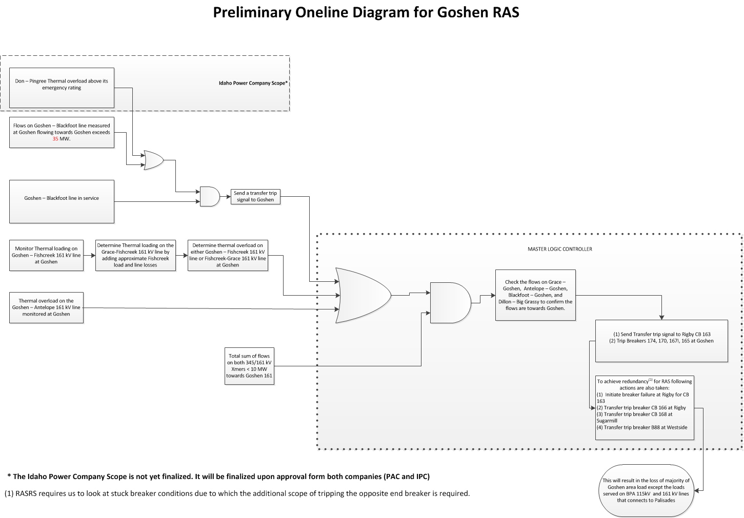

Currently IPC has developed an operating procedure that alleviates the overload on either the Don – Pingree 138 kV line or the Blackfoot 161/138 kV auto transformer by opening Breaker 101A at Blackfoot. This operating procedure will no longer be required once the proposed RAS is in service.

