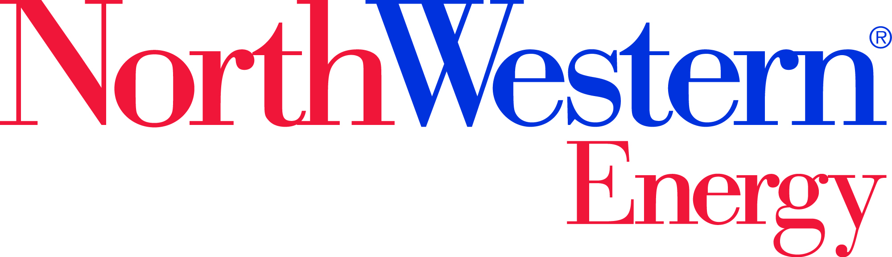

Local Area Transmission Plan 2024-2025
Stakeholder Comment Form
Open Comment period is from November 19, 2024 until December 19, 2024 (5:00 pm Mountain time)
Please submit comments to Ryan.Munson@northwestern.com
Commenter Contact Information
Date: 4/3/2024
Name: [Type text]
Organization: [Type text]
Email address: [Type text]
Phone number: [Type text]

Stakeholder Comments
Section | Page # | Paragraph/Line # | Comment
[Type text] | [Type text] | [Type text] | [Type text]
[Type text] | [Type text] | [Type text] | [Type text]
[Type text] | [Type text] | [Type text] | [Type text]
[Type text] | [Type text] | [Type text] | [Type text]

