

FERC Order 890
Strawman

May 29, 2007

Table of Contents

Introduction 3
Timeline 4
NWE Montana Electric Transmission System Description 6
NWE’s Actions To Comply With The 9 Principles 7
Principle 1 – Coordination 7
Principle 2 – Openness 9
Principle 3 – Transparency 9
Principle 4 - Information Exchange 11
Principle 5 – Comparability 12
Principle 6 - Dispute Resolution 13
Principle 7 - Regional Participation 14
Principle 8 - Economic Planning Studies 15
Principle 9 - Cost Allocation for New Projects 17
Next Steps 18
Attachments 19
Attachment 1: Principle 6 – Examples of Dispute Resolution Options 20
Attachment 2: Principal 9 – NTTG Straw Proposal Cost Allocation 25

Introduction
The Federal Energy Regulatory Commission (FERC) issued its Order No. 890 on February 16, 2007 (Order). The Order provided amendments to the regulations and the pro forma open access transmission tariff adopted in Orders 888 and 889. The Order became effective May 14, 2007, which is 60 days following the date the Order was published in the Federal Register. One objective of the Order is to limit undue discrimination in planning the transmission system by requiring coordinated, open, and transparent transmission planning on both a local and regional level by involving stakeholders in the early stages of transmission planning. FERC outlined the need for reform in transmission planning through Order No. 890 (see Table 1).
Table 1: Need for Reform
Need for Reform - FERC Order Requirement
Para 435: “…require coordinated, open, and transparent transmission planning on both a local and regional level.
Para 437: “…each public utility transmission provider is required to submit, as part of the compliance filing in this proceeding, a proposal for coordinated and regional planning process that complies with the planning principles and other requirements in the Final Rule.”
Para 438: “… do not address or dictate which investments identified in the transmission plan should be undertaken by transmission providers.”
Para 438: “… except for the discussion below of cost allocation for transmission investments under Principle 9, the planning obligations included in the Final Rule do not address whether or how investments identified in a transmission plan should be compensated.”
Para 442: “… each OATT planning process attachment must incorporate the transmission planning principles and concepts in this Final Rule and must be filed with the Commission within 210 days after the publication of the Final Rule in the Federal Register.”
Para 443: “The Commission will endeavor to hold the technical conferences 90 to 120 days after the publication of the Final Rule in the Federal Register. To facilitate these conferences, each transmission provider should, within 75 days after the publication of the Final rule in the Federal Register, post a “strawman” proposal for compliance with each of the planning principles adopted in the Final Rule, including a specification of the broader region in which it will conduct coordinated regional planning. … We strongly urge transmission providers to consult with their stakeholders in the development.
Accordingly, each public utility transmission provider is required to submit, as part of a compliance filing, a proposal for a planning process that complies with the planning principles and other requirements in the Order. The Order requires a more inclusive transmission planning process incorporating the following nine principles: (1) Coordination, (2) openness, (3) transparency, (4) information exchange, (5) comparability, (6) dispute resolution, (7) regional participation, (8) economic planning studies, and (9) cost allocation for new projects.
Pursuant to FERC’s Order requirements, NorthWestern Energy (“NWE”), with input from its stakeholders, developed this strawman. On May 3, 2007, NWE held an open stakeholder meeting in Butte, Montana. The thirty participants in the meeting reviewed, discussed and modified NWE concept paper that was posted on NWE’s OASIS on June 30. To establish this meeting, NWE notified about fifty of its stakeholders of the meeting on April 24 and simultaneously expanded its OASIS site to include a Transmission Planning area wherein an agenda and other related material were posted. The stakeholders included load serving entities, cooperatives, generators, the Montana Public Service Commission, the Montana Consumer Council, the Governor’s office, environmental and renewable groups, interconnected transmission utilities and other interested parties. NWE also received response from several stakeholders who could not participate in the meeting, but stated that they were interested in participating in the future.
During the strawman stakeholder meeting the concepts and ideas for each of the nine planning principles were discussed. A timeline that allowed for a series of drafts with comment periods was also adopted. Between the time when the strawman was posted on the OASIS and when the stakeholder meeting was held, NWE provided stakeholders with two opportunities to review and comment on NWE’s draft strawman proposal. NWE posted the drafts of NWE’s strawman on OASIS and simultaneously notified stakeholders that a new draft was available. NWE posted its final strawman on OASIS on May 29, 2007.
FERC Order 890 and other strawman related documents can be obtained on NWE’s OASIS at www.oatioasis.com/NWMT/. Clicking the Transmission Planning button that is to the left in the blue ‘Document’ area can access the information. It should be noted that all posted information relating to transmission planning and this strawman deal with NorthWestern’s Montana transmission system.

Timeline
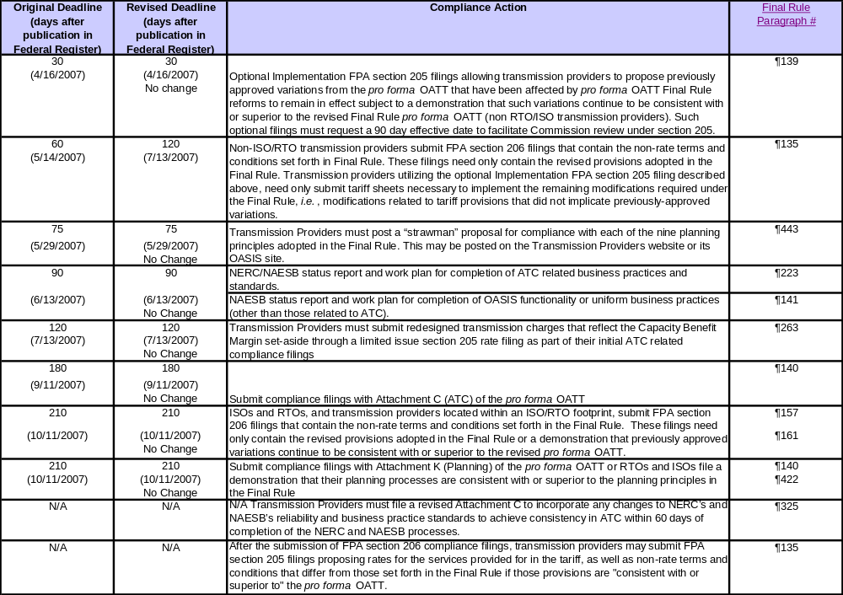
The following table displays FERC’s timeline for implementing the requirements of FERC Order 890.

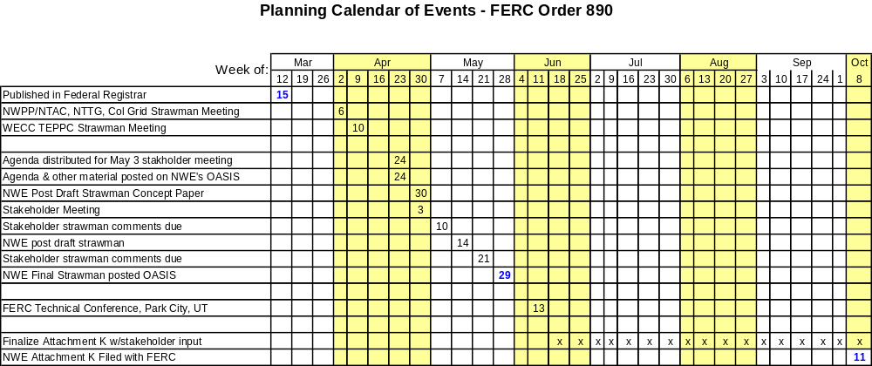
The following calendar displays the timeline that applies to NWE and its stakeholders. Dates in red are dates established by FERC Order 890.

NWE held a stakeholder meeting May 3, 2007, in Butte, MT. This stakeholder meeting was open to the public and was designed to review the nine principles and to provide opportunity for comment on NWE’s draft concept proposal to meet the requirements. From that meeting the following actions were agreed upon to meet FERC’s May 29th deadline for posting a strawman on NWE’s OASIS:
- May 10th – Stakeholders to provide comments/input to NorthWestern Energy
- May 14th - NorthWestern Energy to post next draft of strawman on OASIS
- May 21st – Stakeholders to provide comments/input to NorthWestern Energy
- May 29th - NorthWestern Energy to finalize and post strawman on OASIS
Between the time when FERC’s technical conference will be held and when NWE Attachment K will be posted, NWE will work with its stakeholders to develop the nine principles that will be included in NWE’s October 11 filing. NWE will use a series of meetings and emails to receive input from stakeholders.

NWE Montana Electric Transmission System Description
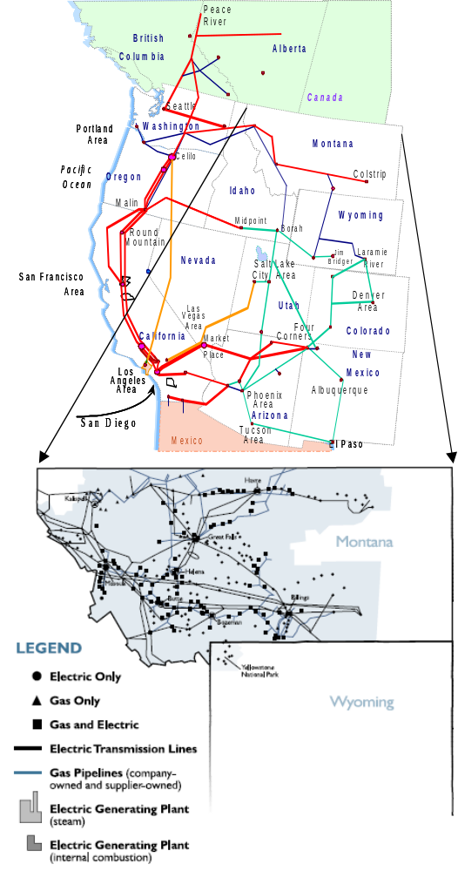
The NWE electric transmission system provides regulated electric transmission services to approximately 295,000 electric customers. NWE’s electric transmission system consists of over 7,000 miles of transmission lines and associated terminal facilities. This system, with voltage levels ranging from 50,000 to 500,000 volts, serves an area of 97,540 square miles, which is equivalent to two-thirds of Montana. The system has interconnections to five major transmission systems located in the Western Electricity Coordinating Council (WECC) area and one DC interconnection to a system that connects with the Mid-Continent Area Power Pool (MAPP) region. NWE is registered as a Balancing Authority, Planning Authority and Transmission Planner. NWE does not currently own generation.

NWE’s Actions To Comply With The 9 Principles
The following information for NWE’s strawman principles was developed in collaboration with interested stakeholders. Some of the principles are not fully developed at this time. However, this strawman provides the concept that NWE envisions at this time. Input from NWE’s stakeholders obtained through stakeholder meetings will help NWE’s define its principles before Attachment K is filed with FERC. NWE will work with its stakeholders in an open, transparent forum as described below to define these principles before the October 11, 2007 filing.

Principle 1 – Coordination
FERC Order Requirement Summary
Commission Determination is found within paragraphs 451 – 454 of the Order. The Coordination principle requires appropriate lines of communications among transmission providers, transmission-providing neighbors, State authorities, customers, and other stakeholders. Transmission providers are allowed to craft coordination requirements that work for those providers, their customers and stakeholders.
NWE’s Actions to meet requirements
NWE will have an open public process that allows and promotes customers, interconnected neighbors, regulatory and state bodies and other stakeholders to participate in a coordinated nondiscriminatory process for transmission plan development. To accomplish this coordination, NWE will have an open meeting policy and a transparent process that will afford stakeholders an opportunity to regularly meet with NWE to provide input on methodology, process and other elements used in the development of NWE’s transmission plan. The number of meetings each year, the scope of the meetings, the notice requirements, and the format are described below.
Number of Meetings: NWE will form a permanent planning committee that meets regularly in an open forum. The permanent planning committee will determine the number of meetings per year, perhaps monthly, bi-monthly, quarterly or semi-annual. NWE will also hold at least two public meetings each year to receive input on its transmission plan. The permanent planning committee may adjust the number of public meeting as needed. These meeting (i.e., coordination meetings) will be described further below.
Scope of Meetings: The permanent planning committee meeting will be open to discuss all aspects of transmission planning activities including, but not limited to methodology, study inputs and study results. The intent is to provide a forum that allows stakeholders to collaboratively develop transmission plans. Dissemination of market sensitive information or critical infrastructure information must follow FERC Standards Of Conduct (SOC) requirements and Critical Energy Infrastructure Information (CEII) requirements.
Notice: There will three forms of notice: (1) A list of participants (name, organization, phone and email) in the public meetings will be maintained and notice for each open public meeting will be provided to prior participants by email or by mail if email is not available; (2) Local media (radio, newspaper, etc) will also be used as appropriate to announce the open public meetings; (3) Notice of the open public meetings and the permanent planning committee meetings will be posted on NWE’s OASIS prior to the meeting.
Format: NWE will retain a neutral moderator to help plan and moderate the meetings. These meetings will be designed to provide opportunities for information exchange about NWE’s transmission plans, methodology and processes. NWE will present and seek input into its 15-year electric transmission plan. Notes taken at the meetings and other information from the meetings will be posted on NWE’s OASIS (www.oatioasis.com/NWMT/).
NWE’s planning process will be designed to avoid undue discrimination in planning. The process will open appropriate lines of communication between transmission providers, transmission-providing neighbors, affected state authorities, customers, and other stakeholders as described below.
It is NWE’s intent to make its stakeholder meetings open to the public, except when SOC concerns require portions of the meeting to be closed to some participants. NWE will have an open process that will allow participation by stakeholders, including, but not limited to, the Montana Public Service Commission, the Montana Consumer Council, transmission customers (network and point-to-point), generators, cooperatives, interconnecting utilities, the Governors Office, transmission-providing neighbors and other stakeholders.
NWE will have two types of coordination meetings – a permanent planning committee meeting and an open public meeting.
Permanent Planning Committee Meeting: NWE will form a permanent planning committee that will be actively engaged at the early stages of development of the transmission plan. The purpose of this committee will be to provide advice to NWE on its transmission plan and not to make decisions and develop the plan. The ultimate responsibility for the transmission plan will remain with NWE.
This planning committee will meet regularly as determined by the committee and it will develop its own form of communication. Membership will be open to anyone and will be established through self-nomination. If the membership is either too small or too large, NWE will work with the committee to determine whether adjusting the size is appropriate and, if so, what mechanism should be used to accomplish the adjustment. NWE will encourage membership from neighboring transmission providers, affected state authorities, customers and other stakeholders.
All permanent planning committee meetings will be open to the public and will allow open and transparent dialogue on all aspects of the transmission plan to the maximum extent allowed without violating Standards of Conduct (“SOC”) information and Critical Energy Infrastructure Information (“CEII”). Members on this committee will be encouraged to be involved in each meeting and to be actively engaged in the process.
Open Public Meeting: Meetings held with the public during open public meetings will allow a two-way communication on the transmission plan and will provide a forum for public input to the plan. These open public meeting will be scheduled at different geographic locations in Montana and will allow stakeholder input throughout the development of the transmission plan.
With respect to regional coordination, NWE is a member and actively engaged in the Northern Tier Transmission Group (NTTG), which is a permanent planning committee. NTTG membership includes PacifiCorp, Idaho Power, NorthWestern, Deseret Power Electric Cooperative, and Utah Association Municipal Power Systems (UAMPS). NTTG has participation of state commissions, including the Montana PSC. NTTG will coordinate its planning proposals with WECC and other sub-regional planning groups (e.g., NWPP and Columbia Grid, WestConnect, etc.). NTTG is an open stakeholder process that has had several stakeholder meetings. NTTG Strawman is posted on their website (www.nttg.biz).

Principle 2 – Openness
FERC Order Requirement Summary
Commission Determination is found within paragraph 460 of the Order. The Openness principle requires that Transmission planning meetings are open to all affected parties, including all transmission and interconnection customers, state commissions and other stakeholders. If subgroups are used, the overall transmission plan and planning process must remain open.
NWE’s Actions to meet requirements
NWE’s stakeholder meetings will be open to the public and will be designed to allow an open transparent two-way communication between NWE and its stakeholders and affected parties. These communications will allow stakeholders that choose to participate to have an opportunity to provide effective input into NWE transmission planning process. NWE will retain a coordinator for these meetings to ensure that the Openness principle is achieved. The permanent planning committee and the public meetings will be announced on NWE’s OASIS along with relevant data and information. Announcement of the open public meeting will use the OASIS posting and other appropriate communications such as email notice to prior attendees, and local media. NWE’s OASIS also includes information about contacting NWE by phone, email or through normal mail.
Protection of Critical Energy Infrastructure Information (CEII) and market sensitive information covered by FERC Standards Of Conduct (SOC) will be observed. NWE will work with the permanent planning committee to develop a confidentiality agreement for certain data and databases (e.g., WECC power flow, WECC TEPPC economic analysis data and other market sensitive data). It is recognized that certain data may not be available to certain participants, even though a confidentiality agreement is signed, because of their relationship to the market. NWE will also work with the permanent planning committee to develop password-protected access to confidential information. See Principle 4 – Information Exchange for additional information.
With respect to regional openness, NWE will coordinate and follow NTTG and WECC requirements for confidentiality.

Principle 3 – Transparency
FERC Order Requirement Summary
Commission Determination is found within paragraphs 471-479 of the Order. The Transparency principle requires disclosure of basic criteria, assumptions, methodologies and data that underlie transmission system plans. Methodologies, criteria and processes must be published and consistently applied. The Standards of Conduct (SOC) compliance to the release of certain information is critical. NWE’s Actions to meet requirements
NWE will disclose all basic criteria, assumptions and data used to develop its transmission plan. This disclosure will be communicated through written documentation that describes NWE’s basic methodology, criteria and process. In addition to the written documentation, NWE will use its planning meetings (i.e., permanent planning committee and public meetings) to communicate this information and to receive comments that may improve the methodology, criteria and process.
As a starting point for this written document, NWE will use its existing FERC Form 715 filing and its past local area planning documentation. Over the past several years, NWE has conducted local area transmission studies that encompassed many of the FERC 890 principles. These documents will be revised and expanded to provide a more robust expression of NWE’s transmission planning methodology, criteria, data and process. This information, coupled with appropriate data and software, would enable customers, stakeholders or independent third parties to replicate the results of NWE power-flow planning studies and associated economic studies. Replication of NWE’s transient stability studies will require a party to obtain NWE’s non-proprietary software that must be used with the PTI PSS/E model. As in the past, NWE transmission planning will consider non-transmission alternatives, such as demand resources, in its planning to defer or displace new transmission.
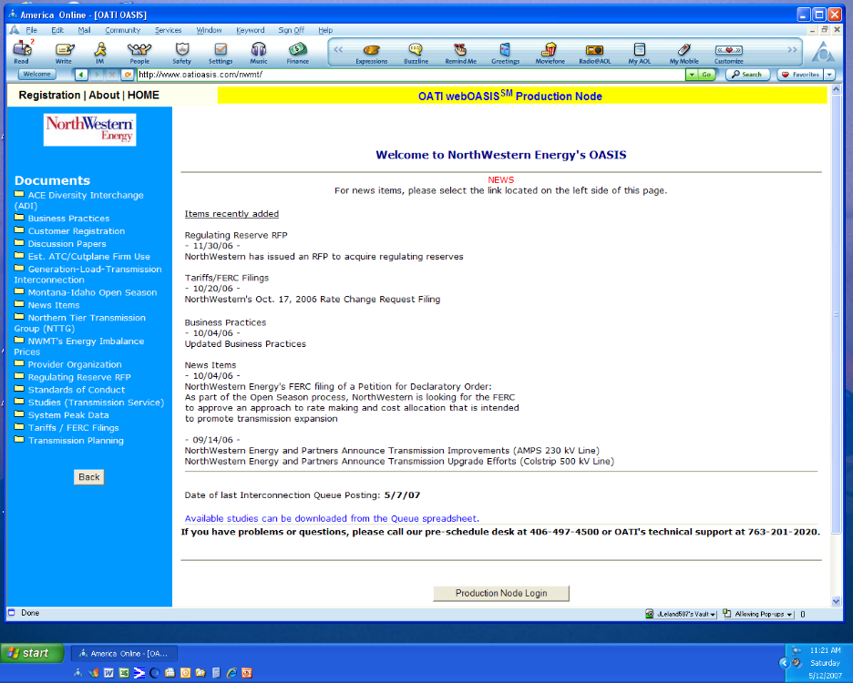
Once the analysis is complete, NWE will develop a written report for its transmission plan. This report will be a published transmission plan document or a briefing paper. It was noted in the May 3 stakeholder meeting that this report should present the results in a manner that the stakeholders will understand and not just a compilation of engineering results. With the help of the permanent planning committee, NWE will endeavor to achieve the level of clarity in its written documentation. NWE will also communicate the status of its transmission upgrades and study results through its stakeholder meetings.
NWE will use OASIS postings (see graphic to right) and the coordination meetings, described in Principle 1 above, to disseminate information to help achieve the objectives of the Transparency principle. Stakeholders will have access to information through NWE’s OASIS. The graphic shows the Transmission Planning button as the last item in the Documents list detailed in the blue area to the left. Clicking this button will expand to reveal the information that is posted for download. NWE will post non-confidential data, study results and other information in this transmission planning area of NWE’s OASIS (www.oatioasis.com/NWMT/).
Confidential data will also be posted, but access will be obtained through an additional link on the transmission planning area of NWE’s OASIS. This access link has not been developed yet. Access will be restricted to those who have received access rights and a password from NWE. As noted in Openness principle above, NWE will consult with its stakeholders and affected parties in development of the confidentiality agreement and the OASIS password-protected access to confidential information. A confidentiality agreement may be required for some data such as WECC power flow data. WECC members do not need a WECC Confidentiality Agreement. Pursuant to this principal, NWE will seek simultaneous disclosure of transmission planning information, with appropriate safeguards for confidential and CEII data to avoid inappropriate release of market sensitive information.
In the region, NWE will participate in and rely on NTTG and WECC transparency documentation for major projects that involve NWE transmission. NWE will take necessary precautions to protect CEII and SOC information using appropriate mechanisms.

Principle 4 - Information Exchange
FERC Order Requirement Summary
Commission Determination is found within paragraphs 486-488 of the Order. The Information Exchange principle requires transmission customers to submit information on projected load and resources. Network, native load and point-to-point customer’s information is to be supplied on a comparable basis. Transmission providers must develop a process, format and schedule for submittals.
NWE’s Actions to meet requirements
NWE will work with stakeholders to develop guidelines and a schedule for information submittal. These guidelines should describe how customers (i.e., point-to-point and network customers, and generators) are to provide forecast data to NWE for use in transmission planning.
In developing this guideline, NWE’s historical process to respond to regional load and resource (“L&R”) data requests will have to be modified. Historically, NWE developed its response to the annual WECC L&R Data Request using internal sources and responses received from some generators and entities serving load in NWE Balancing Authority area and coordinating transfers with interconnect utilities. In the future, NWE, generators and load serving entities are required to comply with the North American Electric Reliability Corporation (NERC) 83 reliability standards. These standards will require that historical and load forecast data for generators and load serving entities be submitted to NWE. NWE recognizes that this compliance requirement should be considered in developing these guidelines. The data received will be used to develop NWE’s transmission plan and for reporting purposes. Confidential data will be administered according to SOC and CEII requirements.
There are two timeframes to consider in developing the schedule for information submittal.
First, in the fall NWE receives a load and resource data request from WECC. NWE will suggest to the permanent planning committed, when it is formed, that the timing and format of NWE’s transmission planning data needs be coordinated with the WECC reporting requirements.
Second, NWE’s budget process for its 15-year assist plan will be finalized the first half of each year. This requires transmission planning to have its recommendations for the 15-year plan by the first quarter of the year. Planning’s analysis and recommendations should be in place by this date.
These two time frames should be considered developing the guidelines and schedule.

Principle 5 – Comparability
FERC Order Requirement Summary
Commission Determination is found within paragraphs 494-495 of the Order. The Comparability principle requires the Transmission Provider to develop a transmission plan, after considering the data and comments supplied by customers and other stakeholders, that: 1) meets the specific service requests of its transmission customers; and 2) provides comparable treatment to similarly situated customers (network and retail native load). Customer demand resources should be considered on a comparable basis to the service provided by comparable generation resources.
NWE’s Actions to meet requirements
Once NWE has received the data, the transmission plan will be developed after considering and including appropriate comments on the data, process and methodology received from stakeholders. The data will augment and replace NWE data that has historically been used to develop the load and generation data used in transmission plan.
There are two assessments in transmission planning that must integrate the Comparability principle – reliability and economic assessments.
Reliability Assessment: Comparability will be achieved in the technical engineering assessment of the data by including all data received from customers in the database that is used in the reliability assessment. NWE believes this will cause the Comparability principle to be achieved. That is, to conduct a technical reliability assessment, a base case database is developed by combining the forecast load and generation information received from the customer with NWE’s transmission line and equipment data for the desired year to be studied. The load forecast and/or generation dispatch patterns are varied independently, within appropriate ranges, to depict a specific operating condition such as the summer peak period. Varying the load and generation patterns caused the flows across the various transmission lines to also vary. NWE does not conduct studies for every possible load and resource combination for the 8760 hours of the year. Instead, only the load and resource dispatch patterns that stress the transmission system are evaluated. These base case databases that stress the transmission system are then used in a computer simulation for these critical conditions. The reliability of the transmission system can be evaluated with all transmission lines in service or with a variety of lines out of service. For each computer simulation run, the transmission system voltage, transmission line loading, reactive support and other parameters are measured and compared to specific reliability criteria. If the reliability criteria are not met, then appropriate mitigation (e.g., a new transmission line) is modeled in the base case database and the computer model simulation is run again. This process continues until the reliability criteria are met. The mitigation measures could include enhancements to the transmission system, generation development, demand resource development or other alternatives. Thus, because there is not a distinction within the base case database as to the type of customer being modeled, NWE believes that by including customer load or generation forecast information in the base case database used to develop the transmission plan, the resulting plan will meet the specific service requests of its transmission customers transmission needs and will treat similarly situated customers in a comparable manner.
Economic Assessment: The economic assessment of a transmission plan evaluates the costs to meet the demands of future customer transmission needs. Comparability will be achieved by including all customers’ data that is received into the reliability assessment that feeds the economic analysis. A plan’s economic assessment will evaluate the cost of the mitigation measures and other factors such as risk and/or environmental considerations. Classical economic measures, such as total present value (“TPV”) of construction costs and TPV of revenue requirement, risk assessment and perhaps other economic or environmental factors will be computed for the plan. Alternative plans will be developed and will be distinct from each other because they will include different mitigation options to meet NWE transmission customers’ future transmission needs. NWE will seek input from the permanent planning committee to help define the methodology and the various economic costs that should be included in the assessment.

Principle 6 - Dispute Resolution
FERC Order Requirement Summary
Commission Determination is found within paragraphs 501-503 of the Order. The Dispute Resolution principle requires an Alternate Dispute Resolution (ADR) process be available to manage disputes that arise from the planning process. ADR must address both substantive and procedural planning disputes. Three steps should be included in the ADR process: 1) Negotiation, 2) Mediation, and 3) Arbitration. Existing ADR procedures can be used if appropriate.
NWE’s Actions to meet requirements
See “Attachment 1: Principle 6 – Examples of Dispute Resolution Options” that NWE suggested to the stakeholders as possible alternatives during in the May 3 meeting. NWE and its stakeholders will fully discuss these and perhaps other alternatives before the October 11 Attachment K filing date and will resolve, if possible, to a specific ADR methodology.

Principle 7 - Regional Participation
FERC Order Requirement Summary
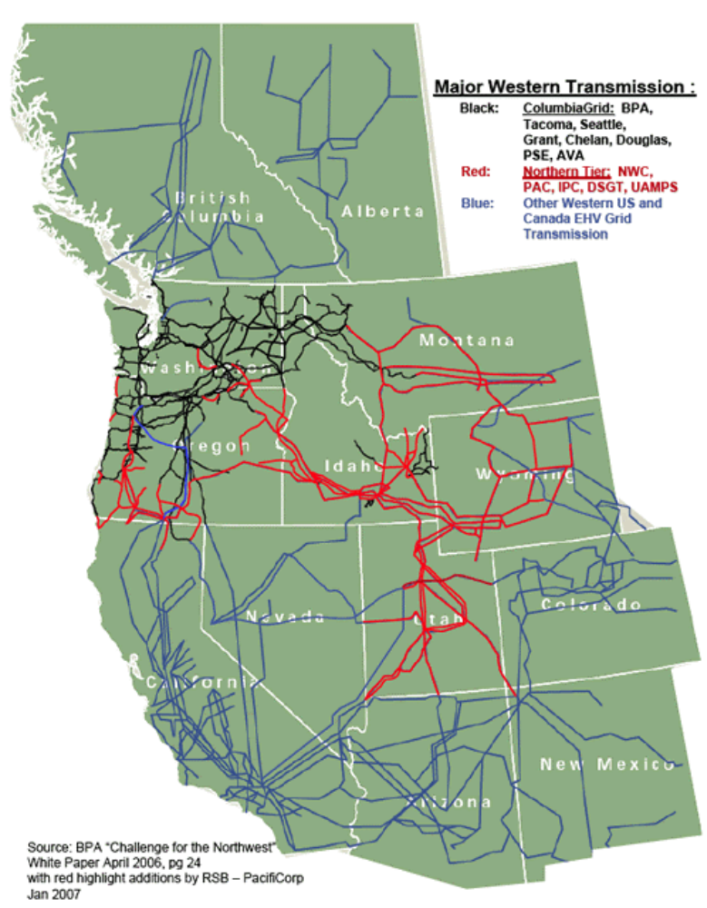
Commission Determination is found within paragraphs 523-528 of the Order. The Regional Participation principle requires Transmission Providers to coordinate with interconnected systems to: 1) share system plans to ensure they are simultaneously feasible and otherwise use consistent assumptions and data, and 2) identify system enhancements that could relieve congestion or integrate new resources. The existing regional processes may be used if they are open and inclusive, address both reliability and economic considerations, and coordinate these issues across the region. Sub-regions must have adequate scope and coordination.
Proposed Actions to meet requirements
NWE’s local transmission plan will be shared with interconnected transmission systems as NWE develops its plan. If appropriate, NWE’s base case database will be provided to the interconnect transmission system, thereby further coordinating the data and assumptions with the interconnected transmission system plan.
In the sub-regional context, NWE is an active member of the Northern Tier Transmission Group (NTTG). The red bulk transmission lines shown in the graphic depict the NTTG footprint. NWE will submit its transmission plans to the Northern Tier Transmission Group (NTTG) as required for inclusion in the NTTG sub-regional transmission plan. NWE will actively participate in the NTTG planning process to ensure data and assumptions are coordinated between NWE’s plan and the NTTG sub-regional plan. Once the sub-regional plan is coordinated with its membership’s plans, NTTG will coordinate its plan with other sub-regional entities such as NWPP NTAC and ColumbiaGrid.
In the region, NWE’s plan will coordinate through the NTTG sub-regional plan to the WECC regional plan. NTTG’s plan will be shared and coordinated with the WECC regional plan. NWE will participate in regional planning processes as appropriate to ensure data and assumptions are coordinated.
Thus, by participation in regional (WECC) and sub-regional (NTTG) planning groups, NWE will endeavor to ensure that this Regional Participation principal is met.

Principle 8 - Economic Planning Studies
FERC Order Requirement Summary
Commission Determination is found within paragraphs 542-551 of the Order. The Economic Planning Studies are studies provided to all parties with information on future transmission needs. These studies are separate from those performed for requests for transmission service and generation interconnection. This Economic Planning Studies principle requires planning to address both reliability and economic considerations. Stakeholders are given the right to request a defined number of high priority studies annually to address congestion or integration of new resources or load. The rule does not obligate Transmission Providers to fund economic projects and it does not “assign cost responsibility for those investments or otherwise determine whether they should be implemented”. The rule also requires customers, stakeholders and merchants to provide economic data.
NWE’s Actions to meet requirements
NWE will seek input from stakeholders on the economic planning study methodology through the permanent planning committee. The information presented below is a placeholder until the stakeholders have had an opportunity to consider and comment on this methodology. NWE will consult with stakeholders before its Attachment K compliance filing.
NWE does not interpret this Principle to require this economic planning study to be completed unless requested by customers, nor to obligate NWE to fund economic projects, nor to assign cost responsibility for investments nor to determine whether the investment should be implemented.
Stakeholders will have the right to request a defined number of high priority studies annually to address congestion and/or the integration of new resources or loads. NWE’s process will encompass the study of upgrades to integrate new generation resources or loads on an aggregated or regional basis. Once received, NWE will conduct the studies, including appropriate sensitivity analysis, in a manner that is open and coordinated with the affected stakeholders. An economic planning study will either be done as a local area study or as a regional study through WECC and NTTG, depending on the request. If the study request does not affect interconnected transmission systems and the remedies are confined to a local area that can be resolved within the local area (i.e., NWE’s control area), then NWE may conduct the study internally and coordinate assumptions and results with its customers, stakeholders and interconnected neighbors. However, if the study encompasses a larger area (sub-region or region) to resolve, NWE will forward the study request to NTTG (and/or WECC) for evaluation. In this instance, NWE will coordinate data and assumptions for the sub-regional or regional economic planning study. Because NWE’s control area has significantly more generation than load, it is anticipated that most economic planning studies will encompass an area that is larger than NWE’s local area.
NWE will ask the permanent planning committee to assist NWE in developing a means to allow the transmission provider and stakeholders to cluster or batch request for the local economic planning studies. Clustering or batching of requests could be accomplished by grouping similarly located customer requests in the study (e.g., on the source side of the congestion point) in the studies.
In the local economic planning studies (also called congestion studies), NWE will analyze and report on the following four elements.
Location and Magnitude of Congestion: The location of the congestion will be made known either through historical path performance or through study. To the extent hourly data is available, NWE will evaluate historical records to assess the magnitude of congestion across the congested path. Several years of data will be analyzed if it is available to make this assessment. With respect to forecast congestion that is likely to occur in the near future, once NWE’s studies identify the location of a future congested path, NWE will obtain that path’s historical hourly flows and extrapolate the flow data to the year when congestion occurs. This extrapolated data may provide an example of the congestion hourly profile. Extrapolation of the hourly data will be completed for a pre-defined assumption about the load and generation dispatch pattern.
Possible Remedies: NWE will define the transmission mitigation options that could relieve the congestion in whole or in part. NWE transmission planning will likely need to seek input from NWE’s Default Supply and/or the customers making the request to define the non-transmission mitigation measures that could relieve the congestion in whole or in part. A plan will be considered acceptable only if it meets all reliability criteria.
Associated Cost of Congestion: The economic study will be the most difficult for NWE to evaluate since NWE is a transmission company only and does not have knowledge of generation dispatch costs or step changes to forecast loads (unless the customer provides the forecast data). If NWE does not obtain this data from the customers making the request or from NWE’s Default Supply, NWE will not be able to study the cost of congestion. Also, NWE will not be able to complete this portion of the economic study internally if the study requires an economic dispatch model such as PROMOD. NWE will have to provide this study request to NTTG (or WECC) to complete the associated cost of congestion portion of the study. NWE’s Default Supply will be required to supply its data as appropriate. Confidential information and CEII data will be protected as appropriate.
Cost to Relieving Congestion: Once the mitigation measures are identified, NWE will be able to define the cost to relieve the congestion. NWE will be able to define the costs for transmission mitigation measures, but may need help from the customers making the request or NWE’s Default Supply to define the costs of the non-transmission solutions.
The study results will be measured using reliability and economic considerations and the results will be posted on NWE OASIS.

Principle 9 - Cost Allocation for New Projects
FERC Order Requirement Summary
Commission Determination is found within paragraphs 557-561 of the Order. The Cost Allocation for New Projects principle requires the planning process to address cost allocation for joint projects, economic projects, and projects that do not fit into existing OATT cost allocation principles. Examples of new projects requiring a cost allocation principle are projects involving several transmission owners or economic projects that are identified through the study process described in Principle 8 – Economic Planning Studies. The rule does not specify a particular allocation method, but the method should provide for fair allocation to beneficiaries, adequate incentives to construct transmission, and should have the support of state authorities and region-wide participants.
NWE’s Actions to meet requirements
NWE will seek input from its stakeholders, including NWE’s regulators, on this cost allocation principle. It is possible that the cost allocation principles for economic studies will be different from the cost allocation methods for projects involving multiple owners. There are various methods that could be used to allocate costs for new local area projects that do not fall under NWE’s Tariff. One methodology is the principle based on cost-causation. The costs that are allocated to customers are the costs for the system mitigation (i.e., upgrades, enhancements, etc) that eliminate the unacceptable system performance. Through this principle, the customer requests that cause the problems are the customers that benefit most through the elimination of the problem and the quantification is based on the relative contribution to the problem being eliminated. Other methods for cost allocation include an open season to determine ownership share; open season for allocation of capacity without ownership; and share prorated on MW use. All of these could be an appropriate method for a particular situation. In selecting a particular cost allocation method, NWE will use the Orders guidance that the cost allocation method should fairly assign costs, provide adequate incentive to construct new transmission, and be supported by state authorities and participants in the region.
During NWE’s stakeholder meeting, NWE received input regarding the second guidance statement that assigns a portion of the costs to “those otherwise benefiting from them”. It is clear from this input that this a sensitive issue that may not have general support of customers or state authorities. This will be a major topic of discussion within the permanent planning committee. NWE was also advised to seek input from the Montana Public Service Commission in this matter. Because of the significance of this issue, NWE is not convinced that acceptance of this portion of the principle will be achieved.
At the sub-region and region, cost allocation methods can include open season to determine ownership share and open season for allocation of capacity without ownership. NWE, with input from its stakeholders, will work with NTTG and WECC in proposing cost allocation methods. If the parties are not able to agree to an allocation methodology for interregional lines, NWE may defer to NTTG methodology. A draft of this methodology is shown in Attachment 2: Principal 9 – NTTG Straw Proposal Cost Allocation. It is also clear from the input receive at NWE stakeholder meeting that cost allocation is a sensitive issue.

Next Steps
NWE will attend FERC’s Technical Conference in Park City, Utah on June 13, 2007. At that time NWE anticipates that FERC will provide their thoughts on NWE Strawman (i.e. are the actions outlined in this strawman appropriate – do they meet the requirements – are we headed in the right direction). After receiving this input, NWE will have call for a meeting of the permanent planning committee to discuss FERC comments and start the coordinated effort to develop NWE’s Attachment K. A describe in Principle 1, membership of this committee will be through self-appointment. NWE will have regular meetings with the permanent planning committee for this effort.

Attachments

Attachment 1: Principle 6 – Examples of Dispute Resolution Options
Attachment 2: Principal 9 – NTTG Straw Proposal Cost Allocation

Attachment 1: Principle 6 – Examples of Dispute Resolution Options
DRAFT SUBJECT TO REVISION
ORDER 890 STRAWMAN DISPUTE RESOLUTION
OPTION A: Dispute Resolution
- Parties agree to use the following dispute resolution process:
Before filing complaints, directly relating to transmission planning, to the FERC against other Parties shall complete the process set forth below:
1.1.2 Step 1 – Direct negotiation between representatives who have authority to settle the controversy and who are at a higher level of management than the persons with direct responsibility for the matter.
1.1.3 Step 2 -- If Step 1 is unsuccessful at reaching a consensus agreement to resolve the dispute, the next step shall be mediation, as defined in Appendix C of the Western Electricity Coordinating Council (WECC) bylaws.
    - Step 3 – If Step 2 is unsuccessful at reaching mutual agreement among parties to the dispute, the next step shall be binding arbitration, as defined in Appendix C of the Western Electricity Coordinating Council (WECC) bylaws.
1.1.5 Step 4--All negotiations and proceedings pursuant to this process are confidential and shall be treated as compromise and settlement negotiations for purposes of applicable rules of evidence and any additional confidentiality protections provided by applicable law.
OPTION B: Dispute Resolution
1. Parties agree to use the following dispute resolution process:
1.1.1 Step 1-- When a Dispute has arisen and negotiations between the parties have reached an impasse, either party may give the other party written notice of the Dispute. In the event such notice is given, the parties shall attempt to resolve the Dispute promptly by negotiations between representatives who have authority to settle the controversy and who are at a higher level of management than the persons with direct responsibility for the matter. Within ten (10) days after delivery of the notice, the receiving party shall submit to the other a written response. Thereafter, the representatives shall confer in person or by telephone promptly to attempt to resolve the dispute. All reasonable requests for information made by one party to the other will be honored.

1.1.2. Step 2-- If the dispute has not been resolved by negotiation between the representatives within thirty (30) days of the notice, or if the parties have failed to confer within twenty (20) days after delivery of the notice, the parties shall endeavor to settle the dispute by non-binding mediation. The mediation shall consist of both parties agreeing to one neutral mediator, providing the mediator with simultaneous, non-shared written position statements, and daylong mediation at the chosen mediator’s desired location.
1.1.3. Step 3--Should the mediation not lead to settlement of the dispute, then either party may proceed to FERC or court of competent jurisdiction.
1.1.4. Step 4--All negotiations and proceedings pursuant to this process are confidential and shall be treated as compromise and settlement negotiations for purposes of applicable rules of evidence and any additional confidentiality protections provided by applicable law. The parties shall equally share all costs associated with the arbitration or mediation process described herein.

OPTION C: MODIFIED WECC Dispute Resolution Process:
- The parties agree to the following dispute resolution process:
Step 1—Mediation
Notice. To initiate the dispute resolution process, Written notice must be provided by the party seeking to initiate the process described herein to all other affected parties (“Dispute Notice”) The Dispute Notice Shall include(1) include a brief general description of the matter(s) in dispute; (ii) include a complete list of all other parties to the dispute.
Selection of Facilitator. Within 10 calendar days after the delivery of a Dispute Notice, the parties to the dispute shall select a neutral facilitator by mutual agreement. If the parties to the dispute cannot agree on a facilitator within 10 days of a Dispute the facilitator shall be selected from WECC’s standing list of qualified facilitators: The parties to the dispute shall take turns striking names from WECC’s standing list of qualified facilitators until there is only one name remaining. ( The parties to the dispute shall draw lots to determine the order in which they take turns striking names.) The last person whose name remains on the list shall serve as facilitator. No facilitator other than a facilitator chosen by agreement of all parties to the dispute may (i) have a personal or financial interest in the matter(s) in dispute (including any indirect personal or financial interest that could arise because of interests or relationships affecting any of the facilitator’s immediate family members); or (ii) be (or have an immediate family member who is) a past or present director, commissioner, officer, employee, consultant, agent or other representative of any of the parties to the dispute. If the facilitator selected through the process of striking names specified above is disqualified under the preceding sentence, the facilitator whose name was stricken last shall server in his or her place.
Mediation Process. The facilitator and representatives of all the parties to the dispute shall meet within 14 calendar days after the facilitator has been selected and attempt in good faith to negotiate a resolution to the dispute. Each Party’s representative designated to participate in the mediation process must have the authority to settle the dispute (or, at a minimum, be authorized to negotiate on behalf of the party and make recommendations with respect to settlement of the dispute if final authority to approve a settlement is reserved to a party’s board executive committee, commission, or other governing body). At the parties’ initial meeting with the facilitator, the facilitator shall, after soliciting input from the parties to the dispute, set the schedule for further meetings among the parties to the dispute (subject to the 60-day maximum mediation period specified below). The parties to the dispute shall comply with the schedule set by the facilitator and attempt in good faith at every meeting to negotiate a resolution to the dispute. To the extent permitted by law, neither the facilitator nor any party to the dispute may publicly disclose, rely on, or introduce as evidence in any subsequent arbitration, FERC proceeding, Canadian Regulatory Authority, appeal, or litigation concerning the same or any related dispute: (i) any views expressed or suggestions made by another party to the dispute with respect to a possible settlement of the dispute; (ii) admissions made by another party to the dispute in the course of the mediation proceedings; (iii) proposals made or views expressed by the facilitator; or (iv) the fact that another party to the dispute has or has not indicated willingness to accept a proposal for settlement made by the facilitator.
Referral for Resolution. With consent of all parties to the dispute, a resolution may include referring the matter to a technical body (such as a technical advisory panel of WECC) for resolution or an advisory opinion, to arbitration, directly to FERC.
Mediation Impasse. If the parties to the dispute have met and negotiated in good faith in accordance with the schedule set by the facilitator but have not succeeded in negotiating a resolution of the dispute within 60 calendar days after the first meeting with the facilitator the parties shall be deemed to be at impasse and shall also be deemed to have fulfilled their obligations under of these bylaws to fully comply with the dispute resolution provisions before pursuing any other available remedy. If any party participating in the mediation process is subject to contractual or statutory limitations period with respect to the matter in dispute, and the limitations period will expire before the 60-day period for mediation under this is completed, then the parties shall be deemed at impasse on the seventh calendar day preceding the expiration of the shortest applicable limitations period.
Elective Arbitration. Unless otherwise provided, at any time during the mediation the parties to the dispute are deemed at impasse, the dispute may be submitted to binding arbitration in accordance with the applicable terms set forth below.
Cost of Facilitator Service. Except as otherwise provided, the costs of the facilitator’s services shall be borne equally by all parties to the dispute unless the parties to the dispute agree otherwise, but the parties also intend that the costs of mediation should be taken into account in any resolution proposed through mediation process.
Binding Arbitration. Selection of Facilitator. Within 10 calendar days after the delivery of a Dispute Notice, the parties to the dispute shall select a neutral facilitator by mutual agreement. If the parties to the dispute cannot agree on a facilitator within 10 days of a Dispute the facilitator shall be selected from WECC’s standing list of qualified facilitators: The parties to the dispute shall take turns striking names from WECC’s standing list of qualified facilitators until there is only one name remaining. (The parties to the dispute shall draw lots to determine the order in which they take turns striking names.) The last person whose name remains on the list shall serve as facilitator. No facilitator other than a facilitator chosen by agreement of all parties to the dispute may (i) have a personal or financial interest in the matter(s) in dispute (including any indirect personal or financial interest that could arise because of interests or relationships affecting any of the facilitator’s immediate family members); or (ii) be (or have an immediate family member who is) a past or present director, commissioner, officer, employee, consultant, agent or other representative of any of the parties to the dispute. If the facilitator selected through the process of striking names specified above is disqualified under the preceding sentence, the facilitator whose name was stricken last shall server in his or her place.
Initial Statements. Within 10 calendar days after the selection of an arbitrator each party to the dispute shall submit a statement in writing to all other parties to the dispute and to the arbitrator. Each disputing party’s state shall set forth in reasonable detail the nature of the dispute, the issues to be arbitrated, and the party’s reasonable, good faith proposal for resolving the dispute. As provided above, to the extent permitted by law, no party to an arbitration conducted under this provision shall public ally disclose, rely on, or introduce as evidence in any arbitration, FERC proceeding, or litigation concerning the same or any related dispute any information required to be kept confidential.
Procedural Matter. The arbitrator shall determine discovery procedures, how evidence shall be taken, what written submittals may be made, and other such procedural matters, taking into account the complexity of the issues involved, the extent to which factual matters are disputes and the extent to which the credibility of witnesses is relevant to a resolution. Each party to the dispute shall produce all evidence determined by the arbitrator to be relevant and material to the issues presented. If such evidence involves proprietary or confidential information, the party submitting the evidence shall petition the arbitrator for a protective order, and to the extent the arbitrator determines there is good cause the arbitrator shall issue an appropriate protective order and all parties to the dispute shall comply with the protective order. The arbitrator may elect to resolve the arbitration matter solely on the basis of written evidence and arguments.
Out of Court Sworn Testimony. At the request of any disputing party, the arbitrator shall have the discretion to allows that party to examine witnesses through sworn out-of-court testimony (referred to in the United States as “deposition” and in Canada as “discovery”) to the extent the arbitrator deems the evidence sought to be relevant and appropriate. In general out-of court witness examinations shall be limited to a maximum of three per party and shall be limited to a maximum of three hours’ duration. The arbitrator shall have the discretion to permit the number and duration of examination sessions allowed under the is section to be increased, and to extend the 30 day time limit, upon request for good cause show. All objections are reserved for the arbitration hearing except for objections based on privilege and proprietary or confidential information.
Evidence and Rebuttal. The arbitrator shall consider all issues material to the matter in dispute. The arbitrator shall take evidence submitted by the parties to the dispute in accordance with procedures established by the arbitrator and may request additional information when the arbitrator deems material to the resolution of the dispute. With the const of all parties, the arbitrator’s request for additional information may include the opinion of any individual or organization with recognized expertise in the matters in dispute, subject to the following conditions: (i) any verbal communications with an expert consulted by the arbitrator must take place exclusively in the presence of all parties to the dispute and copies of written communications between the arbitrator and the expert must be provided to all parties(iii) any expert consulted by the arbitrator must agree to comply with any applicable restrictions on disclosure; and (iv) all parties shall be afforded a reasonable opportunity to question the expert and rebut any additional information submitted by the expert at the request of the arbitrator..
Arbitrator’s Decision. The arbitrator shall make all reasonable efforts to complete hearings (if applicable) and submissions of written evidence not more than 90 calendar days after receiving initial statements. As soon as practicable, but in no event more than 30 calendar days after the completion of the hearings and submittal of evidence, the arbitrator shall render a final decision for resolving the dispute. For good cause the Arbitrator may extend the deadlines described herein. The arbitrator’s decisions shall be based on the arbitrator’s good faith determination the resolution will: (i) be consistent with any and all applicable laws or regulations; (ii) be consistent with any valid preexisting agreements.
Cost of Arbitration. Except as otherwise provided, the costs of the facilitator’s services shall be borne equally by all parties to the dispute unless the parties to the dispute agree otherwise, but the parties also intend that the costs of mediation should be taken into account in any resolution proposed through mediation process.

Attachment 2: Principal 9 – NTTG Straw Proposal Cost Allocation
The following pdf document was downloaded from the NTTG site (www.nttg.biz)

Northern Tier Transmission Group
Cost Allocation Principles Work Group
Straw Proposal
May 29, 2007
INTRODUCTION
This paper makes a strawman proposal responsive to the Federal Energy Regulatory Commission’s Order 890 Principle 9 on transmission cost allocation principles and processes. This work is undertaken by the Cost Allocation Work Group of the Northern Tier Transmission Group (NTTG) and builds on previous work undertaken by a workgroup of the Committee on Regional Electric Power Cooperation. We encourage interested parties and stakeholders to review the document and provide comments.
An underlying premise of FERC’s Order 890 is that the lack of transmission expansion in the Western Interconnection is partly the result of project developer and investor concern over inadequate cost recovery for long term projects due to state and federal regulatory uncertainty. Order 890 stressed the need for involvement of state regulatory bodies in the process. One of NTTG’s strengths is that it draws its membership and governance from the regulatory bodies and transmission owners of its footprint states.
NTTG’s cooperative efforts attempt to remove some of that uncertainty, achieving for potential project developers and investors a degree of clarity and consistency regarding the regulatory evaluation of transmission projects -- and hence cost recovery -- especially for lines that cross multiple states. Because state regulators do not set wholesale transmission rates and most bundle transmission costs into retail electric service rates, we understand the FERC’s Order 890 directive to be one of exploring the adoption of common state or regional entity cost recovery principles and processes.
Review of the New England ISO, Midwest ISO and Southwest Power Pool (“SPP”) cost allocation rules reveals that an ISO or tight power pool institutional structure is required to directly adopt such rules. Because these structures do not currently exist throughout the west and are not expected in the near term, the workgroup agreed to review the substance of the rules but to concentrate on options that can be implemented using existing institutional structures.
On a forward- looking basis, we propose the use of a regional process to make the task of developers clearer and simpler and to ensure that information is shared among the stakeholders early in the process. We do not call on the states to revise their regulatory requirements but to help interested persons better understand the various processes and engage them more constructively. States and project developers should work together within the NTTG framework during this process.
Below we propose a group of Cost Allocation Principles (Section 1) and a Process for their application in the context of NTTG (Section 2).
SECTION 1
NTTG Cost Allocation Principles
Introduction
The workgroup has identified a number of principles that should be observed for transmission cost allocation. In doing so, we have assumed that the costs of certain projects in the West (e.g., those the SPP would classify as Requested Projects or Generation Interconnection Projects) would be largely assigned directly to the parties involved and would not generally involve allocations to other transmission owners or users. We believe that project developers should be encouraged to use open seasons or other processes to determine cost allocations without resorting to other processes. However, to the extent project developers believe such projects exhibit specific benefits for identified subscribing users and common benefits for others, then such projects, including the portion of the costs attributed by the developer to reliability benefits, would be subject to the principles and procedures identified here. We also recognized that, in some cases, the costs of such projects may be subject to interjurisdictional allocation principles developed outside of the NTTG context and discussed below.
It is important to understand the broader context within which decisions are made for selecting any given project in the West. Unlike in the SPP and MISO areas, there is no RTO or equivalent entity functioning on a West-wide basis. Thus, successful transmission planning must be conducted on a cooperative basis, and transmission investment cost recovery for specific projects will be subject to state and/or federal approval. This process is expected to continue for the foreseeable future.
In addition, utilities in the Western Interconnection are predominantly subject to integrated resource planning (IRP) or least-cost planning requirements. Wyoming, for example, does not have a mandatory IRP process, but subjects transmission investments to examination in the rate making context and is developing an IRP review process. Although purely merchant transmission development has attracted serious interest in the West, it is reasonable to expect that most major transmission investments are going to be undertaken by utilities within an IRP environment. Even utility-built transmission, however, may be built for the purpose of simply accessing wholesale markets, including markets outside of the NTTG footprint.
Where a project is essentially intrastate in character and its costs are intended to be recovered from native load customers within one state or utility system, these principles might not apply directly if a single commission or multi-state allocation procedure sufficiently oversees the inclusion of costs fairly in retail rates. However, system benefit issues may arise in which these principles and procedures would be used; and a state or states considering such a project might use the NTTG process and principles for guidance and consistency to aid in their determinations. A project developer will need to apply these principles if it seeks to justify recovery of reliability-related project costs.
Transmission Configurations and Cost Types
Our transmission scenarios describe a variety of reasonable ownership and topographical configurations in which new transmission might be built. These configurations are useful for relating aspects of project ownership to regulatory processes and jurisdiction. In terms of principles for cost allocation, however, an equally crucial characteristic is the purpose for which the transmission is built, as this provides the underlying rationale for the allocation of its costs. That is, is the transmission line to be built for the provision of retail service to the transmission owner’s native load, or for generic wholesale market access?
The following classification scheme is built around the costs related to the end-use characteristics of the transmission line. Because transmission lines might be built and owned by multiple parties, each of whom may have different uses in mind, any given transmission line could, in fact, include multiple types of costs. For purposes of developing the Draft Cost Allocation Principles, the types of transmission line costs are:
Type 1 transmission line costs are those related to the provision of retail service to the transmission owner’s native retail load, including the following sub-types:
- • Type 1-A: costs incurred by a single load serving entity for its native load within a single state.
- • Type 1-B: costs incurred by a single load serving entity for its native load in more than one state.
- • Type 1-C: costs incurred by more than one load serving entity for native load within one state.
- • Type 1-D: costs incurred by more than one load serving entity for native load in more than one state.
- • Type 1-E: costs incurred to provide service for, to lower the costs of, or to increase the quality of service for a specific retail customer or specifically identifiable group of retail customers. While there may be some “generic” benefit to other retail customers, those benefits would be incidental to the primary purpose of the line.

Type 1 costs might be incurred to:
- a. Provide capacity needed to serve load; or,
- b. Fulfill reliability or other technical operating requirements, the benefits of which generally inure to the consuming public; or,
- c. Lower costs for the general consuming public (e.g. congestion relief that provides access to cheaper, remote generation); or,
d. Fulfill requirements related to state or federal environmental or other policies.¹
Type 2 transmission line costs are those related to the sale or purchase of power at wholesale not directly for the benefit of native load, or on behalf of or at the request of a wholesale generator or a wholesale transmission customer. Type 2 transmission line costs will typically be FERC-jurisdictional and not subject to state review. However, to the extent that the physical transmission line associated with these costs might also have Type 1 characteristics, a state or states may allocate costs to retail rate payers, and project developers should therefore be prepared to bring the project before the NTTG. State regulators have three ways to include transmission costs in retail rates (bundled, functionally unbundled, functionally and service (retail versus wholesale) unbundled). Depending on the method used, either the utility shareholders or the utility customers bear the risk of differences in FERC and state cost recovery decisions. Our NTTG Principles are designed to minimize the possibility of incomplete allocation of appropriate project costs while not imposing unwarranted costs on retail ratepayers.
Type 3 costs are those incurred specifically as alternatives to (or deferrals of) transmission line costs (typically Type 1 projects), such as the installation of distributed resources (including distributed generation, load management and energy efficiency). Type 3 costs do not include demand-side projects which do not have the effect of deferring or displacing Type 1 costs.
For purposes of these Cost Allocation Principles, it is critical to keep in mind the distinction between transmission projects and transmission cost types. Any given transmission project may have multiple transmission cost types. For example, a transmission line may be jointly owned by owners who utilize the line for different purposes (one owner may utilize the line for native load, while another utilizes the line for access to wholesale markets); and even for a single owner, the line may serve multiple purposes (part native load and part direct off-system sales or out of region export sales to another transmission user). These principles are built around the characteristics of the associated costs. Therefore, transmission project developers, working with the NTTG Planning Committee, are obligated to develop the allocation of costs for projects using the cost types identified above and the Principles described below.
A Note on Project Size
For purposes of this draft, we have chosen not to specify a de minimis threshold beneath which, in either cost or size, these principles and processes would not apply. If such a threshold is identified, it should be developed later based on actual NTTG experience.
¹ This Cost Allocation Proposal does not specifically address either generation interconnection or renewable and other generation in remote locations because they are addressed by the Transmission Provider’s OATT and other federal and state laws and policies. However, NTTG will integrate regional planning and IRP processes to ascertain if renewable and other generation projects can be aggregated and located more efficiently, than if considered individually, along transmission corridors.
NTTG Principles
Below are the NTTG Cost Allocation Principles. A discussion of each individual principle follows.
Principle 1. As a matter of equity, cost allocations will reflect the classic principles that ‘cost causers should be cost bearers’ and that ‘beneficiaries should pay’ in amounts that are reflective of the benefits received.
Principle 2. Projects brought forward for consideration will be shown not to be in conflict with state and federal IRP, Competitive Bidding, RPS (Renewable Portfolio Standard), siting, certification and other policy and planning requirements affecting transmission development, to the extent they are applicable to the project. Selecting an efficient portfolio of remote generation, in-state generation and demand-side solutions requires that the proposed allocation of transmission project costs be known with clarity. Therefore, the NTTG process will encourage efficient and stable resource planning processes by which the project developer identifies the extent of cost allocation consensus for a proposed transmission project as soon as practical in the project life cycle, allowing the states to evaluate the proposed project for compliance purposes and to understand costs relative to other resource options. Regional and subregional planning resources should be utilized and the results demonstrated.
Principle 3. Cost allocations will result in a reasonable opportunity for the transmission owner(s) to achieve full recovery of the costs of the project, but no more.
Principle 3a. Transmission project costs should be directly assigned to a single transmission customer or allocated to multiple transmission customers or areas (or the entire region) based upon the distribution of benefits.
Principle 3b. Upgrades and other projects proposed on the basis of economic or other benefits for specific transmission customers will be accommodated if [i] the customers and/or transmission owner accept responsibility for the associated costs; [ii] the project does no harm to the network; and [iii] the project otherwise has no adverse impact on regional transmission service.
Principle 4. For Type 2 project costs, the rest of the network and its customers will be held harmless and the transmission owner should look to its transmission customers for direct recovery of costs.
Principle 1
Principle Type: Equity
Applies to all Transmission Cost Types
“As a matter of equity, cost allocations will reflect the classic principles that ‘cost causers should be cost bearers’ and that ‘beneficiaries should pay’ in amounts that are reflective of the benefits received.”
“As a matter of equity, cost allocations will reflect the classic principles that ‘cost causers should be cost bearers’ and that ‘beneficiaries should pay’ in amounts that are reflective of the benefits received.”
Discussion:
This principle is consistent with traditional utility cost recovery principles historically applied by utility commissions. However, the “cost causer” and “beneficiary” concepts are not necessarily identical. That is, there may be situations where the project construction or the problem being solved is “caused” by one party, but where the solution being applied also provides benefits to others or increases costs to others. As such, application of this principle necessarily implies a balancing of these interests.² This principle presumes that the term “benefit” includes transmission service allocation (meaning transmission rights, whether physical or financial) and that allocation of service rights is consistent with cost allocation. Further, given the characteristics of the Western Interconnection and the development of electricity markets to date, the party funding a project should retain its rights as market structure, e.g., formation of an ISO, evolves.
Implementation Requirements:
This principle states the conceptual basis for cost allocations. No institutional changes are necessary to implement this principle, other than an affirmation by each state in the NTTG footprint that it intends to recognize this principle in the consideration of transmission project costs. In this regard, such recognition might be included in an informal memorandum of understanding among NTTG’s participating states.
Principle 2
Principle Type: Efficiency
Applies to all Transmission Cost Types

“Projects brought forward for consideration will be shown not to be in conflict with state and federal IRP, Competitive Bidding, RPS (Renewable Portfolio Standard), siting, certification and other policy and planning requirements affecting transmission development, to the extent they are applicable to the project. Selecting an efficient portfolio of remote generation, in-state generation and demand-side solutions requires that the proposed allocation of transmission project costs be known with clarity. Therefore, the NTTG process will encourage efficient and stable resource planning processes by which the project developer identifies the extent of cost allocation consensus for a proposed transmission project as soon as practical in the project life cycle, allowing the states to evaluate the proposed project for compliance purposes and to
² For example, in the SPP, for “Base Funded” projects, this is addressed through the use of an arbitrary allocation of costs. One third of the cost is allocated on a region-wide basis and the balance is allocated to the identified zone or zones that benefit from the project, using an “incremental MW mile” approach.
understand costs relative to other resource options. Regional and subregional planning resources should be utilized and the results demonstrated.”

Discussion:
Transmission projects should support applicable state and federal resource choice policies and regulatory requirements and should result in efficient transmission development. Project developers should demonstrate how the project achieves these requirements and what the costs are, in real terms and relative to other resource choices. In reviewing project costs, the developer will show that non-transmission alternatives (e.g., demand side management, distributed resources and energy efficiency programs) have been fairly considered. Project developers should demonstrate how their proposals have been identified and assessed by WECC and by any other entities (e.g., groups planning interregional transmission projects such as the Trans West Express or the Frontier Line) which may be involved.
Implementation Requirements:
Transmission projects are currently identified or proposed through a variety of channels and by a variety of entities. To understand the consensus (or other) cost allocation scheme for a project, NTTG must be able to examine the extent to which projects have completed the various planning and other activities that must be addressed before construction can begin. Once projects are proposed, they must obtain all required federal, state and local approvals, including those concerning IRP, competitive bidding, RPS, certification, siting, etc. This policy ensures that certifications and permitting, to the extent possible, have been obtained, and that alternatives at the regional or sub-regional level been identified and considered.
Currently IRP and least cost analyses are typically done on a state-by-state or single utility system basis. NTTG will encourage utilities and other transmission developers to conduct such reviews and planning on a cooperative regional and sub-regional basis. In this regard, NTTG can assist in the development of a framework for such a more broadly integrated planning process. An informal memorandum of understanding among state commissions may be helpful in this regard.
An IRP review in one state or a single utility system would not typically consider the cost savings associated with demand-side alternatives in another state or utility system. Fulfillment of Principle 2 will enhance the implementation of a broader regional or sub-regional IRP review of all proposed transmission projects and alternatives. Principle 2 encourages cooperative engagement early in a specific project’s life cycle.
Principle 3
Principle Type: Fair and Full Cost Allocation
Applies to all Transmission Cost Types
“Cost allocations will result in a reasonable opportunity for the transmission owner(s) to achieve full recovery of the costs of the project, but no more.”

Discussion:
Order 890 recognizes this critical principle. Needed transmission projects will not be undertaken if there is no reasonable assurance that the project developers can obtain an appropriate recovery of costs. Type 1 or Type 3 project costs should all be fully recoverable from the appropriate ratepayers; and all of the costs of multi-state projects of Types 1-B and 1-D should be allocated to one or more utility systems for recovery. For a Type 2 project related solely to wholesale generation or transmission, this may not require action by NTTG because (except for any system reliability case that might be made) there should be no expectation of recovery from ratepayers. In any situation, there should be no over- or under-allocation of these costs.
Historically, utilities have largely recovered multi-jurisdictional costs through allocation mechanisms that were, for the most part, sufficiently consistent to allow recovery of all costs. This has become less consistent as state policies and requirements bearing on electric utility infrastructure construction have diverged over time. While there are legal standards that support full cost recovery at the federal and individual state levels, there have never been formalized rules to assure this result. State and federal standards that provide for a reasonable opportunity to earn a return on the investment, and prohibit confiscatory rates to the utility or excessive rates to customers, demonstrate the careful balance that must be achieved in setting rates.
Implementation:
Because this principle is a key element of the NTTG’s cost allocation principles and is important to the encouragement of needed transmission projects, states should endeavor to implement this principle going forward. While full allocation of costs to ratepayers is not prudent in certain circumstances (e.g., a purely merchant export line without identifiable system reliability benefits), the cost responsibility for each project going through the NTTG process must be fairly assessed. An informal memorandum of understanding among state commissions may be helpful in this regard.
We note that this principle is not intended to cause an automatic reallocation of project costs among developers in the event that one participating developer does not obtain full cost recovery from the relevant regulatory bodies. Any increase in the cost responsibility would have to be provided for contractually among the developers themselves.
Principle 3a
Principle Type: Cost Assignment Should Follow Benefits
Applies to all Transmission Cost Types
“Transmission project costs should be directly assigned to a single transmission customer or allocated to multiple transmission customers or areas (or the entire region) based upon the distribution of benefits.”

Discussion:
To the greatest extent possible, transmission costs should be allocated to the customers or regions that receive the benefits of the project. This elaborates on the “beneficiaries should pay” aspect of Principle 1.
To provide reasonable assurance of cost recovery to project owners and to avoid post-construction cost allocation controversy, the project owner must identify its expectations for the allocation of costs early on in the NTTG review process and always prior to construction. While it is unlikely that any state would endorse “pre-approval” of cost recovery, especially in the regional or sub-regional context, it is important for the project owner to engage the states and NTTG early in the process so the expectations of the project owners and others will be clearly identified and understood during preconstruction review.
Implementation:
No formal action is required with respect to this principle. However, an informal memorandum of understanding among state commissions participating in NTTG, recognizing this principle, may be helpful.
Principle 3b
Principle Type: Customer Specific Allocation
Applies to all Transmission Cost Types (most specifically Type 1-E)

“Upgrades and other projects proposed on the basis of economic or other benefits for specific transmission customers will be accommodated if [i] the customers and/or transmission owner accept responsibility for the associated costs; [ii] the project does no harm to the network; and [iii] the project otherwise has no adverse impact on regional transmission service.”
Discussion:
Where transmission customers require specific projects that are not otherwise identified as having Type 1-E cost aspects, cost recovery should be limited to the affected customer or customers. Incidental benefits to other customers could be considered.
Implementation:
No formal action is required for implementation of this principle, but an informal memorandum of understanding among state commissions recognizing this principle may be helpful.
Principle 4
Principle Type: Allocation for wholesale and merchant project costs
Applies to Transmission Cost Type: Type 2

“For Type 2 project costs, the rest of the network and its customers will be held harmless and the transmission owner should look to its transmission customers for direct recovery of costs.”
Discussion:
These projects fall mostly outside the scope of regional or sub-regional cost allocation mechanisms, and the merchant transmission owner should look to its customers for recovery of costs. As a general rule, it is expected that Type 2 costs will be subject to FERC jurisdiction. NTTG may apply its knowledge of sub-regional facts and circumstances to assist state and federal regulatory bodies in resolving conflicts in defining and adjudicating “harm” and ancillary benefits. Project developers may bring forward assertions of reliability benefits.
Implementation:
Merchant transmission projects will connect to the grid and should therefore be reviewed for their impact on the stability, reliability and capability of the Western Interconnection, including any costs they might impose or advantages they might create for other users of the system. NTTG will work closely with WECC and the project developers to assess the project’s impact early in the development of the project.
SECTION 2
Proposed NTTG Cost Allocation Process
Introduction
FERC’s Order 890 stresses the need for constructive participation in transmission decisions by state regulators. If this involvement can be accomplished through the vehicle of regional organizations, the overall process can be made more efficient, certain and useful to the states and to project developers. Such a regional process would draw on the combined strengths and resources of states in their knowledge of local and regional considerations and give stakeholders -- customers, environmental interests, utilities, the financial community, and others -- a way to become engaged in a more local and less expensive process designed to decide transmission cost recovery issues.
The process must be open and transparent. It must apply principles and processes agreed to in advance of the discussion of a particular case because it is not the intent of the NTTG to create a standardless review process. NTTG’s involvement should begin early in the life of a project to allow for timely decisions by developers and others. This requires regulatory involvement in the planning stage -- well before the project is fully built and functioning; and it
does not replace the jurisdiction of individual state regulatory commissions. A properly open and agreed upon NTTG process is intended to deflect any allegations of prejudgment or impermissible ex parte communication.
Note regarding Steering Committee involvement
The Steering Committee will designate the NTTG Cost Allocation Committee to perform the allocation review during the NTTG Planning Process and to make recommendations for incorporation into the annual and biennial plans submitted to the Steering Committee for approval. The Cost Allocation Committee will consist of representatives appointed by the state regulatory and consumer agency NTTG members and by the publicly-owned and consumer-owned NTTG members. The Cost Allocation Committee will work with the NTTG Planning Committee through all the steps in the NTTG Planning Process and will solicit input from NTTG members and other stakeholders through an open public process. However, the Steering Committee will make final determinations and resolve disputes on cost allocations as a part of its decision on the annual and biennial plans submitted by the Planning Committee. The intent is that this process will, in any case, be consistent with the recommendations of Order 890 and involve the regulatory commission members of NTTG.
A Proposed Cost Allocation Process
The NTTG Cost Allocation Committee will apply the Cost Allocation Principles to the plans produced by the NTTG Planning Committee at two junctures. 1) During the study plan development and study phases, the Cost Allocation Committee will provide preliminary and iterative analysis of cost/benefit allocations. 2) The Cost Allocation Committee will prepare recommendations on cost/benefit allocations to be submitted as part of the annual and biennial Plan Reports to the Steering Committee.
In order for the NTTG Cost Allocation Committee to perform its review of projects in the NTTG Planning Process, project developers, requestors, and/or other interested stakeholders bear sole responsibility for providing sufficiently detailed data, analyses, and/or studies for all proposed projects on the benefits, costs, cost types (as defined in this paper), cost principles (as defined in this paper), and proposed benefit and cost allocations. The Cost Allocation Committee will make the determination of whether it has sufficient information to proceed with its review.
1. When a project proposal is submitted for inclusion in the NTTG Planning Process, the project developers or other stakeholders, in collaboration with the NTTG Planning Committee, will also prepare an application package and transmit it to the NTTG Cost Allocation Committee for its review. Upon the developer’s request, the NTTG Planning Committee may provide its assistance. The project developers shall provide the following information with the application:
a. Project description
b. Physical location
c. Cost/benefit analysis
d. Investors
e. Operator
f. Subscribers/Contracts
g. Pertinent transmission study results
h. A copy of the WECC Phase 2 reliability determinations relative to the project
i. Proposed siting process
j. Proposed cost allocation
k. Proposed cost recovery
l. A risk and benefit analysis of impacts to native utility loads affected by the proposed cost allocation
m. Proposal on dealing with cost overruns
n. Degree of consensus among stakeholders on all of the above
o. How each NTTG cost allocation principle was applied in the analysis
p. A description of any regulatory rulings needed prior to examination of the project
q. Any NTTG Planning Committee analysis pertinent to the project and a description of how it fits into the NTTG Annual or Biennial Plan
r. Description of any proprietary or commercially sensitive information applicants believe should remain confidential during the review process
In order to facilitate the work of the Cost Allocation Committee, this information must be updated as more information becomes available during the course of the NTTG Planning Process.
Note on claims of reliability and other benefits to non-participants
NTTG encourages project developers to provide for the allocation of the costs of their projects through an open season or other similar process. However, any project developer asserting the existence of benefits by which they seek to justify allocation of costs to parties other than direct participants must make a convincing demonstration that the amount and likelihood of such benefits merit the implicit risk sought to be placed on such parties. For example, benefit estimates derived from modeling the electrical system depend on assumptions about system conditions, loads, load shapes, and the future development and use of the transmission system. Any presentation must therefore carefully explain such estimates and provide reasonable sensitivities to aid in the demonstration.
NTTG notes that estimates of benefits will normally involve assumptions, projections and modeling of future conditions and, hence, will involve a large degree of uncertainty. Investments based on uncertain projections of benefits are inherently risky and must involve judgments and comparisons of the amount of risk relative to the expected benefits and the degree of certainty attached to them. NTTG stresses that such judgments and comparisons are not technical exercises and are not appropriately made by the Cost Allocation Committee. Rather, they are most appropriately made by the parties who will receive the projected benefits and who will be asked to share responsibility to pay the allocated costs. Accordingly, the Cost Allocation Committee will look most favorably on proposals for cost allocation that are voluntarily agreed to by the participants. By contrast, the Committee will have substantial difficulties with proposals where projected benefits appear to be driven by a desire by the project developers to shift costs and risks to others.
The Cost Allocation Committee notes that reaching agreement on an appropriate cost allocation that satisfies the criteria of the participants for an adequate relationship between risks and benefits will not be simply a process of technical analysis but will likely also involve a large degree of negotiation and persuasion. Evidence of this process will be helpful to the Cost Allocation Committee in reaching recommendations to the Steering Committee and to the Steering Committee, in turn, in making recommendations to state and federal regulators.
2. The Cost Allocation Committee takes the following actions within 45 days of receipt of an application:
a. A general determination of the completeness of the application and its readiness for consideration. (If it is incomplete, the Cost Allocation Committee will inform the developer about the necessary additional information.)
b. Deciding what, if any, information is to be kept confidential during the review process (with an emphasis on the greatest possible degree of openness and transparency in order to encourage public discussion and input during the NTTG Planning Process).
c. A determination whether the application has fairly observed the NTTG’s cost allocation principles.
d. The Cost Allocation Committee will provide all applications to the NTTG Steering Committee.
3. The Cost Allocation Committee provides cost/benefit allocation analysis for all projects under consideration in the Study Plan Development and Studies phases of the NTTG Planning Process. This analysis will include a review of adherence to the Cost Allocation Principles enumerated herein. The analysis will be updated and presented publicly in synchronization with the NTTG Planning Committee’s timeline for the Planning Process. The Cost Allocation Committee will take information and views orally or in writing from any person involved in a proposed project or the preparation of the application as well as from interested regulators, consumers and other interested persons.
4. Based on its analytical work, application of the Cost Allocation Principles, and input from the public processes described above, the Cost Allocation Committee provides recommendations on cost/benefit allocations for inclusion in the NTTG Plan Reports submitted to the Steering Committee for approval.
5. If it is satisfied with the recommendations of the Cost Allocation Committee contained in the submitted Plan Report, the Steering Committee will issue a determination letter on the project(s) to each affected authority having jurisdiction over siting and cost recovery of the project(s) describing the extent to which the project complies with NTTG cost allocation principles. The Steering Committee may, in the alternative, decline to issue a determination and

send the project back to the Cost Allocation Committee for modification or clarification. The determination letter will discuss the extent to which the project developers have provided adequately for project cost recovery, including any evidence produced to support allocation of any portion of the costs on the basis of reliability enhancement. In its review, the Steering Committee will ensure that all of the NTTG cost allocation principles have been observed and fairly applied. Further procedural rules for the conduct of the review will be added later as experience dictates.

6. The project developers will provide updates on any or all of the application items listed above as the project progresses through construction. The Steering Committee will determine whether any changes are significant enough to trigger additional review of the project. (Significant changes might include, for example, a 15% increase in project costs, a 10% increase in the length of the line, and major unforeseen changes in the routing of the line or its capacity; but it is the workgroup’s intent not to specify any bright line tests, relying instead on NTTG’s experience as to whether any such thresholds are useful.)

7. The Steering Committee will, if possible, resolve disputes concerning cost allocations using the NTTG dispute resolution process. If the dispute persists, the matter will be referred to the WECC for resolution under its established processes.
NOTE:
NTTG-state regulatory agencies must avoid ex parte problems and the appearance of prejudgment. Among the tools available are:
- • Making the entire process open and noticed to the level required by each participating state.
- • Ensuring the Steering Committee’s determination letter is not framed as a decision binding on the individual states and states clearly that each retains its decision-making prerogatives.

Idaho Power Company, Avista Corporation, Bonneville Power Administration, WAPA and PacifiCorp.
Approved June 4, 2007.
Reliability includes adequacy and security considerations. Adequacy evaluates whether or not there is sufficient transmission capacity to serve the load without violating criteria. Security evaluates whether or not the transmission system response will meet appropriate criteria (voltage, thermal, frequency, reactive margin, etc.) after a transmission element(s) become unavailable for service (e.g., a forced outage of a transmission line).
Federal Energy Regulatory Commission, NERC, WECC or NWE reliability criteria.

