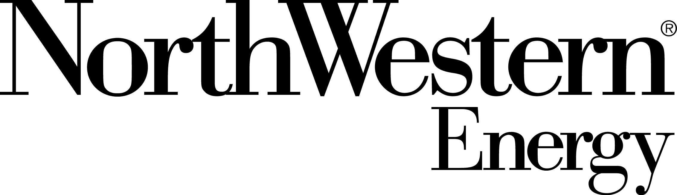

2014 Local Economic Congestion Study
Submittal Reminder

To: All Interested Parties

Date: December 13, 2013

Re: 2014 Economic Study Cycle

The purpose of this notice is to outline the study request window for submittal of Local Economic Congestion Study Requests for 2014.

The Local level submittal window is January 1st through February 28, 2014

NorthWestern Energy has an Economic Study Request Form posted on it’s OASIS as follows:

Shortcut to: http://www.oasis.oati.com/NWMT/NWMTdocs/Economic_Study_Request_Form.xls

If you have a Regional level or Interconnetion-Wide level Economic Study Request, please submit those requests to NTTG or WECC respectively. Please check the NTTG and WECC websites for appropriate forms and submittal deadlines.

Please submit your Local Economic Study Requests directly to:

Kathy Bauer, Analyst
Regional Transmission Planning
NorthWestern Energy
40 East Broadway
Butte, MT 59701
(406) 497-3576
Kathleen.bauer@northwestern.com

Thank you.

