

Comment by Chelsea Loomis, NWE p.21
Business Practice

ETP Methodology, Criteria and Process

FERC Order 890
Transparency Principle

If there is any difference between this Business Practice and the Tariff, the Tariff is correct.

Effective Date: October 25, 2013
From: October 18, 2013
To: ___Update for Comment: July 17, 2014________________

Table of Contents

Introduction 3
NWE Local Transmission System 5
Basic Methodology 7
NWE Local Transmission Planning Methodology 8
Goal and Scenario Definition 9
Technical Study 10
Decision 14
Reporting 15
Load Forecast Methodology 15
WECC Annual Study Program 16
Economic Congestion Study 17
Criteria 18
Reliability Criteria 18
NWE Internal Reliability Criteria 18
FERC Standard Requirements and WECC Reliability Criteria 26
Process Detail 27
NWE Local Transmission Planning Process 27
Timeline 28
Goal and Scenario Definition 28
Technical Study 29
Decision 29
Reporting 30
Regional Participation 30

Introduction
NorthWestern Energy (“NWE”) methodology, process and criteria described herein are used to evaluate the transmission system, ensuring that system reliability is maintained into the future. Reliability, by definition, examines the adequacy and security of the electric transmission system. One of NWE’s Electric Transmission Planning (ETP) goals is to identify the best solution to resolve a transmission reliability concern.

FERC Order 890 Principle 3, Transparency, includes the following requirement.

“In addition, transmission providers will be required to reduce to writing and make available the basic methodology, criteria, and processes they use to develop their transmission plan, including how they treat retail native loads, in order to ensure that standards are consistently applied.” Paragraph 471

The above requirement calls for information as to “how they treat retail native loads, in order to ensure that standards are consistently applied.” Consistent application of the methodology, criteria, and process for all balancing area customers (i.e., retail, network and point-to-point) information is ensured through the openness and transparency of NWE’s process. All customers are treated on an equal and comparable basis using the transmission system planning process, methodology and criteria described herein. All customer data are included in the planning analysis without regard to their classification. NWE’s transmission system planning process is designed to be transparent, open and understandable. The information described herein reflects existing practice.

FERC Order 890 makes a distinction between (1) local transmission planning for native load service, (2) planning for new proposed generation interconnection, and (3) planning for economic projects (or economic congestion studies) that fall outside the OATT. NWE adheres to the FERC Large Generation Interconnection Procedures (“LGIP”) and Small Generation Interconnection Procedures (“SGIP”) requirements to study generation interconnection. In studying a request for transmission service, NWE follows its tariff requirements as provided on NWE’s OATT, which is described in NWE’s “Transmission Service Study Procedures Manual” that is posted on NWE’s OASIS Website at http://www.oatioasis.com/NWMT/NWMTdocs/NWMT_Transmission_Service_Study_Procedures_Manual.pdf. NWE’s study methods requirements for large new transmission-connected load can also be found on NWE’s OASIS website http://www.oatioasis.com/NWMT/NWMTdocs/LoadInterconnectionProcedures.doc. Projects that are outside the OATT are evaluated pursuant to NWE’s Attachment K requirement. The URL address to this document is identified in http://www.oatioasis.com/NWMT/NWMTdocs/Attachment_K_Business_Practice_Links.doc.

In 2011, FERC issued Order 1000 amending their Order 890 regional planning requirements requiring each transmission provider participate in a regional transmission planning process that produces a Regional Transmission Plan by complying with Order No. 890 transmission planning principles of coordination, openness, transparency, information exchange, comparability, dispute resolution and economic planning. This Order also requires each public utility transmission provider to consider transmission needs driven by public policy requirements established by state or federal laws or regulations in its local and regional transmission planning processes and evaluate potential solutions to meet those needs. The order does not prohibit including additional public policy requirements that go beyond state or federal laws or regulations. FERC declined to specify which public policy requirements must be considered or included in the plan. The planning process must provide stakeholders with an opportunity to provide input on needs driven by public policy requirements.

NWE Local Transmission System
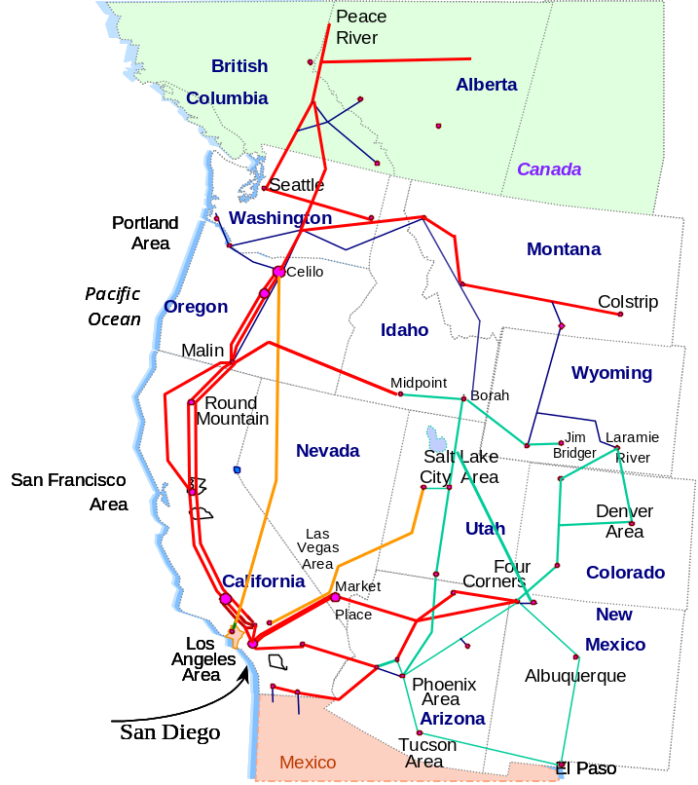
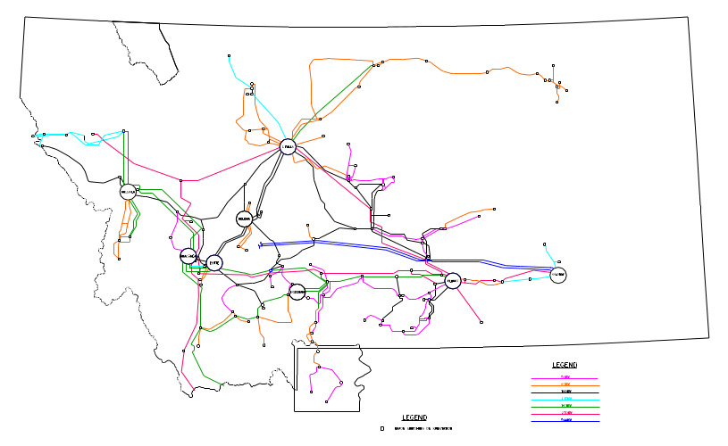
NWE local transmission system in Montana, within NWE and other Balancing Authority Areas, provides regulated electric transmission services to approximately 300,000 electric customers. NWE’s electric transmission system consists of approximately 7,000 miles of transmission lines and associated terminal facilities. NWE is registered with the North American Electric Reliability Corporation (NERC) as a Balancing Authority, Planning Authority and Transmission Planner.

Effective January 1, 2009, 222 megawatts of electricity from the jointly owned Colstrip 4 coal-fired unit in southeastern Montana were approved by the Montana Public Service Commission and included in NWE’s rate base. The 150 MW Dave Gates Generation Station, wholly owned by NWE, began serving Montana electric customers January 1, 2011. This facility provides regulating reserves, which means that it provides the reserve capacity necessary to maintain transmission system reliability by balancing on a moment by moment basis as customer demand and available resources fluctuate. On December 1, 2012, NWMT’s Spion Kop Wind facility commenced commercial operation, adding 40 MW of renewable generation resources to our supply portfolio. Fairfield Wind, a 10 MW facility went commercial on May 16, 2014.

The transmission system, with voltage levels ranging from 50,000 to 500,000 volts, serves an area of 97,540 square miles, which is equivalent to two-thirds of Montana. The 500 kV transmission system is primarily used to move power from Colstrip in eastern Montana to the Northwest. NWE’s lower voltage transmission system is used primarily to serve local load and also for tie lines to neighboring utilities. Path 83, the Montana-Alberta tie line (MATL) from Great Falls to Alberta, commenced commercial operation on September 18, 2013 with a path rating with flows across MATL measured at the Great Falls 230 Switchyard of 300 MW north to south and 325 MT south to north (or 300 MW south to north measured at the MATL 120S substation). Also, with the addition of series capacitors in the 230 kV transmission line at Peterson Flats (to be completed in 2014), the Path 18 southbound rating will increase to 383 MW.

NWE’s transmission system has interconnections to five major transmission systems located in the Western Electricity Coordinating Council (“WECC”) area and one Direct Current (“DC”) interconnection to a system that connects with the Mid-Continent Area Power Pool (“MAPP”) region.

The following graphic displays the external paths and associated non-simultaneous path ratings.

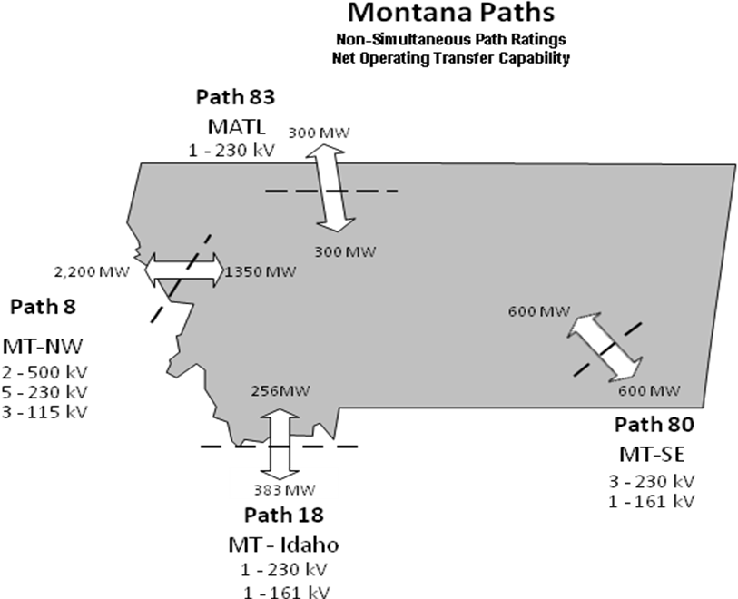

The graphic below displays NWE’s bulk electric transmission system 100 kV and above. The color coding of lines is as follows:
- Red: 230 kV
- Green: 161 kV
- Blue: 115 kV
- Yellow/Black: 100 kV

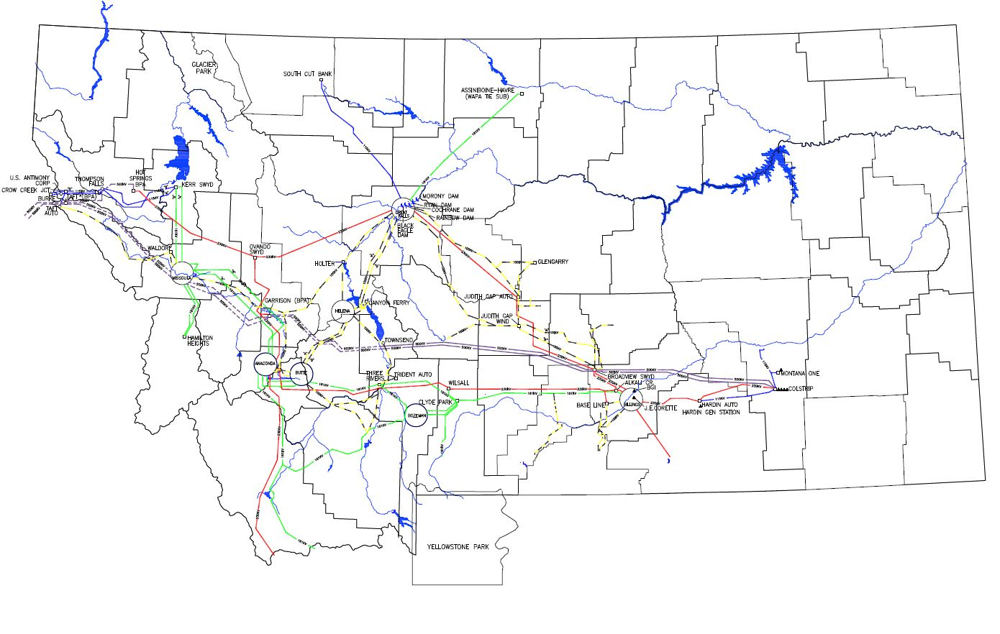

Basic Methodology
Below is a discussion of NWE’s basic methodology that is used to formally analyze its local transmission system. By application of this methodology, NWE ensures that a reliable transmission system exists to serve network customer load and firm point-to-point transmission service requests. NWE’s methodology is intended to define operating conditions that fail to meet reliability criteria and then identify solutions (e.g., transmission and non-transmission) that solve the problem. The operating conditions are for a specific instant in time, such as peak load conditions, and are not an integrated time period, such as an hour, day, month, etc. NWE’s basic methodology described below is focused on transmission reliability and not economic congestion studies that can be requested by customers.

NWE’s goal is to design a reliable, least cost transmission system that will perform under expected operating conditions wherein customer load can be met reliably into the future. NWE’s methodology includes transmission system planning and the WECC Annual Study Plan.

NWE Local Transmission Planning Methodology
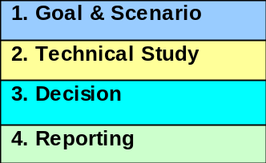
NWE’s methodology includes the four steps shown in the graph to the right. These steps are (1) Goal and Scenario Definition, (2) Technical Study, (3) Decision, and (4) Reporting. How these steps are weaved together to formulate the transmission plan is described in the Process section of this document. Local transmission planning may be confined to a specific geographic area, such as the Bozeman area, or it may be broadened to examine a specific transmission line or lines that extend over a large geographic area, such as NWE’s Montana balancing area. The transmission lines used in a local transmission planning study may range in size from 50 kV to 500 kV and may be networked or radial.

Local transmission planning methodology involves forecasting customer demand, identifying area reliability problems, evaluating possible mitigation options and selecting a solution that solves the area’s transmission needs. Transmission planning evaluates the transmission system reliability up to 15 years in the future. The planning effort considers transmission and non-transmission alternatives to resolve the reliability problem for a specified area. NWE’s methodology is flexible and is intended to develop a plan that:

- Responds to customers’ needs;
- Is low cost (e.g., Total Present Value Revenue Requirement, Rate Impact, etc.);
- Considers non-transmission and transmission alternatives;
- Considers public policy requirements and considerations
- Assesses future uncertainty and risk;
- Promotes NWE’s commitment to protecting the environment;
- Includes input from the public and other interested parties;
- Provides adequate return to investors;
- Complements corporate goals and commitments;
- Meets applicable NERC and WECC Standards and Requirements;
- Meets the Montana Public Service Commission expectations;
- Meets Regional and Interconnection wide planning requirements;
- Addresses customer and stakeholder concerns in an open, fair, and non-discriminatory manner.
- Satisfies the requirements of applicable FERC and MPSC Orders; and
- Conforms to applicable state and national laws and regulations.

Goal and Scenario Definition
NWE works with its Transmission Advisory Committee (“TRANSAC”) to establish the goal of the transmission plan at the beginning of each two-year local area transmission planning cycle.

Scenarios are developed based on the goal. Scenarios are developed to examine different load, generation, public policy requirements and associated transmission and various generation dispatch patterns in the future in order to identify conditions that stress the transmission system in planning models and simulations in order to reveal potential problems in system adequacy or security under normal or abnormal system conditions. Scenarios are determined per the goals of the transmission plan and looks at a 15-year planning study period. NWE uses scenario planning and not probabilistic planning for developing the local transmission plan. NWE may, however, use probabilistic assessment methods within a defined scenario to evaluate uncertainty.

The scenarios will be developed using this goal as a basis. A scenario will depict a specific condition such as summer peak load with maximum generation and exports out of the state and/or public policy requirement or considerations. NWE’s transmission system is exporting power most of the time since Montana has significantly more generation than load. It is important to note that a scenario should be designed to stress the transmission system under conditions that may cause inadequate transmission system performance to meet reliability criteria. Experience has shown that the transmission system is stressed when flows across it are heavy. However, experience has also shown that the transmission system may display problems under conditions that are less than maximum flows due to the way electrical equipment engages operation or ceases operation. Once a problem is found, solutions that mitigate the problem are defined and evaluated.

NWE’s basic methodology is to define the base scenarios to study and then to develop uncertainty scenarios from the base scenarios. This methodology is described in more detail below.

Base Scenarios
Base case scenarios will be used to examine the transmission system under a variety of future assumptions for a specific period of time. These assumptions include, but are not limited to, the following:
- Load Forecast (e.g., study year)
- Load Condition to Study (e.g. season, peak load or light load, etc.)
- Generation Available (e.g., generation additions/changes)
- Generation Dispatch Conditions (e.g., how is the generation operated)
- Transmission System Elements Available (e.g., transmission element additions/changes)
- Transmission System Configuration (e.g., what elements are out-of-service)
- Public policy requirements that are driven by local, state or federal law or regulations

Even though new interconnect projects follow FERC’s defined interconnection methods, the study results from the new interconnect projects cannot be ignored in developing the local transmission plan. The addition (or elimination) of generation or transmission to NWE’s transmission system can affect the flows throughout the system. NWE, with input from its TRANSAC, will consider scenarios including new generation, new transmission and new load.

Uncertainty Scenarios
The uncertainty scenarios are intended to recognize that the future, as assumed in the base scenarios, is not known and to examine potential transmission solutions for public policy requirements and/or considerations, after input from TRANSAC, for uncertainty scenarios. This uncertain future creates risk, which may be quantifiable or non-quantifiable. Risk may be expressed as a dollar cost or other impact. The base scenarios must make assumptions about future conditions, but the uncertainty scenario helps with understanding the risk associated with those assumptions. The purpose of the uncertainty scenarios is to develop information about the cost and electrical performance of base scenarios so that an informed decision about future transmission investments can be made.

Technical Study
The technical study is the second step in local transmission plan planning. It examines the reliability of NWE’s electric transmission lines that move power around NWE’s balancing area and between the bulk electric transmission system and the distribution system. NWE uses a sophisticated computer model (i.e., PSS/E) to simulate generator output, electrical flows over the transmission lines, electrical equipment action, customer loads and export (or import) path flows. The purpose of the technical study is to quantify transmission system performance by measuring the bus voltage, equipment loading, reactive power requirement, system frequency and other electrical parameters.

NWE does not conduct studies for every possible load and resource dispatch combination for the 8760 hours of the year. Instead, only the load and resource dispatch patterns that stress the transmission system are evaluated. The conditions that stress the transmission system are used in a computer simulation of the electrical system. The reliability of the local transmission system is evaluated with all transmission lines in-service or with a variety of elements out-of-service. For each computer simulation run, the transmission system voltage, transmission line loading, reactive support and other parameters are measured and compared to specific reliability criteria. If the reliability criteria are not met, then appropriate mitigation (transmission and non-transmission) is modeled in the base case database and the computer model simulation is run again. This process continues until the reliability criteria are met. The mitigation measures could include enhancements to the transmission system, generation development, demand resource development or other alternatives.

A database is developed that includes technical data for generation, transmission lines, public policy requirements with associated transmission, electrical system equipment and customer load levels and geographic distribution. NWE will consult with the TRANSAC in developing forecast data for transmission, generation, public policy with associated transmission and demand response resources. The basic methodologies for developing this forecast data are described below.

- Transmission: NWE will use the existing transmission infrastructure as a starting point. This data will be reviewed and any updates to the existing transmission data will be included in the base case. Future additions to the transmission system may or may not be included. If a new transmission project is under construction, then it will be included in the base case. Future new transmission additions not under construction will not be included in the initial base case unless a prior planning study has accepted the project and NWE agrees to include it after discussing it with TRANSAC. These projects may be included in some of the base and/or uncertainty scenarios and not others. Other future new transmission additions will be considered as one of the mitigation options should transmission system reliability problems arise during the study.
New regional transmission projects that may affect NWE’s transmission system will be considered on a case-by-case basis and may be included depending on project status and progress. NWE will discuss with TRANSAC. These projects may be included in some of the base and/or uncertainty scenarios and not others.

  - Generation: NWE will use the existing generation infrastructure and historical operation as a starting point to dispatch the generation to its seasonal capability or other dispatch patterns as dictated by the particular study. This generation data will be reviewed by TRANSAC. Existing generation will be included and can be dispatched up to rated capacity, historical performance levels and/or seasonal dispatch pattern that is appropriate for the study/scenario to reveal any reliability issues. Transmission Service Agreements will also be considered when determining generation dispatch patterns.

  - Future generation additions, including generation from NWE’s generation interconnect and transmission service request queue may be included if a signed interconnection or transmission service agreement exists. Since NWE’s Balancing Area currently has significantly more generation installed than load, proposed new generation additions may significantly change the transmission system configuration because of the mitigation requirements (i.e., transmission fixes) to connect and move power across NWE’s transmission. The Local Transmission Plan planning process cannot ignore this. NWE studies each generation addition individually using either the FERC or MPSC generation interconnection procedures. NWE will review these potential new generation additions and their transmission fixes with TRANSAC and then consider including them into the base scenarios and/or uncertainty scenarios. Proposed projects may be included in some of the base scenarios and not others or may be included in the uncertainty scenarios only.

  - Demand Resources: NWE will obtain demand response resource forecasts directly from the LSEs and customers within the balancing area. TRANSAC and NWE will review these forecasts and include them in the base case.

  - Public Policy Requirements: NWE will use public policy requirements that are driven by local, state or federal law or regulations in the base cases. In the uncertainty scenarios NWE will determine, after input from TRANSAC, which public policy requirements and/or considerations to use.

Using this database information, NWE will develop the base cases that are used to model the transmission system. NWE’s base case also includes this data for the entire WECC region. The time frame that the base case data represents is for a very specific condition that may occur over the course of the year. Thus, defining the conditions for a base case involves defining the generation, transmission configuration and customer load levels that are the focus of the study. In order to study each hour of a year, 8760 different base cases could be developed (8760 hours = 8760 base cases). This is impractical. Transmission planning’s purpose is to ensure transmission system reliability under all operating conditions, which means that the studies need focus only on the conditions that may stress the system. The following two examples describe stressed system conditions:

Example 1: Montana load at peak load conditions, such as summer peak day, and high generation will stress the local area transmission system serving the local area load.
Example 2: Montana load at light load conditions, such as the middle of the night, with high generation levels and high export levels will stress the high voltage transmission system.

The technical analyses will use different engineering studies to evaluate the system performance. These studies are designed to use different engineering perspectives to ensure system reliability is maintained. These methods may include, but are not limited to, the following:

- Steady-State Powerflow Analyses
- Post Transient Steady-State Powerflow Analyses (or Steady-State Post-Fault Analysis)
- Transient Stability Analyses (or Dynamic Analyses)
- Fault Duty Analyses
- Reactive Margin Analyses

A study of the transmission system under static conditions is a steady-state powerflow study, and a study over time is called a transient stability study. The steady-state powerflow analysis is a static evaluation of a local area transmission system that examines the transmission system under normal operating conditions with all lines in-service and with single and creditable multiple transmission lines or elements out-of-service (i.e., N-1, N-2, etc. conditions). Note that the “-1” in N-1 represents the number of transmission elements that are out-of-service. A transient stability study (i.e., a dynamic simulation study) evaluates the transmission system performance on a progressive time dependent basis. These studies evaluate credible outage events to determine if the transmission system will recover to acceptable steady-state operation after the outage. The studies include an assortment of outage events that are intended to provide a thorough test of the reliability of the transmission system. After a powerflow simulation is completed, a search of the simulation results for unacceptable thermal overload and voltage excursion is made. Unacceptable transmission system performance must be corrected by including transmission and non-transmission (e.g., demand-side resource, generation, etc.) fixes into a second simulation. Additional mitigation or fixes are included in the simulation until a valid solution is found. A valid solution is one that meets the reliability criteria described below. Economic and system performance information for this scenario is identified and retained for comparative analysis between scenarios during the decision step.

The credible “worst case” single and multiple fault events must be simulated to determine if the transmission system will recover to acceptable steady-state operation. A dynamic simulation includes an assortment of outage events that are intended to provide a thorough test of the reliability of the transmission system.

Each scenario study must evaluate the effectiveness of existing Remedial Action Schemes (“RAS”) within NWE balancing area. A RAS is used to maintain system reliability for voltage performance problems. Existing RAS include NWE's Acceleration Trend Relay (“ATR”) device to trip generation at Colstrip for major events, the Bonneville Power Administration's RAS to directly trip the Miles City DC tie for certain 500 kV events west of Garrison and a RAS to trip the Hardin generation for certain 500 kV events. The Colstrip generation employs generator tripping for critical outage events on the 500 kV electric transmission system. The generator-tripping scheme is a computer-based relay called the ATR. This device monitors the generator speed and acceleration (real time), and digitally analyzes these quantities to determine when an unstable event is in progress. If an unstable event is in progress, the device determines the amount of generator tripping that is required to protect the electric transmission system from instability and unacceptable low-voltage swings caused by the event. The ATR then proceeds to trip the necessary number of generating units at Colstrip before the event causes instability problems to occur. To model the ATR in the study software requires special non-proprietary NWE software be used in conjunction with the PSS/E model.

In addition, as new generation is added to the existing generation sources, NWE must fully evaluate the impacts to the existing RAS operation and whether or not the new generation must be on a RAS or if other forms of mitigation are required. NWE may also consider a Special Protection Scheme (“SPS”) to control for thermal overloading. See the Criteria section for a more detailed discussion of the RAS and SPS use.

These studies and analysis of the changes in system scrutinize: steady-state and transient voltage levels after the loss of a single line or other system element (e.g., transformer, generator, etc.) and multiple lines or other system elements; changes in the line and equipment thermal loading conditions; changes in Volt-Ampere reactive (“VAr”) requirements (voltage support); and unacceptable frequency excursions. All relevant reliability criteria are applied in these evaluations. See the Criteria segment of this document for a discussion of NWE’s criteria.

NWE will also conduct fault duty studies- and reactive margin studies as needed. A fault duty study is a study of electrical current interrupting devices (e.g., breakers) to ensure the device can open under maximum fault conditions. When a fault or short circuit occurs on a power line, the protective relay equipment detects the increased current (i.e., fault current) flowing in the line and signals the line’s circuit breakers to open. When the circuit breakers open, they must be capable of interrupting the full fault current. The worst-case fault current is commonly referred to as the “fault-duty”. A reactive margin study is a study to ensure that the transmission system has sufficient voltage control to maintain adequate voltage levels.

Decision
An objective of a local transmission planning study is to evaluate the range of potential transmission and non-transmission (e.g., demand side management, generation, conservation, demand response, etc.) solutions within the technical study and then use the results from the base studies and the uncertainty studies to make an informed decision. The decision rule, which will be developed for each transmission plan as describe below, can include quantifiable results (e.g., cost) and non-quantifiable information (e.g., written discussion of an issue). NWE’s decision rule may include, but is not limited to, the following information:

- Total present value of utility costs
- Cost/Benefit of potential system upgrades or operational improvements
- Societal Costs
- Adverse Impact
- System performance statistics to measure customer impacts
- Environmental assessment and/or costs
- Reliability metrics, including measures necessary for meeting approved NERC/WECC compliance standards.
- Uncertainty and Risk assessment results
- Non-quantifiable assessment
- Provide consistent, documented process

The primary purpose of the decision rule is to provide descriptive information (e.g., costs, risks, etc.) about the system and mitigation needed to resolve the problems. This information can be ordered or weighted so that stakeholders can understand the differences between the scenarios and provide input to NWE. NWE management can then use this information and input to make an informed decision for future transmission investment to serve future network load and point-to-point requests. Once approved, the mitigation will be prioritized into NWE’s 15-year business plan.

Reporting
The results of the local transmission plan will be reported and prioritized into NWE’s 5-year and 15-year business plan. Information from the local transmission plan will aid NWE management in this priority. It is NWE’s intent to publish a formal report bi-annually. This report will be posted on NWE’s OASIS website and electronically distributed to regional, interconnection wide entities and TRANSAC Stakeholders.

Load Forecast Methodology
NWE will develop its peak load forecasts, conservation and demand-response data (“load forecast data”) from two sources – customer provided forecast and regression model forecast – as described below:
Customer provided: NWE will obtain load forecast data from its customers. Pursuant to FERC Reliability Standard MOD-016, which became effective in June 2007, NWE will obtain load forecasts from Load Serving Entities (LSE) within its Balancing Area Authority (BAA). NWE will obtain load forecast data from Network Customers and Point-to-Point Customers pursuant to NWE’s tariff and FERC Order 890, respectively. NWE will ask that these load forecasts be adjusted for any MW savings from customers’ conservation programs. These peak load forecasts will be summed, assuming they are time coincident, to calculate the BAA load forecast.
Regression Model: NWE’s second source is a regression-based peak load forecast model that NWE has maintained over the years. The regression-based forecast results will be adjusted for MW savings resulting from conservation programs.

The loads within NWE’s balancing area are metered and tracked; that is, the loads are well defined. If the LSE and NWE load forecast results are significantly different, NWE will attempt to reconcile these differences. If NWE cannot reconcile these differences, NWE will choose which forecast to use in the study.

NWE obtains load forecast data for ten years of monthly data and annual data extending through a fifteen-year planning horizon.

NWE will use a peak load forecast that is based on a 50% probability of being exceeded (i.e., 1-in-2 assumption). The forecast may be adjusted up to a 1-in-10 or 1-in-20 (i.e., 10% and 5% probability, respectively) to capture heavy peak load conditions. A 1-in-2 (50% probability of being exceeded) or a 1-in-10 (10% probability of being exceeded) summer and winter peak load forecast within the BAA will be used.

The NWE BAA area peak load forecast will be adjusted to reflect demand response resource reductions, conservation reductions and other appropriate peak load modifying sources. Once a BAA load forecast is developed, this forecast will be disaggregated to the load buses in NWE’s BAA. There are two types of load buses: 1) a load bus where the load does not change over time (e.g., a single large industrial load bus); and 2) a load bus where the load changes over time (e.g., residential load). NWE uses its knowledge of load characteristics along with regression analysis to extrapolate the individual load bus data in time. The load bus forecasts will be summed and compared to the BAA load forecast. If the two forecasts do not match, NWE will adjust the changing load bus forecasts until the two forecasts are the same.

WECC Annual Study Program
In addition to NWE’s own local transmission planning study, NWE participates in the Western Electricity Coordinating Council (“WECC”) Annual Study Program and the WECC Transmission Expansion Planning Policy Committee (“TEPPC”) 10-year transmission planning effort. This program examines the reliability of electric transmission lines that are instrumental in moving electricity across the NWE system from sources of supply inside and outside Montana to markets inside and outside Montana. These lines generally range in size from 100 kV through 500 kV. A detailed simulation model is used for steady-state and dynamic event analysis that assesses electric transmission stability before and after a loss of a critical electrical element (e.g., line). NWE provides its local transmission plan, data and assumptions to WECC regional committees that are responsible for building databases. Regional committees use these data for database development, load and resource assessments, operating studies and planning studies.

Two types of study assessments are conducted – System Operating Limit (“SOL”) studies and Bulk System Planning Studies. The distinction between these studies is that the SOL study establishes the next season’s maximum transfer capacity for selected electric transmission path and the planning studies evaluate the bulk transmission system’s adequacy and security 2-10 years into the future. The Annual Study Program requires that each year approximately ten detailed studies be conducted to assess bulk electric transmission reliability. The mix of operating and planning studies varies each year.

When conducting a seasonal SOL study, NWE follows the WECC policy of using a critical outage for a load condition and generation pattern defined by WECC to establish the SOL that meets reliability criteria. The specific load and generation patterns may include heavy winter or summer loads with maximum thermal generation and critical hydro conditions and light spring loads with maximum generation. The outages that are of interest may include single or double line loss of the critical lines. After completing a study, NWE looks within its system and outside its system for unacceptable voltage concerns, overloaded electrical equipment and frequency excursion. The equipment includes, but is not limited to, generators, transmission lines, transformers, series capacitors, wave-traps, circuit switchers, and circuit breakers. Other electrical equipment on the system may limit the transfer of power through a system; therefore, they need to be considered when conducting studies. Voltage levels are reviewed to make sure that the steady-state, post-fault and transient voltage performances comply with all criteria. NWE checks for unacceptable equipment thermal loading, voltage swings and positive damping after transient excursions on a system-wide basis. See the Criteria section of this document for criteria requirements.

SOL studies are conducted by adjusting the load and generation patterns in a computer simulation model (i.e., PSS/E) to maximize the loading on the electric transmission path (e.g., set of branches being assessed). The initial generation, load, and transmission data are taken from an appropriate WECC base case. Assessments must evaluate the effectiveness of the RAS in NWE’s BAA. These RAS include NWE's Acceleration Trend Relay (“ATR”) device to trip the Colstrip generation for major events, the Bonneville Power Administration's RAS to directly trip the Miles City DC tie for certain 500 kV events west of Garrison and the Hardin generation RAS. Maximum loading on the path is achieved when the system performance for the most sensitive parameter, either steady-state or transient, just meets the reliability criteria. This establishes the SOL for that path. Planned equipment changes and/or additions are allowed in the study.

The Bulk System Planning Study originates through the WECC System Review Work Group (“SRWG”) annual planning program. The WECC study follows the same process as the SOL studies, except the season can range from 2 to 10 years in the future and may include proposed new facilities. The goal of the planning study is to examine the reliability of the future transmission system under prescribed seasonal loads, generation patterns, and various outage conditions and to identify appropriate upgrades and/or new facilities to maintain bulk system reliability into the future.

Economic Congestion Study
Pursuant to FERC Order 890, stakeholders may request an Economic Congestion Study. The purpose of FERC Order 890 Economic Congestion Studies is to ensure that customers may request studies that evaluate potential upgrades or other investments that could reduce congestion or integrate new resources and loads on an aggregated or regional basis (e.g., wind developers), not to assign cost responsibility for those investments or otherwise determine whether they should be implemented. This is different than a proposed new generation interconnect study in that an interconnect study is to interconnect a new Generating Facility, or to increase the capacity of, or make a Material Modification to the operating characteristics of, an existing Generating Facility that is interconnected with the Transmission Provider's Transmission System. Attachment K Section 2.7 also addresses economic congestion studies. The URL to access NWE’s Attachment K can be found in http://www.oasis.oati.com/NWMT/NWMTdocs/Attachment_K_Business_Practice_Links.doc.

A request for an Economic Congestion Study may be confined to NWE’s balancing area, in which case NWE would complete the study using the methodology, criteria and process described within this document. A request for an Economic Congestion Study may be included as a scenario in NWE’s local transmission planning cycle if it is received in a time that would allow this inclusion. If the request is received at a different time, the request may be considered in the Economic Congestion study cycle the following year.

If a request for an Economic Congestion Study expands beyond NWE’s BAA, then the request will be classified as a regional or interconnection wide study request and NWE will forward the request to Northern Tier Transmission Group (“NTTG”) or to WECC TEPPC. NWE will coordinate and participate in their Economic Congestion Study as required.

Criteria
NWE reliability criteria, NERC/WECC regional reliability criteria (hereafter called WECC Standards), FERC Standards and industry standards (e.g., IEEE Standards) are the basis for NWE transmission planning criteria. This section describes these criteria.

Reliability Criteria
Electric transmission reliability is concerned with the adequacy and security of the electric transmission system. Adequacy addresses whether or not there is enough transmission, and security is the ability of the transmission system to withstand contingencies (i.e., the loss of a single or multiple transmission elements).

- NWE Internal Reliability Criteria is a set of technical transmission reliability measures that have been established for the safe and reliable operation of NWE’s transmission system.

- The FERC approved Standards (consisting of those implemented by NERC and the WECC) and the WECC Standards set minimum performance standards for voltage excursions and voltage recovery after a credible outage event on the transmission system. Credible outages are those more likely or plausible, or required to be considered by the governing standards.

NWE uses these criteria in evaluating a change or addition to its electric transmission equipment and/or a change or addition to load or generation. NWE will use these reliability criteria as needed to fully evaluate the impacts to its electrical system of proposed lines, generation or loads. NWE augments these criteria with other standards such as, but not limited to, the American National Standards Institute (“ANSI”) and Institute of Electrical and Electronics Engineers (“IEEE”) standards.

NWE planning ensures that any change that either directly or indirectly affects its transmission system will not reduce the reliability to existing customers to unacceptable levels. The NWE electric transmission system must remain dependable at all times so that it may provide reliable high quality service to customers.

NWE Internal Reliability Criteria
NWE Internal Reliability criteria are used for reliability performance evaluation of the electric transmission system. Steady-state implies the condition on the transmission system before an outage, or after an outage and after switching occurs, regulators adjust, reactors or capacitors switch, and the electrical system has settled down (typically three minutes or more). This latter condition is also called post-fault reliability requirements.

NWE’s criteria include a collection of ANSI standards as well as past and current practices, that when applied with experienced engineering judgment, lead to a reliable and economical electric transmission system. These NWE criteria support the NERC/WECC Standards and WECC Reliability Criteria that disallow a blackout, voltage collapse, or cascading outages unless the initiating disturbance and corresponding impacts are confined to either a local network or a radial system. An individual project or customer load may require an enhanced reliability requirement.

NWE plans for a transmission system that provides acceptable voltage levels during system normal conditions and outage conditions. Areas of the NWE system that are served by radial transmission service are excluded from single contingency evaluation, due to economic considerations.

Steady-State and Post-Fault Voltage Criteria for 230 kV and Below
The steady-state voltage criteria listed in the tables below are based on the assumption that all switching has taken place, all generators and transformer load tap changers have regulated voltages to set values, and capacitors or reactors are switched. The basis for the percent voltages is the designed operating voltage.

As shown in Table 1, the recommended upper voltage limit for a load-serving bus is 105% unless equipment rating dictates a different limit. For example, if the equipment used on a particular 100 kV system is rated at a nominal voltage of 102 kV, then its upper limit is 107 kV (i.e., 105% times 102 kV nominal). NWE follows the limit as outlined in the American National Standards Institute (i.e., ANSI C84.1). It is possible that a load-serving bus voltage may exceed the tabled value if conditions allow a higher voltage without harm to NWE or customer equipment.

Table 1
Maximum Upper Voltage Criterion
At Unregulated Load-Serving Bus
 | Upper Operating Limit
Voltages | 105%

The allowable minimum percent voltage for any load-serving bus that is within a network configuration is shown in Table 2 (see next page). It is possible that a load-serving bus voltage may fall below the tabled value if conditions allow a lower voltage without harm to NWE or customer equipment. This table considers FERC/NERC and WECC criteria as applied to the bulk electric system busses (100 kV and above). Table 2 is also applied on lower voltage transmission busses that are not part of the bulk electric system (50 kV and 69 kV).

Table 2
Minimum Allowable Percent Voltage
At NWE Unregulated Load-Serving Bus
Nominal Voltage | Existing  System  (N-0) | First Contingency  (N-1) | Second Contingency  (N-2)
230 kV and 161 kV | 95% | 95% | 93%
115 kV and 100 kV | 95% | 93% | 90%
69 kV and 50 kV | 93% | 93% | 90%
Note:
1. Percent voltage is measured from the nominal voltage listed in the table.
2. The 50 & 69 kV and radial 100 kV segments are not bulk electric system elements.

The minimum allowable percent voltage for a load serving bus that is on a radial transmission system for an event on the radial line must only meet the existing system performance (N-0) shown in Table 2. Any unacceptable voltage performance must be mitigated in accordance with the criteria described in Table 2. The use of a Remedial Action Scheme (RAS) will be evaluated on a case-by-case basis, with no assurance that NWE will accept or use a RAS. Table 2 assumes that all other methods to control voltage have been explored (such as capacitors, reactors, and line switching, etc.).

Under emergency conditions, bus voltage between 90% and 110% of nominal is permitted for up to 30 minutes.

Steady-State and Post-Fault Voltage Criteria for 500 kV
The allowable operating voltage range for the 500 kV transmission system is 100% to 110% of 500 kV nominal, or 500 to 550 kV. The percent range is different from other voltage levels because most equipment used on the 500 kV system is rated at 525 kV. This criterion applies to both steady-state and post-fault conditions.

Transmission Equipment Rating and Loading

Transmission Conductors
Transmission conductor continuous summer rating is based on 25°C (77°F) ambient air at 1.4 mph (2 ft/sec), 50°C conductor temperature rise, and 75°C (167°F) maximum operating temperature unless conditions dictate otherwise (e.g., some conductors and lines may be specifically designed for higher operating temperatures). Winter transmission conductor continuous thermal ratings are 125% of the summer rating, during the winter months November - February, or any time ambient temperatures are below 0°C (32°F). This rating is entered as Rate A in the powerflow base cases. Unacceptable conductor loading can be mitigated by system improvements or, in some cases, a Special Protection Scheme (SPS) that changes system conditions to mitigate the overload. The use of an SPS or operator intervention is evaluated on a case-by-case basis, with no assurance that NWMT will accept or use these options.

Emergency ratings for transmission conductors are developed on a case by case basis, and are dependent on conductor size, line voltage and available ground clearance under elevated conductor temperature conditions. Under emergency conditions for standard conductors (e.g. not "high temp" conductors), conductor temperatures are limited to 100°C (212°F) or less, and thermal ratings are limited to 125% of the seasonal rating for up to 30 minutes.

Transformers
Transformer rating is based on the following:

- For standard service conditions (24-hour average ambient air temperature of 30°C or 86°F, or less), the continuous rating is 100% of the highest operational nameplate rating. This rating is entered as Rate A in the power flow base case.

- For winter service conditions (November - February, or any time 24-hour ambient air temperature is less than 0°C, or 32°F,) loading to 125% of the standard service condition rating may be allowed.

- Under emergency operating conditions, loading to 125% of the standard service condition rating may be allowed for up to 30 minutes during any season. Note this is the same as the winter rating, and under winter conditions this load level is permitted continuously.

Unacceptable transformer loading can be mitigated by transformer replacement, system improvements or, in some cases, a SPS that changes system conditions to mitigate the overload. The use of an SPS is evaluated on a case-by-case basis, with no assurance that NWMT will accept or use an SPS.

General Minimum Equipment Specifications

The general minimum specifications for NorthWestern Energy Transmission and Substation equipment are listed in Table 3. Table 3 also summarizes the MVA, voltage, current, Basic Impulse Level (“BIL”), Maximum Continuous Over Voltage (“MCOV”) for lightning arresters, and interrupt ratings of equipment as applicable and associated grounding requirements.

Table 3
Transmission and Substation Equipment: General Minimum Specifications
 | Nominal System Voltages - kV
 | 230 kV | 161 kV | 115 kV | 100 kV | 69 kV | 50 kV
MVA and Current Ratings *(1) | As Req'd | As Req'd | As Req'd | As Req'd | As Req'd | As Req'd
Equipment BIL (kV) *(2) | 900 | 750 | 550 | 550 | 350 | 350
Maximum Design Voltage (kV) *(3) | 242 | 169 | 121 | 121 | 72.5 | 72.5
Breaker Interrupt Current (kA) | 40 | 40 | 40 | 40 | 40 | 40
Breaker and Switch Continuous Current (A) *(4) | 1200 | 1200 | 1200 | 1200 | 1200 | 1200
Arrester Duty Rating/MCOV (kV) *(5) | 172/140 | 120/98 | 90/70 | 90/70 | 54/42 | 39/31.5
Substation Insulator Class | TR-304 | TR-291 | TR-286 | TR-286 | TR-216 | TR-214
Transmission Line BIL, wood (kV) *(6) | 1105 | 780 | 610 | 525 | 440 | 355
Transmission Line BIL, steel (kV) *(7) | 1265 | 945 | 695 | 610 | 525 | 440
*Notes:
1. Project and equipment specific as required to avoid thermal overloads
2. 1050 kV BIL is also used on some 230 kV equipment
3. At least 5% over nominal
4. 2000 amp equipment is used in some applications
5. For effectively grounded systems
6. Insulator support hardware ungrounded
7. Insulator support hardware grounded

New Facility (Generation, Transmission, Load, or Line):
The primary goal when interconnecting a new facility to NWE’s transmission system is to ensure that the configuration of the interconnection will not materially reduce the reliability of the transmission system or the reliability of service to customers. A material reduction in reliability occurs when operation associated with a new facility or the interconnection itself precludes complying with NWE criteria, WECC criteria, NERC/WECC Standards or good utility practice. System reliability cannot be jeopardized as a result of connecting a new or up-graded facility. Steady-state and transient electric transmission system performance must meet or exceed NWE, FERC and WECC performance criteria, and changes in fault duty cannot exceed equipment capability. Any unacceptable system performance (voltage, thermal, frequency, fault duty, PV/QV, power quality, etc.) must be mitigated prior to interconnection.

The addition of new generation to NWE transmission system, including induction machine generation, must not cause unacceptable voltage fluctuations (i.e., a flicker problem) or harmonics as the units operate or as the generators cycle on and off during marginal operating conditions. New generation connected to NWE’s electric transmission system shall comply with the limits set by IEEE Standard 519. A high-speed dynamic responsive reactive device (e.g., STATCOM, Static Compensator) must be provided to protect against flicker unless it can be demonstrated that the new generation does not cause a flicker problem. Instead of a high-speed dynamic responsive device, it might be proven that a different solution, such as managing individual wind turbine generation starts through a master control system, solves the flicker problem.

NWE requires that new generators connecting to the NWE transmission system be capable of producing or absorbing reactive power within a range of 0.9 leading to 0.9 lagging power factor -- as calculated at the generator terminals at rated continuous power output -- to support voltage schedules specified by NWE. The intent of this requirement may be effectively met through machine characteristics or other external means. This requirement does not apply to wind generators.

Wind generators must have operational characteristics either through internal or external capabilities to operate throughout a power factor range of 0.95 leading to 0.95 lagging at the Point of Interconnection at their rated power output.

Special Protection Scheme (SPS) Application
NWE may consider a SPS application to protect the electric transmission system against certain types of events, but each application will be evaluated on a case-by-case basis with no assurance that a SPS application will be acceptable.
• An SPS may be used to mitigate a thermal overload that is less than the thermal rating of a system element by tripping or by generator run-back. This may be an appropriate application for an overload that results from a single (or multiple) contingency outage event. This type of SPS may be manual (with a response time not greater than 30 minutes) or automated (with a faster response time). Typically, response time for a thermal SPS application is measured in tenths of seconds to minutes. Generally, a thermal SPS can be thought of as a scheme that can be backed up by relay operation or operator intervention if necessary. A SPS will not be considered as acceptable mitigation for system element overload if its failure to operate properly could lead to widespread outages on the Bulk Electric System.
• Another type of SPS, also known as a RAS (Remedial Action Scheme), may be used for certain single and multiple contingency outage events that result in unacceptable electric system reliability performance that is not related to minor thermal overloading and that requires a more immediate response (e.g., unacceptable transient stability performance). A RAS must be an automated response to the outage. Typically, response time for a RAS application is measured in cycles or at most a few seconds. While the ranges of expected response times may overlap, there is a distinctly different character to a RAS. It may be expected to meet a higher reliability standard, depending on the application. There is no expectation that a transmission system operator could intervene if the RAS were to fail to operate. Any RAS application must be redundant and meet WECC system planning criteria. NWE will submit any RAS application that may be proposed to the WECC RASRS for their approval if the RAS failure could lead to widespread outages on the Bulk Electric System of the Western Interconnection. If a RAS does not receive the approval of the RASRS, NWE will not use it.

NWE’s criterion for the use of a SPS is consistent with the performance requirements of existing facilities connected to NWE transmission system. NWE’s criterion is stated below:

- All lines and equipment in-service:
    - SPS application with Conditional Firm Transmission Service: NWE may consider a SPS for thermal overloads with all lines and equipment in-service for generation resources receiving Energy Resource Interconnection Service (“ERIS”) and submitting an application for Conditional Firm Service if the overload condition is well-defined, is not acute (i.e., sufficient time for operator intervention to prevent equipment damage), and is isolated to the local area transmission. The ability to control the overload must be simple, and the SYS must completely eliminate the overload in a time specified by NWE with no impact to third party customers. An assessment will be made on a case-by-case basis with no assurance that a SPS will be acceptable. The equipment to control the generation output must be automated, redundant (with no common point of failure), set to execute mitigation procedure below 100% of thermal capability as specified by NWE, and NWE must also have automated control of a breaker that can be used to trip the facility (or a sufficient portion of the facility) off-line to eliminate the overload completely should the redundant control equipment fail to perform as designed.

- N-1 Outage: For single contingency (N-1) conditions with a new facility (i.e., generation, transmission, load, line, etc.) connected, unacceptable system performance must be mitigated.

    - N-1 RAS Application: Any RAS application to mitigate for an N-1 outage should be comparable to other RAS applications on NWE’s system. NWE has not had a RAS operation from its Acceleration Trend Relay (“ATR”) at Colstrip caused by any N-1 line outage. Studies show, however, that the current ATR design may call for RAS unit-tripping under high Colstrip generation levels and high transmission loading conditions coupled with a single 500 kV three-phase line fault. A three-phase line fault has a very low probability of occurrence (there has never been a three-phase fault on the Colstrip 500 kV system). NWE may consider a RAS for an N-1 three-phase line fault, but this will be evaluated on a case-by-case basis with no assurance that the RAS application will be acceptable. NWE will not consider a RAS application as an acceptable mitigation for any N-1 condition caused by anything other than a three-phase fault (e.g., no fault, single-phase outage, two-phase outage, phase-to-phase outage, etc.). Any RAS application must be redundant and meet FERC/NERC/WECC system planning criteria. NWE will require that the WECC Remedial Action Scheme Reliability Subcommittee (“RASRS”) approve any RAS application that may cause widespread outages if the RAS fails to perform as designed.

    - N-1 SPS application for line overloads: Using a SPS may be acceptable to mitigate (i.e., reduce overload) for a thermal overload condition caused by a single contingency. Each overload situation will be evaluated on a case-by-case basis with no assurance that NWE will choose to apply a SPS instead of system changes or enhancement. In all instances, a SPS must:
      - Limit loading to below 100% of rated capacity;
      - Allow no accelerated loss of life, or degradation of utility equipment per accepted industry standards and/or good utility practice;
      - Maintain a safe system;
      - Limit conductor loading to not exceed the conductor’s maximum design.

    - N-1 SPS application for transformer overloads: Using a SPS may be acceptable to mitigate (i.e., reduce the overload) for a transformer thermal overload condition caused by the loss of a single system element (i.e., line, parallel transformer, etc.). Using a SPS for transformer overloads may be applied if the overload does not exceed 125% of transformer per unit rating. For transformer overloads greater than 125%, a SPS is unacceptable mitigation. In all instances, a SPS must:
      - Limit the overload duration to less than 30 minutes;
      - Maintain a safe system;
      - Allow no accelerated loss of life, or degradation of utility equipment per accepted industry standards and/or good utility practice.

- N-2 (double or greater) Outage: NWE may accept a SPS for thermal overloads or a RAS as the primary mitigation for an N-2 (or greater) outage condition. Each application would be evaluated on a case-by-case basis with no assurance that NWE will choose to utilize a SPS or RAS scheme instead of system changes or enhancement. Any application may be required to be redundant and must meet FERC Standards and WECC criteria.

Any RAS application must be redundant and meet WECC system planning criteria. NWE will require that the WECC RASRS approve any RAS application that may cause widespread outages if the RAS fails to perform as designed.

NWE may consider a SPS for a credible N-2 (or greater) outage condition. Each SPS application will be evaluated on a case-by-case basis with no assurance that the SPS application will be acceptable. Any N-2 SPS application may be required to be redundant.

- RAS Application for a Stuck Breaker: NWE may consider a RAS application to mitigate for a stuck breaker contingency. Each RAS application will be evaluated on a case-by-case basis with no assurance that the RAS application will be acceptable. Any RAS application must be redundant and meet WECC system planning criteria. NWE will require that the WECC RASRS approve any RAS application that may cause widespread outages if the RAS fails to perform as designed.

- RAS Application for a Transformer Outage: NWE may consider a RAS application to mitigate for a transformer outage. However, it is recognized and may not be acceptable because application of a RAS for the catastrophic loss of a transformer could require the local system operations to be reduced until a suitable transformer is installed. Each RAS application will be evaluated on a case-by-case basis with no assurance that the RAS application will be acceptable. Any RAS application must be redundant and meet WECC system planning criteria. NWE will require that the WECC RASRS approve any RAS application that may cause widespread outages if the RAS fails to perform as designed.

Voltage Ride-through
NWE will follow FERC and WECC high and low voltage ride-through criteria as appropriate. Under certain circumstances, NWE may require the generation to trip offline to maintain system reliability instead of riding through the event.

Harmonics
Because some generation facilities, such as wind generation, may include large capacitor banks to supply adequate voltage support, and power electronic installations to accommodate the induction generators that are used for such facilities, and because both such facilities may introduce harmonic currents either due to resonances at harmonic frequencies or through inverter circuitry that is capable of introducing harmonic currents, NWE may require a study be conducted to evaluate the potential for unacceptable levels of harmonic currents that may be introduced by the facility. This study should be performed along with the Facilities Study for the project. NWE will supply the system Thevenin equivalent impedance of its power system at the Point of Interconnection for the purpose of completing this study. This can be used to verify that no harmonic of the system frequency will be above acceptable levels [see IEEE standard 519-1992 and ANSI standard C84.1-1989]. The project will be required to mitigate any harmonics levels outside of acceptable limits.

Subsynchronous Resonance
The 500 kV transmission lines from Colstrip to Broadview to Garrison (and to the west) are series compensated. For this reason, the addition of a new generation project or new transmission lines or upgrades to existing generation or transmission lines may require additional study to evaluate the exposure of each generator connected directly to or near this system. A Subsynchronous Resonance (“SSR”) study will need to be commissioned by the various project sponsors to evaluate generator risk, not only for the new project, but also for all generators currently connected to NWE’s electric transmission system. NWE welcomes the opportunity to participate in the SSR studies.

FERC Standard Requirements and WECC Reliability Criteria
The NERC/WECC Standards and the WECC Reliability Criteria are used to evaluate NWE’s Bulk Electric System performance under steady-state and transient stability and the recovery performance of NWE’s transmission system. These criteria apply to all of NWE’s bulk electric transmission lines. See the latest standards posted on the NERC or WECC websites at http://standards.nerc.net and http://www.wecc.biz.

Process Detail
NWE’s local transmission planning process is depicted in the following flowchart.

NWE Local Transmission Planning Process
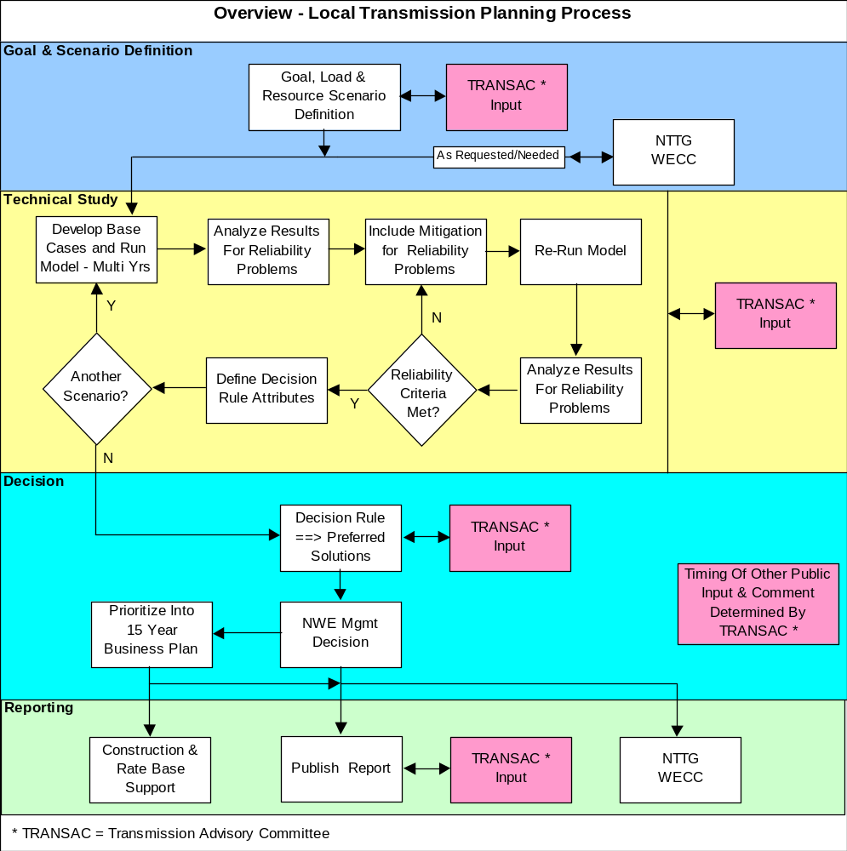

NWE will follow a biannual cycle to complete the above process. This process will be used to develop a 15-year local transmission plan. The methodology steps (i.e., scenario definition, technical study, decision and reporting) are weaved together by this process to produce NWE’s local transmission plan.

Timeline
The typical timeline for NWE’s two-year planning process cycle can be accessed through the URL address identified for the “LTP Study Cycle” in http://www.oatioasis.com/NWMT/NWMTdocs/Attachment_K_Business_Practice_Links.doc.

Goal and Scenario Definition
NWE will work with TRANSAC to establish the goal of the transmission plan. This goal should support the various stakeholder interests. The scenarios will be developed using this goal as a basis.

Armed with this goal, NWE will define the planning scenarios with input from TRANSAC. A scenario will depict a specific condition such as the peak summer load, maximum balancing area generation and maximum export to the northwest and public policy requirements and considerations appropriate for the scenario. This scenario represents a “snapshot” in time that is to be studied. Since there are a large number of combinations of load, generation and export/import conditions, careful consideration must be given to design each scenario to depict a future load and generation dispatch pattern that stresses the transmission system. Transmission system reliability planning is about ensuring the transmission system remains reliable under all operating conditions.

Varying the amount, type and location of generation, balancing area load level and NWE export/import conditions are important in defining a scenario. Defining a scenario can include, but is not limited to, the following:

- Different types of generation to determine how generation responds to outage conditions
- Generation location and magnitude to determine transmission stress
- Higher generation levels to cause more power to be exported out of the balancing area
- Lower generation levels with high imports from the east moving to the northwest to stress import paths
- Higher balancing area load to stress the local area transmission used for load service
- Lower the balancing area load levels with high generation to stress the high voltage transmission
- Different public policy requirements and/or considerations

As can be seen in the preceding flowchart, NWE’s process includes input from NWE’s advisory committee, TRANSAC, in defining the scenarios. The TRANSAC will provide input into NWE transmission planning process pursuant to FERC Order 890 Transparency requirements. Information regarding NWE’s TRANSAC can be found by using the URL address identified for the “Transmission Advisory Committee (TRANSAC) – How to Become Involved” in http://www.oatioasis.com/NWMT/NWMTdocs/Attachment_K_Business_Practice_Links.doc.

Technical Study
Once the scenarios are defined, the technical study will begin by developing a base case that specifies the modeling information for the scenario condition. Each scenario may include several base cases to span the 15-year study horizon. For example, to study the summer peaks in 2010 and 2015 requires two distinct base cases that reflect the load, generation and transmission line and equipment changes and additions for the specific year. Developing a base case that depicts the scenario is critical and can take a significant amount of work and time to develop. A 15-year study for a scenario may actually include only three base cases representing years 5, 10 and 15. These base cases will differ by the load growth, generation and transmission assumptions.

Once a base case is built, running the computer software to simulate the interactions between load, generation and transmission that instant in time provides the engineering statistics to evaluate transmission system performance. The transmission system performance (voltage, thermal, etc) is analyzed to identify whether or not reliability requirements have been met. If inadequate performance is observed, a mitigation measure (e.g., transmission or non-transmission) is defined, and the base case is modified to include the mitigation. The simulation is repeated and system performance is compared to reliability requirements. This circular process is repeated until the system performance meets or exceeds reliability requirements. Note, that at the conclusion of the study only a single mitigation solution will be defined and implemented, so once a mitigation measure is defined for a scenario, it must be included in all scenarios to ensure that it works for all scenarios.

The results of the above process yield a valid plan from which various statistics can be defined and included in a decision rule. NWE’s TRANSAC will help define the decision rule attributes. The decision rule attributes can include, but are not limited to, the following:
- Total present value of utility costs
- System performance statistics
- Environmental assessment and/or costs
- Reliability metrics
- Uncertainty and Risk assessment results
- Non-quantifiable assessment

Decision
Information from the base case scenarios and associated risk scenarios will establish a set of descriptive system performance information for each scenario. NWE will seek input from the TRANSAC in identifying the specific attributes to include in the decision. This information will be applied into a decision rule to describe each scenario’s positive and negative aspects. The planning process will use quantifiable and non-quantifiable descriptors to describe the plan. One logical organization would be to develop a matrix that has attributes listed down the left column and the scenario and underlying mitigation across the top two rows. Each cell would provide a discussion or assessment for that scenario’s attribute.

The primary purpose of the decision rule is to provide information about the system problem and mitigation to resolve the problem. NWE management can then use this information to make an informed decision for future transmission investment to serve future network load and point-to-point requests. Once approved, the mitigation will be prioritized into NWE’s 15-year business plan.

Reporting
NWE will develop a local transmission plan report for the above information. This report will describe the scenarios, technical studies, decision rule attributes and how the plan was developed. With the aid of TRANSAC, NWE will make every attempt to clearly describe the methodology, criteria, and process that clarify how the transmission plan was developed.

Regional Participation
NWE’s participation in regional planning activities will be broad, ranging from providing data to participating in studies and committees. NWE electric transmission system data, assumptions and plan will be shared with interconnected transmission systems, regional planning entities and interconnection wide entities as required.

NWE provides its local transmission plan’s data and assumptions to regional and interconnection wide committees that are responsible for building databases and then using this database for load and resource assessments and for operating and planning reliability studies. This is an annual process that requires NWE to provide basic transmission data, balancing area load forecast and generation information to be shared and included in the databases used by regional and interconnection wide planning entities. NWE will participate in these forums as appropriate.

NWE’s will provide its local transmission plan to WECC, Northern Tier Transmission Group (“NTTG”), and other regional planning entities as appropriate. In the regional context, NWE is an active member of NTTG. NWE will submit its data, assumptions and transmission plan to NTTG as required for inclusion in its regional transmission plan. NWE will actively participate in the NTTG planning process to ensure data and assumptions are represented in the NTTG regional plan. Once NTTG’s regional plan is developed, NTTG will coordinate its plan with other regional planning entities and with WECC. NWE’s plan will coordinate through the NTTG regional plan to the WECC. As appropriate, NWE will also provide its transmission plan information to WECC.

NWE will participate in regional and interconnection wide planning studies as appropriate to ensure data and assumptions are coordinated. These studies may be focused on integrating new transmission line(s) into the regional transmission network or a broad planning study of regional or interconnection wide transmission needs. NWE’s participation in these studies will be guided by the intent of the study and how NWE’s local transmission system might be affected.

NWE will also participate in regional studies to identify enhancements that could relieve “significant and recurring” congestion. In the past NWE participated in Northwest Power Pool, RMATS and WECC studies that focused on a broader footprint than NWE’s balancing area. In the future, NWE will work closely with the NTTG and WECC process to identify congestion.

Additional information of the coordination between the local, regional and interconnection wide planning can be found using the URL address identified for the “Transmission Planning Guidance Document” in http://www.oatioasis.com/NWMT/NWMTdocs/Attachment_K_Business_Practice_Links.doc.

NERC defines a Balancing Authority as: “The responsible entity that integrates resource plans ahead of time, maintains load-interchange-generation balance within a Balancing Authority Area, and supports Interconnection frequency in real time.”
NERC defines a Planning Authority as: “The responsible entity that coordinates and integrates transmission facility and service plans, resource plans, and protection systems.”
NERC defines a Transmission Planner as: “The entity that develops a long-term (generally one year and beyond) plan for the reliability (adequacy) of the interconnected bulk electric transmission systems within its portion of the Planning Authority Area.”
Idaho Power Company, Avista Corporation, Bonneville Power Administration, Western Area Power Administration and PacifiCorp.
Demand Response resource, generation, interruptible load, etc.
Public policy requirements are established by local, state, or federal laws or regulations, meaning enacted statues (i.e., passed by the legislature and signed by the executive) and regulations promulgated by a relevant jurisdiction. Public policy considerations are not driven by local, state or federal law or regulations.
TRANSAC is an advisory stakeholder committee that meets regularly with NWE to provide input and comments during the planning stages of NWE’s electric transmission system plan. Membership is open and communication is open and transparent. For more information visit NWE’s Transmission Planning section on NWE’s OASIS Website (http://www.oasis.oati.com/NWMT/index.html).
Reliability includes adequacy and security considerations. Adequacy evaluates whether or not there is sufficient transmission capacity to serve the load without violating criteria. Security evaluates whether or not the transmission system response will meet appropriate criteria (voltage, thermal, frequency, reactive margin, etc.) after a transmission element(s) becomes unavailable for service (e.g., a forced outage of a transmission line).
Federal Energy Regulatory Commission, NERC, WECC or NWE reliability criteria.
The PSS/E model automatically completes a transient stability study by running the computer model repeatedly over time and recording how the generation and transmission elements change over time as the result of an outage. A sequence of results is produced that depict how the generation and transmission system equipment responds to this outage condition. The time step must be very small to accurately capture transmission system changes because generation and load are matched instantaneously. For example, a dynamic study runs a powerflow simulation of the system, with progressive “real” time adjustments, every ¼ cycle or 0.00417 seconds. Thus to make a 5 second study, the program must be run 1200 times.
NWE models the WECC transmission system using the PTI PSS/E software. NWE base case data includes the 100 kV to 500 kV transmission system data.
For example: WECC System Review Work Group (SRWG) and WECC LRS Subcommittee.
WECC is in the process of removing standards that duplicate the FERC Standards; so only the more stringent WECC criteria will remain.
NERC develops the standards, which are approved by FERC.
Also known as Special Protection Scheme (SPS)
For example: WECC System Review Work Group (SRWG), WECC LRS Subcommittee, and Northern Tier Transmission Group Planning Committee, etc.

