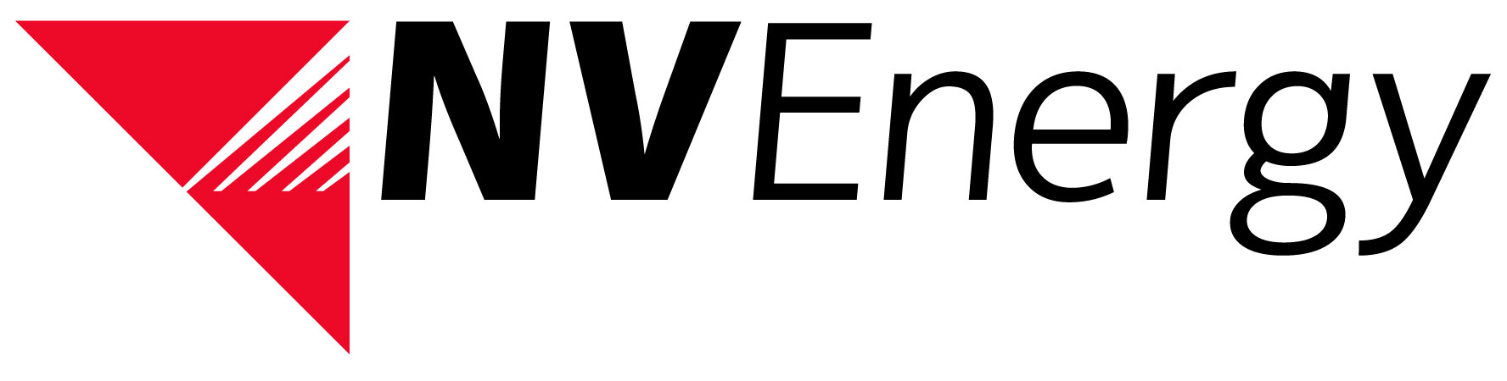
NV Energy Network Customer Lead Information Sheet
Dear Network Transmission Customer,

FERC has issued Order No. 676-H, which directs all Transmission Providers to adopt the NAESB Wholesale Electric Quadrant (WEQ) Standards for Business Practices and Communication Protocols Version 003. Consequently, NV Energy Transmission (NEVP) must establish specified features for managing Network Integration Transmission Service (NITS) through OASIS. The NITS management features that customers must access through OASIS include, for example, applying for NITS; associating load; designating resources; acquiring transmission rights; modifying transmission use; and undesignation of network resources. Order No. 676-H also directed the Transmission Providers to adopt the NAESB implementation timeline, which anticipate all Network Customers using NITS on OASIS by April 25, 2016.

NEVP is offering one-on-one training for each of our Network Customers during the transition to NEVP NITS on OASIS. All Network Customers must ultimately participate in this transition by entering customer information into the appropriate templates on the NITS on OASIS Production website. NEVP requests that your organization identify a representative to take the lead in coordinating with NEVP to ensure timely participation in this transition process. NEVP will be reaching out the contact identified regarding training and other information and updates related to NITS on OASIS implementation

Please fill-in the form below and email the information to the contact below. With your help, we hope to make this a smooth and successful transition. Please contact me if you have any questions.

Thank you,
Marilyn Franz
Transmission Strategy
775.834.5388
mfranz@nvenergy.com
Network Company:

Network Company Representative Name:

NITS on OASIS Representative Name:

NITS on OASIS Representative Email:

NITS on OASIS Representative Phone:

