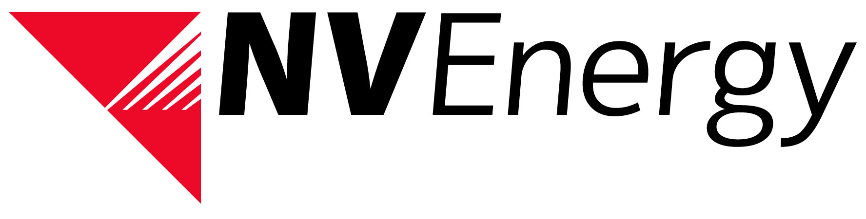

NV Energy Imbalance Market (EIM) Overview Meeting

Registration Form

Please e-mail completed Registration Form to rbixby@nvenergy.com by September 10th, 2014.

EIM Meeting Details
Tuesday, September 16th, 2014
09:00 pm - 3:00 pm (PDT) Lunch will be provided
NV Energy Beltway Offices
7155 Lindell Rd.
Las Vegas, Nevada 89118
Meeting Room 1A-1B

Attendee Information:
Organization | Last Name | First Name | E-Mail Address | In Person | *Webinar

*webinar details will be sent out via e-mail and on the OASIS website

