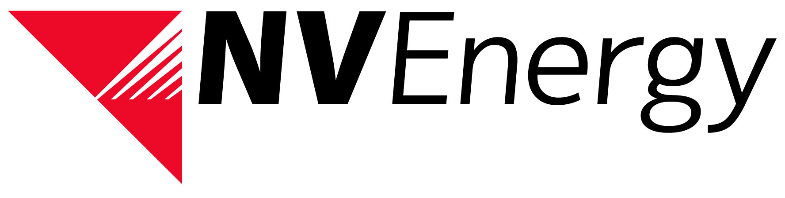

NV Energy Imbalance Market (EIM) Stakeholder Meeting

Registration Form

Please e-mail completed Registration Form to rbixby@nvenergy.com by October 6th, 2014.

EIM Stakeholder Meeting Details
Wednesday, October 8th, 2014
09:00 pm - 3:00 pm (PDT) Lunch will be provided
NV Energy Beltway Offices
7155 Lindell Rd.
Las Vegas, Nevada 89118
Meeting Room 1A-1B

Thursday, October 9th, 2014
09:00 pm - 3:00 pm (PDT) Lunch will be provided
NV Energy Sierra Plaza Offices
6100 Neil Rd.
Reno, Nevada 89511
Sierra Plaza Auditorium

Attendee Information:
Organization | Last Name | First Name | E-Mail Address | In Person – Las Vegas | In Person - Reno | *Webinar

*webinar details will be sent out via e-mail and on the OASIS website

