TSR Metric Query Instructions

- Select the ‘Reservations ‘ tab in OASIS:

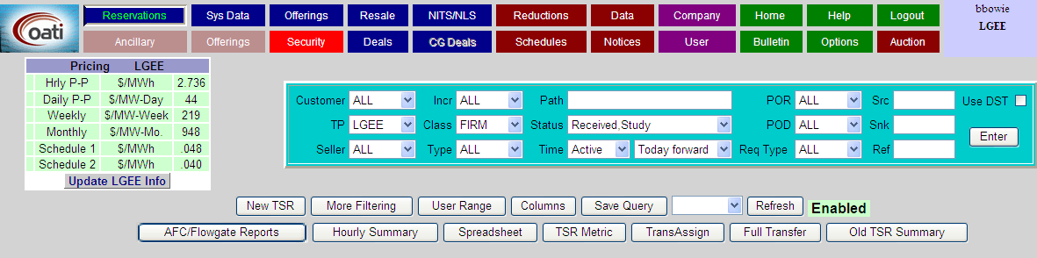
- Select the ‘TSR Metric’ tab:

- Select the ‘Provider’, ‘Report Type’, and ‘Queued Time’ needed for your custom report
