METHODOLOGY TO ASSESS AVAILABLE TRANSFER CAPABILITY
(DEF ZONE)

This Attachment C-2 describes the DEF methodology used to assess Total Transfer Capability ("TTC") and Available Transfer Capability ("ATC"). Members of the Florida Reliability Coordinating Council (FRCC) have formed the Florida Transmission Capability Determination Group (FTCDG) in an effort to provide ATC values to the regional electric market that are transparent, consistent, timely, and as accurate as possible. The FTCDG has contracted with Open Access Technology International, Inc. (OATI) to provide and host an OATI TTC Calculator Software that will produce ATC and TTC values for the region.

MATHEMATICAL ALGORITHM:
The table below describes the mathematical algorithms used to calculate firm and non-firm ATC for the scheduling, operating and planning horizons.

 | CALCULATION HORIZON
 | SCHEDULING | OPERATING | PLANNING
FIRM | N/A | ATC = TTC - ETC - TRM - CBM | ATC = TTC - ETC - TRM - CBM
NON-FIRM | ATC = TTC - ETC | ATC = TTC - ETC - CBM | ATC = TTC - ETC - CBM

The Scheduling Horizon is the same day and real time.
The ATC Operating Horizon is day ahead and pre-schedule.
The ATC Planning Horizon is beyond the operating horizon out to month 13.

N/A - Firm products do not exist in Scheduling HORIZON.

ATC, TTC, ETC, and TRM Calculation:
ATC values are determined using an area interchange method to determine ATC on paths within the FRCC.

Loadflow Model Development

Base models are derived from the current FRCC Transmission Working Group (“TWG”) seasonal models by the FTCDG and represent seasonal load profiles, in-service generating units, in-service transmission facilities and firm interchange contracts according to NERC guidelines. FTCDG provides summer and winter base models to OATI. OATI creates loadflow models of planned operations, expected load levels, facility outages by using current data from the FRCC FTMS. The FTCDG base model currently includes the total load; therefore, interruptible demands are not utilized in determining ATC values.

TTC and ATC Calculation
TTC values are calculated each time the calculation engine runs. At a minimum, the engine runs once every hour to calculate TTC values for the next 72 hours. Additionally, the engine runs at least once a day to calculate daily TTC values for the next 13 months. Firm and non-firm ATC values are determined using the mathematical algorithms for each calculation horizon.

Process to Calculate TTC

TTC definition:
Total Transfer Capability (TTC) - The amount of electric power that can be moved or transferred reliably from one area to another area of the interconnected transmission systems by way of all transmission lines (or paths) between those areas under specified system conditions.

OATI calculates the First Contingency Incremental Transfer Capability ("FCITC"), between two areas that define a transmission path; the “From” area and the “To” area. The generation is economically increased in the “From” area and decreased in the “To” area while monitoring for contingency overload conditions. The generation that participates in the “From” and “To” is determined by a FTCDG approved economic merit order.

The TTC is the lower of the contractual limitations for a path and the FCITC added to the “impacts of firm transmission services.” The value for this “impact of firm transmission service” is based on the transactions existing in the study model.

OATI utilizes a discrete contingency and monitor list supplied by FTCDG for FCITC calculations:

Monitored facilities are those facilities that are monitored for overloads and low voltage conditions (limits) under normal or first contingency analysis when calculating TTC. Monitored facilities for use in TTC calculations will include facilities operated at 69 kV and above and all tie lines between Transmission Providers. Other facilities operated at lower voltage levels may be added to the monitored facilities list. The FTCDG is responsible for compilation of the monitored facilities list, and uses the current monitored facilities list for the FRCC Reliability Coordinator and FRCC Operations Planning Coordinator functions as a starting point.

Critical contingencies are those facilities that, when outaged are deemed to have an adverse impact on the reliability of the transmission network. These facilities may be transmission facilities, including multi-terminal lines, or generating units. All tie-lines regardless of voltage and the largest unit of each control area will be considered critical contingencies. The FTCDG is responsible for compilation of the critical contingencies list for TTC calculations.

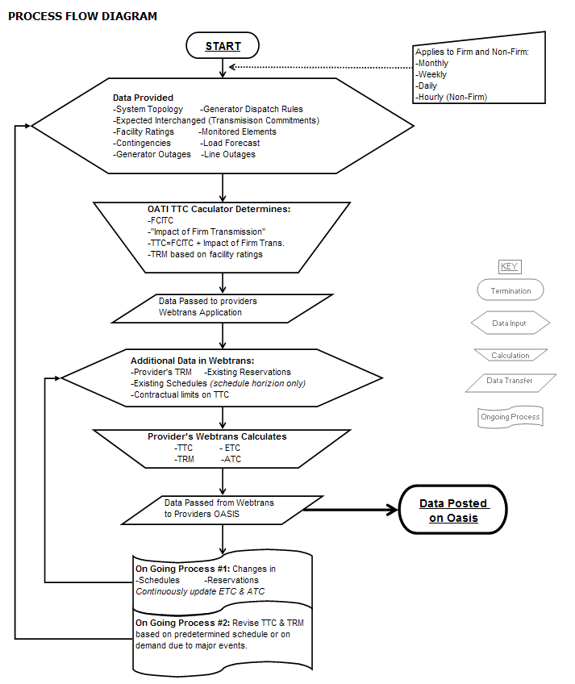

Existing Transmission Commitments (ETC)

Definition- DEF defines ETC as the committed uses of the DEF transmission system considered when determining Available Transfer Capability.

ETC Calculation Methods – To set aside transfer capability for native load and non-OATT customers for the operating and planning horizons, DEF explicitly models the transactions and load using load forecasting when appropriate. The generation assumed to participate for native load and non-OATT customer impact is determined by using a FTCDG approved economic merit order. Point to Point (PTP) OATT transactions are modeled explicitly and the generation assumed to participate for Point to Point (PTP) OATT is determined by using an FTCDG approved economic merit order. For models at various load levels the loads are scaled down, and generation is adjusted using the economic merit order.

Rollover – DEF assumes in ATC determinations that existing transactions eligible for rollover by a customer will rollover. If a customer has elected to not exercise rollover rights, DEF would exclude that transaction from ATC determinations.

Release of unscheduled Firm ATC reservations - DEF releases unscheduled firm as nonfirm ATC in the scheduling horizon (next 4 hours). The release is accomplished automatically on OASIS by comparing the reserved ATC and the pending or committed schedules (tags). The tags have an OASIS reservation number on them, and when the tag does not exist at all or in models when the tag scheduled ATC is less than the OASIS reservation amount, the unscheduled portion is not subtracted from TTC in the nonfirm ATC algorithm for the scheduling horizon, and thus the capacity is released.

TRM

Transmission Reliability Margin (TRM) - The amount of transmission transfer capability necessary to provide reasonable assurance that the interconnected transmission network will be secure. TRM accounts for the inherent uncertainty in system conditions and the need for operating flexibility to ensure reliable system operation as system conditions change.

There are two portions to the TRM values used in the determination of ATC:

- An FTCDG value that represents difference between the higher rating some entities are willing to use for Non Firm transactions, and the lower rating they use for Firm Transactions. The second value is the DEF Specific TRM. The FTCDG value is added to DEF’s specific TRM to reach the total TRM value. The FTCDG wide TRM value can frequently be zero.
The TTC is based on the “non-firm” rating FCITC run, however some FTCDG members allow a higher non-firm rating on facilities then the rating they use for firm transactions. An FCITC is calculated using this firm rating and the difference between this firm FCITC and the non-firm FCITC is the FTCDG TRM value.

2.) The DEF specific TRM is posted at the following link

https://www.oasis.oati.com/woa/docs/FPC/FPCdocs/TRMID_4.pdf

Transmission Reliability Margin (TRM) Calculation Methodology for DEF specific TRM - DEF determines the appropriate amount of TRM at each of its interfaces based upon the operating reserve obligations contained in the FRCC Operating Reserve Policy. On most paths the TRM is based upon a maximum delivered or received reserve obligation.

Export Path TRM - DEF has an obligation to deliver up to 193 MW for a reserve call, thus the TRM is 193 MW on most DEF export paths. Due to the small size of some reserve share participants, a reserve call that would require DEF to deliver 193 MW of operating reserves is not possible. For those situations, the TRM is reduced to DEF’s share (20%) of the MW output of the reserve sharing participant’s largest generator. DEF has a maximum reserve obligation of 20% for each reserve call.

Import Path TRM - DEF must be able to receive up to the maximum amount of operating reserves allowed by the Reserve Sharing Agreement. On import paths the TRM is set to the maximum reserve sharing obligation to be delivered from each reserve sharing participant. The TRM for import paths varies between 0 MW and 386 MW depending upon the reserve obligations for the particular path.

Pass Through Path TRM - The TRM on pass through paths is the larger of the operating reserve requirement of the POD and POR for each path. The POR operating reserve requirement for pass through paths is adjusted by a loop flow factor where appropriate. For example, the reserve requirement to deliver to DEF may be 100 MW for a particular POR, however a pass through path from the same POR to a POD may only be impacted by 50 MW for the 100 MW reserve obligation, thus the loop flow factor is 0.5, and the resulting TRM is 100*0.5 = 50 MW.

Use of TRM – DEF subtracts TRM from TTC for all firm products in all of the time horizons. To the extent that system conditions allow without adversely impacting reliability, TRM will be made available for transmission service on a nonfirm basis.

CBM
Capacity Benefit Margin (CBM) - The amount of firm transmission transfer capability preserved by the transmission provider for Load-Serving Entities (LSEs), whose loads are located on that Transmission Service Provider’s system, to enable access by the LSEs to generation from interconnected systems to meet generation reliability requirements. Preservation of CBM for an LSE allows that entity to reduce its installed generating capacity below that which may otherwise have been necessary without interconnections to meet its generation reliability requirements. The transmission transfer capability preserved as CBM is intended to be used by the LSE only in times of emergency generation deficiencies.

DEF’s Resource Planning group performs its resource adequacy analysis and incorporates both deterministic and probabilistic methods in its assessment of generation reliability. This assessment is accomplished by system reliability analyses which are typically based on a dual planning criteria of a minimum peak period reserve margin of 20% (DEF applies this to both summer and winter peaks) and a maximum loss-of-load probability (LOLP) of 0.1 day per year. Both of these criteria are commonly used throughout the utility industry. Historically, two types of methodologies, deterministic and probabilistic, have been employed in system reliability analysis. The calculation of excess firm capacity at the annual system peaks (reserve margin) is the most common method, and this relatively simple deterministic calculation can be performed on a spreadsheet. It provides an indication of the adequacy of a generating system’s capacity resources compared to its native load during peak periods. However, deterministic methods do not take into account probabilistic-related elements such as the impact of individual unit failures. For example: two 50 MW units which can be counted on to run 90% of the time are more valuable in regard to utility system reliability than is one 100 MW unit which can also be counted on to run 90% of the time. Probabilistic methods also recognize the value of being part of an interconnected system with access to multiple capacity sources. For this reason, probabilistic methodologies have been used to provide an additional perspective on the generation resource adequacy of a generating system. There are a number of probabilistic methods that are being used to perform system reliability analyses. Of these, the most widely used is loss–of-load probability or LOLP. Simply stated, LOLP is an index of how well a generating system may be able to meet its demand (i.e., a measure of how often load may exceed available resources). In contrast to reserve margin, the calculation of LOLP looks at the daily peak demands for each year, while taking into consideration such probabilistic events as the unavailability of individual generators due to scheduled maintenance or forced outages. LOLP is expressed in units of the “number of times per year” that the system demand could not be served. The standard for LOLP accepted throughout the industry is a maximum of 0.1 day per year. This analysis requires a more complicated calculation methodology than does the reserve margin analysis. LOLP analyses are typically carried out using computer software models such as the Tie Line Assistance and Generation Reliability (TIGER) program used by DEF.

The result of this step of resource planning is a projection of how many MW of resources are needed to meet both reserve margin and LOLP criteria, and thus maintain system reliability.

Determination of CBM

DEF has adopted the following CBM Methodology:

DEF currently has zero CBM reserved on each of its interfaces (posted paths). DEF's CBM on each interface is currently established through the transmission provider functions within DEF.

Since DEF does not calculate a CBM component to meet any resource adequacy reliability requirement; CBM on each of DEF’s path’s where DEF is the POD will be 0 and will not be included in the calculations.

