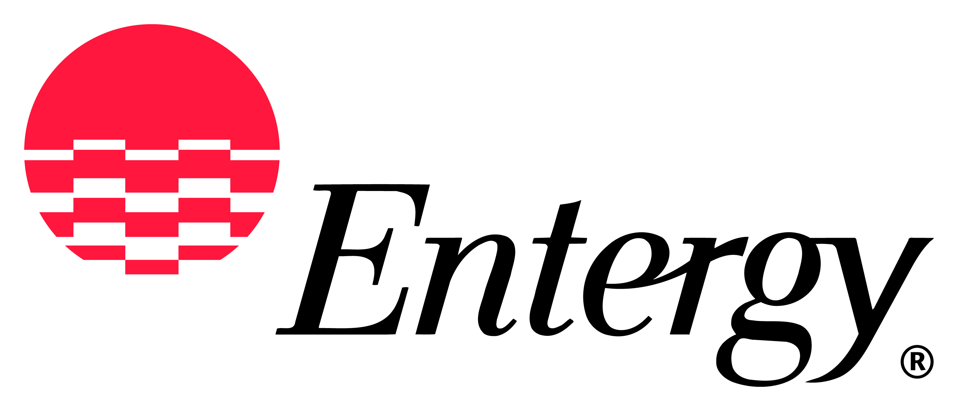
Entergy Services Inc.
425 West Capitol Avenue
P. O. Box 551
Little Rock, AR 72203-0551
_____________________________________________________________________________________

Entergy Arkansas, Inc.
Entergy Louisiana, LLC
Entergy Mississippi, Inc.
Entergy New Orleans, LLC
Entergy Texas, Inc.

Attachment O Annual Update Meeting for 2018 Rate Year

Pursuant to MISO Formula Rate protocols established in FERC Docket No. ER13-2379, the Entergy Operating Companies’ invite you to participate in the Annual Meeting for the 2018 MISO Attachment O transmission formula rate update. This meeting is to allow interested parties an opportunity to seek information and clarifications from Entergy Services about the annual Attachment O updates.

The Entergy Operating Companies will conduct the meeting via WebEx audio conference on Monday, July 30, at 10 AM Central. You may also attend in person at the address below.

The Entergy Operating Companies’ Attachment O formula rate updates are linked through the MISO OASIS website to their posted location on the Entergy OASIS website and are available at:
http://www.oasis.oati.com/EES/EESdocs/attachment_o_master.html

The meeting details are as follows:

Date: Monday, July 30, 2018, 10 AM Central, 11 AM Eastern

WebEx: https://meeting.entergy.com/orion/joinmeeting.do?MTID=b74a42a0afe5785870d1f9d23ab036f2

Telephone: 877-471-3417 (Toll-Free) when prompted enter the meeting access code
504-576-3417 (Toll / International)
When prompted, enter the meeting access code.

Access Code: 995 224 424 (This meeting does not require a password.)

In-Person Location: 27th Floor – Arkansas Room
Simmons Bank Building
425 West Capitol Avenue
Little Rock, AR 72201

