Black Hills / Basin Electric

2016 Local Transmission Plan

Study Scope

- Background
As specified in Attachment K to the Black Hills Basin Electric (“BHBE”) Joint Open Access Transmission Tariff (“JOATT”), the Transmission Provider (“TP”) through cooperation with the Transmission Coordination and Planning Committee (“TCPC”), will develop a Local Transmission Plan (“LTP”) on an annual basis to ensure the transmission system is designed to reliably accommodate resource and load growth as well as transmission service obligations. The LTP study will utilize an open and coordinated process involving input from stakeholders consistent with the principles, practices, policy, and procedures set forth in the Attachment K. Additional information on the LTP process can be found on the BHBE website (http://www.oatioasis.com/BHBE) within the “Transmission Planning” folder.

- Base Case Scenarios
The LTP will focus on 2017-2018LW for the near-term off-peak scenario and 2018HS for the near-term peak scenario. 2021HW was chosen for the five-year scenario and 2026HS for the far-term study period. The study years were selected based on several factors including base case availability, planned system upgrades, and previously completed planning studies. Descriptions of any changes made to a starting case to create a base case scenario will be documented. All generation and transmission system projects that may be included in the base case upon agreement of both the TP and TCPC include:

- Addition of the planned Teckla-Osage-Lange 230 kV line (2016)
- Addition of a second 230/69kV transformer at Yellow Creek (2018)
- Addition of the proposed South Rapid-West Hill 230kV line rebuild (2019)

The LTP study scenarios will be created using cases recently compiled through regional planning studies. This is done to ensure the cases have undergone peer review and reflect current transmission system plans. Table 1 includes the proposed study cases and their respective starting case.
Table 1: LTP Study Cases
Near Term Off-Peak Study Case | Starting Case | Far Term Peak Study Case | Starting Case
2017-2018 Light Winter | CCPG 2017-2018 Light Winter | 2026 Heavy Summer | CCPG 2026 Heavy Summer
Year-Two Peak Study Case | Starting Case | Year-Five Peak Study Case | Starting Case
2018 Heavy Summer | CCPG 2018 Heavy Summer | 2020-2021 Heavy Winter | CCPG 2020-2021 Heavy Winter

- Sensitivity Analysis
Sensitivity scenarios will be utilized to demonstrate the impact of change to the basic assumptions used in the model per NERC TPL-004-1 Standard, Requirement 2.1.4. These include:

- Rapid City DC Tie
- Planned Transmission Upgrade Projects – Delayed
- Wide-Area System Load Deviation

Additional sensitivity scenarios may be created for any of the base case scenarios in Table 1 as deemed appropriate by the TCPC based on stakeholder input.

- Power Flow Simulations
For each base case and uncertainty scenario identified above power flow simulations will be run to evaluate system performance under NERC TPL-001-4 Standard Category P0-P7 events. Rapid City and Wyodak area gas-fired generation will be dispatched as needed to mitigate performance criteria violations. Current operating procedures and remedial action schemes will be employed unless certain circumstances require otherwise.

The study will monitor the performance of the CUS and surrounding transmission system in the Western Interconnection bounded by the Yellowtail, Casper, Difficulty, LRS and Sidney 230 kV substations. Figure 1 shows the general location of Common Use transmission system.

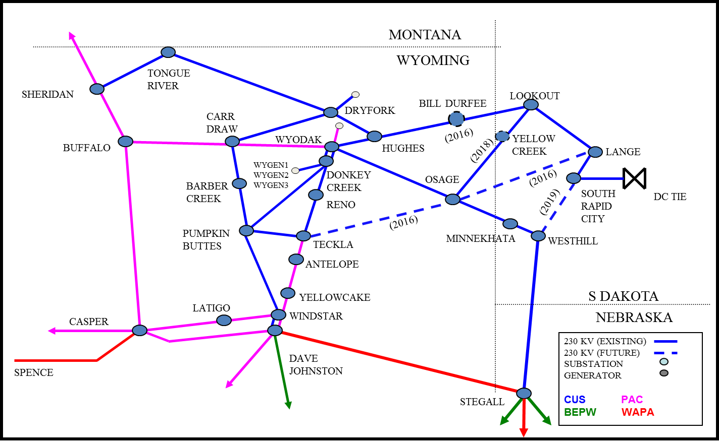
Figure 1: BHBE Common Use Transmission System

- Dynamic Simulations
Dynamic or transient stability simulations will be performed on 2018HS and 2018LW base case scenarios to evaluate system response under NERC TPL-004-1 Standard Category P0 – P7 based upon the results of the power flow simulations. Dynamic simulations may be performed on the 2021HW and 2026HS scenario as dictated by the results of the 2018 analyses.

- Short Circuit Analysis
Short circuit simulations were performed in the 2015 TCPC study. The analysis was based on a 2015 CCPG ASPEN Model and modified to reflect 2017 and 2020 scenarios. The 2020 scenario included the addition of the 230-69kV transformer at Yellow Creek. There are no appreciable transmission changes planned to justify a short circuit study in the 2016 study cycle. It is recommended that short circuit studies be completed as part of individual studies being performed to investigate solutions to issues reported in the 2015 LTP report.

- Additional Analyses or Project Alternatives
Analyses in addition to those mentioned within this study scope may be performed as necessary to address reliability requirements or meet other needs as deemed necessary by the TCPC. Requests for additional studies or scenarios, as well as suggestions for project alternatives, should be submitted to the Colorado Coordinated Planning Group using the official form provided at http://www.westconnect.com/filestorage/ccpg_request_form.xls. The request will be evaluated by the CCPG and directed to the appropriate group for consideration.

For questions regarding this study scope or the study process, please contact me:

Wes Wingen, PE
Manager of Transmission Planning
wes.wingen@blackhillscorp.com
(605) 721-2268

